Experiment-12

Repeart-

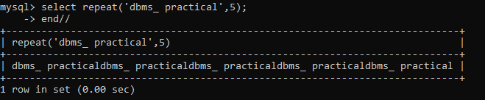

While 