**Experiment-6**

Alter the table name faculty1 with the following structure. The deptno in the table refers the deptno in the department1 table;

1. **Facno primary key!**

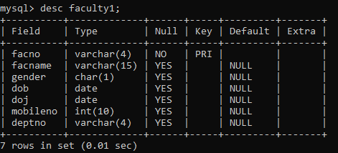

1. **Gender check ‘f’ or ‘m’!**

