Experiment-9

1.inner join

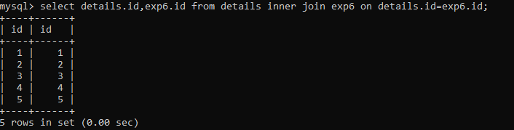

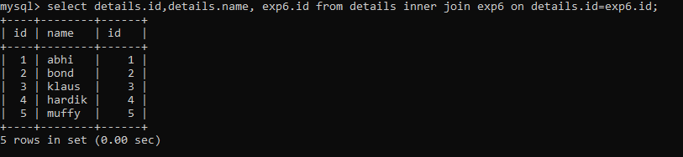

2.equii join

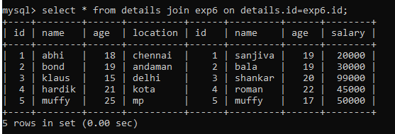

3.outerjoin

1. left outer join.

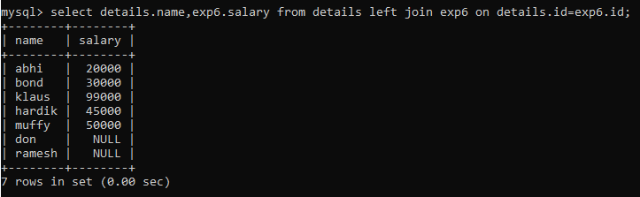

2. right outer join

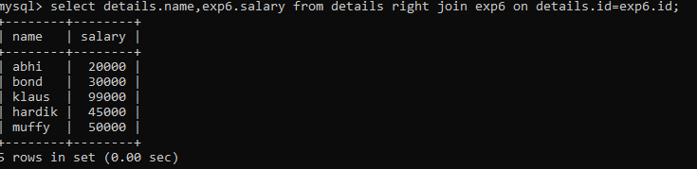

3. full outer join;

