Aim: To design and develop a Beauty Parlour Appointment Booking System using HTML, CSS, and JavaScript that enables customers to explore beauty services, view service prices, select preferred appointments, enter personal details, and receive booking confirmation.
Algorithm:
- Start the program and display the beauty parlour webpage.
- Display the available services, such as haircuts, facials, makeup, and skincare.
- Show the price and description of each service.
- Allow customers to select a service and preferred appointment date and time.
- Collect customer contact details.
- Validate the entered information using JavaScript.
- Display the selected service, appointment details, and estimated cost.
- Show an appointment confirmation message.
- Stop the program.
Program:
<!DOCTYPE html>
<html lang="en">
<head>
<meta charset="UTF-8">
<meta name="viewport" content="width=device-width, initial-scale=1.0">
<title>Glow & Grace | Beauty Parlour</title>

<style>
* {
margin: 0;
padding: 0;
box-sizing: border-box;
font-family: "Segoe UI", Arial, sans-serif;
}

body {
background: #fff8fb;
color: #38243b;
}

header {
background: white;
padding: 18px 7%;
display: flex;
justify-content: space-between;
align-items: center;
flex-wrap: wrap;
gap: 15px;
box-shadow: 0 3px 15px #60305a0d;
}

.logo {
font-size: 25px;
font-weight: bold;
color: #b83b82;
}

.logo span {
color: #38243b;
}

nav a {
text-decoration: none;
color: #49364c;
margin: 0 12px;
font-size: 14px;
}

nav a:hover {
color: #b83b82;
}

.header-btn {
background: #b83b82;
color: white;
border: none;
border-radius: 25px;
padding: 12px 20px;
cursor: pointer;
font-weight: bold;
}

.hero {
background: linear-gradient(120deg, #f9d9eb, #f5e6ff, #fff1f3);
padding: 55px 7%;
display: grid;
grid-template-columns: 1.2fr 1fr;
align-items: center;
gap: 30px;
min-height: 350px;
}

.hero small {
color: #a42e72;
font-weight: bold;
letter-spacing: 2px;
}

.hero h1 {
font-size: 46px;
line-height: 1.2;
margin: 15px 0;
}

.hero h1 span {
color: #b83b82;
}

.hero p {
color: #755a77;
line-height: 1.8;
margin-bottom: 22px;
}

.hero-art {
font-size: 135px;
text-align: center;
filter: drop-shadow(0 12px 15px #a34a8533);
}

.btn {
background: #b83b82;
color: white;
border: none;
padding: 13px 22px;
border-radius: 9px;
cursor: pointer;
font-weight: bold;
transition: 0.2s;
}

.btn:hover {
background: #922660;
transform: translateY(-2px);
}

.container {
width: 90%;
max-width: 1150px;
margin: 40px auto;
}

.heading {
text-align: center;
font-size: 29px;
margin-bottom: 10px;
}

.subtitle {
text-align: center;
color: #8b718b;
margin-bottom: 28px;
line-height: 1.6;
}

.services {
display: grid;
grid-template-columns: repeat(3, 1fr);
gap: 20px;
}

.service-card {
background: white;
border: 1px solid #f1dfeb;
border-radius: 15px;
overflow: hidden;
box-shadow: 0 6px 20px #60305a0b;
transition: 0.25s;
}

.service-card:hover {
transform: translateY(-5px);
box-shadow: 0 12px 25px #60305a18;
}

.service-image {
height: 155px;
display: flex;
justify-content: center;
align-items: center;
font-size: 65px;
background: linear-gradient(135deg, #ffe5f0, #f0e2ff);
}

.service-info {
padding: 19px;
}

.service-info h3 {
margin-bottom: 8px;
}

.service-info p {
font-size: 13px;
color: #866f87;
line-height: 1.6;
min-height: 40px;
}

.service-bottom {
display: flex;
justify-content: space-between;
align-items: center;
gap: 10px;
margin-top: 15px;
}

.price {
font-size: 21px;
color: #b83b82;
font-weight: bold;
}

.book-service {
background: #f8e2ef;
color: #a12d70;
border: none;
border-radius: 8px;
padding: 10px 12px;
cursor: pointer;
font-weight: bold;
}

.book-service:hover {
background: #b83b82;
color: white;
}

.benefits {
display: grid;
grid-template-columns: repeat(3, 1fr);
gap: 20px;
margin-top: 35px;
}

.benefit {
background: white;
border: 1px solid #f1dfeb;
border-radius: 13px;
text-align: center;
padding: 25px 15px;
}

.benefit .emoji {
font-size: 34px;
margin-bottom: 10px;
}

.benefit p {
color: #866f87;
font-size: 13px;
line-height: 1.6;
margin-top: 8px;
}

.booking-section {
background: linear-gradient(130deg, #f7e1f1, #fff0f4);
border-radius: 20px;
padding: 32px;
margin-top: 40px;
}

.booking-form {
background: white;
padding: 25px;
border-radius: 15px;
max-width: 850px;
margin: 20px auto 0;
}

.form-grid {
display: grid;
grid-template-columns: repeat(2, 1fr);
gap: 18px;
}

.field label {
display: block;
font-size: 13px;
font-weight: bold;
color: #604c62;
margin-bottom: 8px;
}

.field input,
.field select,
.field textarea {
width: 100%;
padding: 12px;
border: 1px solid #e4d5e5;
border-radius: 8px;
background: #fffdfd;
outline: none;
color: #38243b;
}

.field input:focus,
.field select:focus,
.field textarea:focus {
border-color: #b83b82;
}

.full {
grid-column: 1 / -1;
}

.total-box {
background: #fff0f7;
color: #a12d70;
padding: 15px;
border-radius: 9px;
font-size: 18px;
font-weight: bold;
margin-top: 20px;
}

.submit-btn {
width: 100%;
margin-top: 18px;
}

footer {
background: #38243b;
color: #fbe8f5;
text-align: center;
padding: 30px 15px;
line-height: 2;
font-size: 13px;
}

footer .logo {
color: #f49bc9;
}

footer .logo span {
color: white;
}

.modal {
display: none;
position: fixed;
inset: 0;
z-index: 10;
background: #211126bb;
justify-content: center;
align-items: center;
padding: 15px;
overflow-y: auto;
}

.modal-content {
background: white;
border-radius: 17px;
padding: 28px;
width: 100%;
max-width: 500px;
max-height: 90vh;
overflow-y: auto;
margin: auto;
}

.modal-content h2 {
color: #b83b82;
margin-bottom: 15px;
}

.confirmation {
text-align: center;
line-height: 1.8;
}

.receipt {
text-align: left;
background: #fff2f8;
border: 1px dashed #b83b82;
padding: 18px;
border-radius: 10px;
margin-top: 18px;
overflow-wrap: anywhere;
}

.receipt p {
margin: 7px 0;
}

.modal-actions {
display: flex;
gap: 10px;
margin-top: 20px;
flex-wrap: wrap;
}

.cancel-btn {
border: none;
background: #f2e7f1;
padding: 12px 20px;
border-radius: 8px;
cursor: pointer;
}

@media(max-width: 800px) {
.services {
grid-template-columns: repeat(2, 1fr);
}

.layout {
grid-template-columns: 1fr;
}
}

@media(max-width: 600px) {
header {
padding: 16px 5%;
}

nav {
width: 100%;
}

nav a {
margin: 0 10px 0 0;
}

.hero {
grid-template-columns: 1fr;
padding: 40px 6%;
}

.hero h1 {
font-size: 35px;
}

.hero-art {
font-size: 90px;
}

.container {
width: 92%;
}

.services,
.benefits,
.form-grid {
grid-template-columns: 1fr;
}

.booking-section {
padding: 18px;
}

.booking-form {
padding: 18px;
}
}
</style>
</head>

<body>

<header>
<div class="logo">✿ Glow <span>& Grace</span></div>

<nav>
<a href="#home">Home</a>
<a href="#services">Services</a>
<a href="#appointment">Appointments</a>
</nav>

<button class="header-btn" onclick="goToBooking()">
Book Appointment
</button>
</header>

<section class="hero" id="home">
<div>
<small>YOUR BEAUTY, OUR PASSION</small>

<h1>Feel Beautiful.<br><span>Look Confident.</span></h1>

<p>
Relax, refresh and rediscover yourself.
Experience professional beauty treatments and
personalized care at Glow & Grace Beauty Parlour.
</p>

<button class="btn" onclick="goToBooking()">
Book Your Visit →
</button>
</div>

<div class="hero-art">💆🏻‍♀️</div>
</section>

<main class="container">

<section id="services">
<h2 class="heading">Our Beauty Services</h2>
<p class="subtitle">
Choose your favorite treatment and let us take care of you.
</p>

<div class="services" id="serviceCards"></div>
</section>

<section>
<h2 class="heading" style="margin-top:45px">
Why Choose Glow & Grace?
</h2>

<p class="subtitle">
Your comfort, care and confidence are our priority.
</p>

<div class="benefits">
<div class="benefit">
<div class="emoji">💆‍♀️</div>
<h3>Expert Stylists</h3>
<p>Professional care tailored to your beauty needs.</p>
</div>

<div class="benefit">
<div class="emoji">🌸</div>
<h3>Premium Products</h3>
<p>Enjoy a relaxing experience with quality products.</p>
</div>

<div class="benefit">
<div class="emoji">📅</div>
<h3>Easy Appointments</h3>
<p>Choose your preferred service, date and time.</p>
</div>
</div>
</section>

<section class="booking-section" id="appointment">
<h2 class="heading">Book Your Appointment</h2>
<p class="subtitle">
A little time for yourself makes a beautiful difference.
</p>

<form class="booking-form" id="bookingForm">

<div class="form-grid">

<div class="field">
<label for="customerName">FULL NAME</label>
<input type="text" id="customerName"
placeholder="Enter your name" required>
</div>

<div class="field">
<label for="phone">PHONE NUMBER</label>
<input type="tel" id="phone"
placeholder="10-digit mobile number"
pattern="[0-9]{10}" maxlength="10" required>
</div>

<div class="field">
<label for="service">SELECT SERVICE</label>
<select id="service" required></select>
</div>

<div class="field">
<label for="stylist">PREFERRED BEAUTICIAN</label>
<select id="stylist">
<option value="Any Available Stylist">Any Available Stylist</option>
<option value="Ananya">Ananya</option>
<option value="Priya">Priya</option>
<option value="Sneha">Sneha</option>
</select>
</div>

<div class="field">
<label for="date">APPOINTMENT DATE</label>
<input type="date" id="date" required>
</div>

<div class="field">
<label for="time">APPOINTMENT TIME</label>
<select id="time" required>
<option value="">Select a time</option>
<option>09:00 AM</option>
<option>10:00 AM</option>
<option>11:00 AM</option>
<option>12:00 PM</option>
<option>01:00 PM</option>
<option>02:00 PM</option>
<option>03:00 PM</option>
<option>04:00 PM</option>
<option>05:00 PM</option>
<option>06:00 PM</option>
</select>
</div>

<div class="field full">
<label for="notes">SPECIAL REQUESTS (OPTIONAL)</label>
<textarea id="notes" rows="3"
placeholder="Tell us about your preferences..."></textarea>
</div>

</div>

<div class="total-box">
Estimated Service Price: <span id="servicePrice">₹500</span>
</div>

<button class="btn submit-btn" type="submit">
Confirm Appointment ✨
</button>
</form>
</section>

</main>

<footer>
<div class="logo">✿ Glow <span>& Grace</span></div>
<p>Beauty • Confidence • Self-Care</p>
<p>Working Hours: 9:00 AM – 7:00 PM</p>
<p>Glow & Grace Beauty Parlour | Student Project Demo</p>
<p>© 2026 Glow & Grace. All rights reserved.</p>
</footer>

<!-- Appointment confirmation window -->
<div class="modal" id="confirmationModal">
<div class="modal-content" id="confirmationContent"></div>
</div>

<script>
const services = [
{
name: "Facial & Skin Care",
category: "Skincare",
price: 799,
icon: "🧖‍♀️",
description: "Relaxing facial treatment for refreshed-looking skin."
},
{
name: "Hair Styling",
category: "Hair",
price: 499,
icon: "💇‍♀️",
description: "Beautiful hairstyles for everyday and special occasions."
},
{
name: "Bridal Makeup",
category: "Makeup",
price: 4999,
icon: "👰",
description: "A special makeup experience for your memorable day."
},
{
name: "Manicure & Pedicure",
category: "Nails",
price: 699,
icon: "💅",
description: "Pamper your hands and feet with a relaxing treatment."
},
{
name: "Hair Spa",
category: "Hair",
price: 999,
icon: "🧴",
description: "A nourishing hair care and relaxation session."
},
{
name: "Party Makeup",
category: "Makeup",
price: 1499,
icon: "💄",
description: "Get ready for celebrations with a glamorous look."
},
{
name: "Eyebrow Threading",
category: "Skincare",
price: 100,
icon: "✨",
description: "A simple beauty treatment for neatly shaped eyebrows."
},
{
name: "Waxing",
category: "Skincare",
price: 399,
icon: "🌸",
description: "Professional waxing service for smooth-looking skin."
},
{
name: "Haircut",
category: "Hair",
price: 299,
icon: "✂️",
description: "Choose a fresh haircut that suits your style."
}
];

const serviceCards = document.getElementById("serviceCards");
const serviceSelect = document.getElementById("service");

function renderServices() {
serviceCards.innerHTML = services.map((item, index) => `
<article class="service-card">
<div class="service-image">${item.icon}</div>

<div class="service-info">
<h3>${item.name}</h3>
<p>${item.description}</p>

<div class="service-bottom">
<span class="price">₹${item.price}</span>
<button class="book-service"
onclick="selectService(${index})">
Book Now
</button>
</div>
</div>
</article>
`).join("");

serviceSelect.innerHTML =
'<option value="">Choose a service</option>' +
services.map((item, index) =>
`<option value="${index}">${item.name} - ₹${item.price}</option>`
).join("");
}

function selectService(index) {
serviceSelect.value = String(index);
updatePrice();
goToBooking();
}

function updatePrice() {
const index = serviceSelect.value;
const price = index === "" ? 0 : services[Number(index)].price;

document.getElementById("servicePrice").textContent =
"₹" + price;
}

serviceSelect.addEventListener("change", updatePrice);

function goToBooking() {
document.getElementById("appointment").scrollIntoView({
behavior: "smooth"
});
}

const dateInput = document.getElementById("date");

const localToday = new Date(
Date.now() - new Date().getTimezoneOffset() * 60000
).toISOString().split("T")[0];

dateInput.min = localToday;
dateInput.value = localToday;

function escapeHTML(value) {
return value.replace(/[&<>"']/g, char => ({
"&": "&amp;",
"<": "&lt;",
">": "&gt;",
'"': "&quot;",
"'": "&#39;"
})[char]);
}

document.getElementById("bookingForm").addEventListener("submit", function(event) {
event.preventDefault();

const name = document.getElementById("customerName").value.trim();
const phone = document.getElementById("phone").value.trim();
const index = serviceSelect.value;
const stylist = document.getElementById("stylist").value;
const date = dateInput.value;
const time = document.getElementById("time").value;
const notes = document.getElementById("notes").value.trim();

if (!name || !/^[0-9]{10}$/.test(phone)) {
alert("Please enter your name and a valid 10-digit phone number.");
return;
}

if (index === "") {
alert("Please select a beauty service.");
return;
}

if (!date || date < localToday || !time) {
alert("Please select a valid appointment date and time.");
return;
}

const service = services[Number(index)];

const booking = {
bookingId: "GG" + Date.now().toString().slice(-8),
name,
phone,
service: service.name,
price: service.price,
stylist,
date,
time,
notes
};

// Save this demo appointment in the current browser.
const bookings = JSON.parse(
localStorage.getItem("glowGraceBookings") || "[]"
);

bookings.push(booking);

localStorage.setItem(
"glowGraceBookings",
JSON.stringify(bookings)
);

document.getElementById("confirmationContent").innerHTML = `
<div class="confirmation">
<div style="font-size:55px">🌸</div>
<h2>Appointment Booked!</h2>
<p>Thank you, ${escapeHTML(name)}!</p>
<p>Your beauty appointment has been recorded in this demo.</p>
</div>

<div class="receipt">
<h3 style="color:#b83b82;margin-bottom:12px">
✿ GLOW & GRACE
</h3>

<p><strong>Booking ID:</strong> ${booking.bookingId}</p>
<p><strong>Customer:</strong> ${escapeHTML(name)}</p>
<p><strong>Phone:</strong> ${escapeHTML(phone)}</p>
<p><strong>Service:</strong> ${escapeHTML(service.name)}</p>
<p><strong>Beautician:</strong> ${escapeHTML(stylist)}</p>
<p><strong>Date:</strong> ${date}</p>
<p><strong>Time:</strong> ${escapeHTML(time)}</p>
<p><strong>Service Price:</strong> ₹${service.price}</p>
${notes ? `<p><strong>Special Request:</strong> ${escapeHTML(notes)}</p>` : ""}
</div>

<p style="font-size:12px;color:#866f87;margin-top:12px">
Demo confirmation only. No real appointment slot is reserved.
</p>

<div class="modal-actions">
<button class="btn" onclick="window.print()">
Print Confirmation
</button>

<button class="cancel-btn" onclick="location.reload()">
Done
</button>
</div>
`;

document.getElementById("confirmationModal").style.display = "flex";
});

document.getElementById("confirmationModal").addEventListener("click", event => {
if (event.target.id === "confirmationModal") {
document.getElementById("confirmationModal").style.display = "none";
}
});

renderServices();
updatePrice();
</script>

</body>
</html>
Output:
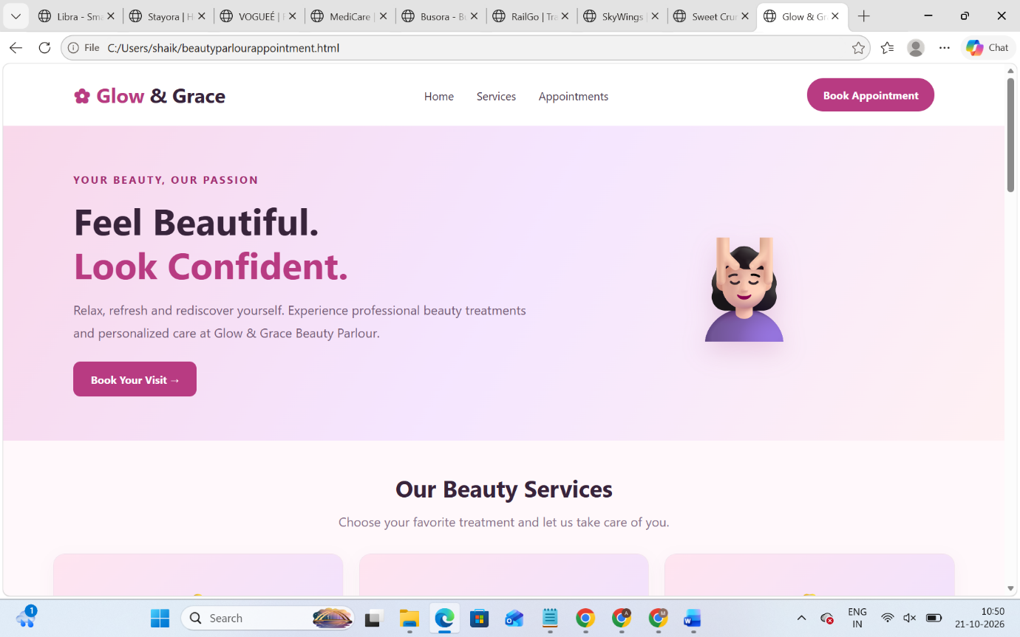
Result: Thus, the Beauty Parlour Appointment Booking System was implemented successfully. It provides a user-friendly interface for viewing beauty services, selecting appointment slots, and displaying booking details and confirmation messages.

