Name:

Reg.No.:

Subject:

1.Factorial Number

#include <iostream>

using namespace std;

int main() {

int n;

long factorial = 1.0;

cout << "Enter a positive integer: ";

cin >> n;

if (n < 0)

cout << "Error! Factorial of a negative number doesn't exist.";

else {

for(int i = 1; i <= n; ++i) {

factorial \*= i;

}

cout << "Factorial of " << n << " = " << factorial;

}

return 0;

}

OUTPUT:

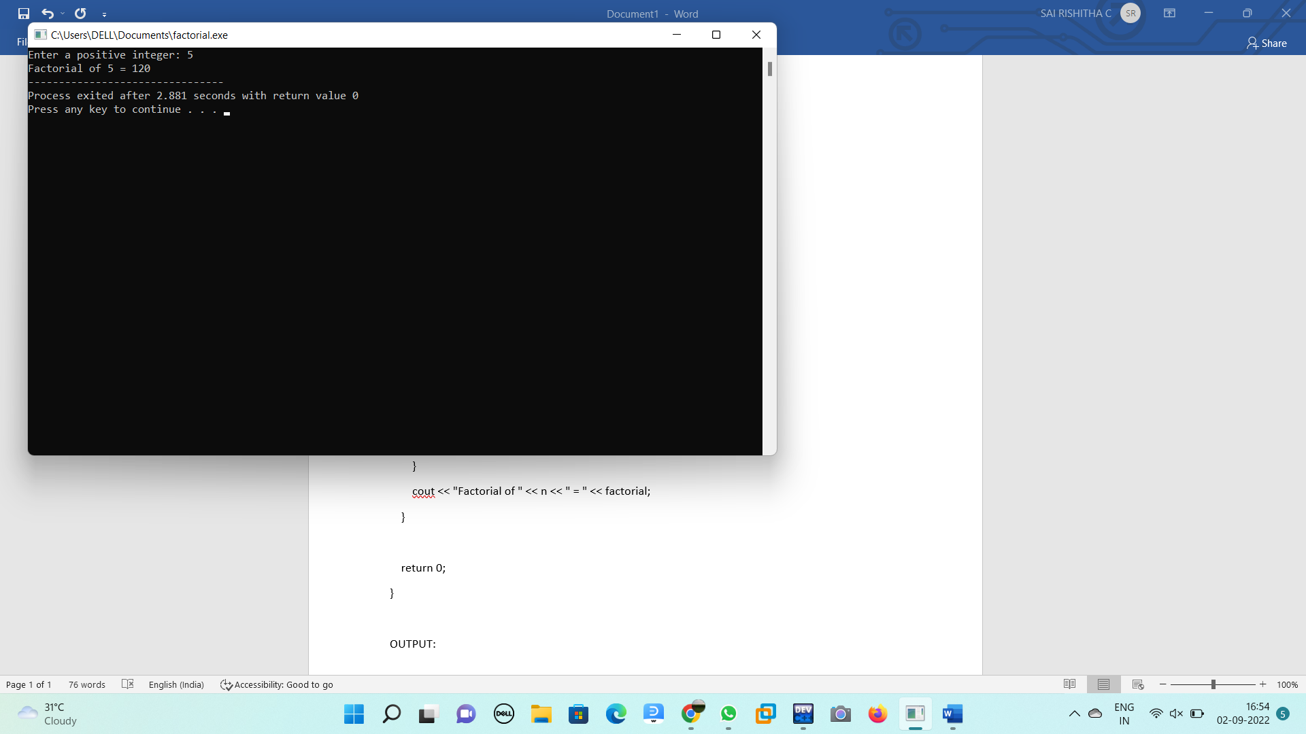

2.Fibonassi Series

#include <iostream>

using namespace std;

int main() {

int n, t1 = 0, t2 = 1, nextTerm = 0;

cout << "Enter the number of terms: ";

cin >> n;

cout << "Fibonacci Series: ";

for (int i = 1; i <= n; ++i) {

// Prints the first two terms.

if(i == 1) {

cout << t1 << ", ";

continue;

}

if(i == 2) {

cout << t2 << ", ";

continue;

}

nextTerm = t1 +t2;

t1 = t2;

t2 = nextTerm;

cout << nextTerm << ", ";

}

return 0;

}

OUTPUT:

