10. **Consider a file system where the records of the file are stored one after another both physically and logically. A record of the file can only be accessed by reading all the previous records. Design a program to simulate the file allocation strategy**

#include <stdio.h>

#include <conio.h>

#include <stdlib.h>

void recurse(int files[]){

int flag = 0, startBlock, len, j, k, ch;

printf("Enter the starting block and the length of the files: ");

scanf("%d%d", &startBlock, &len);

for (j=startBlock; j<(startBlock+len); j++){

if (files[j] == 0)

flag++;

}

if(len == flag){

for (int k=startBlock; k<(startBlock+len); k++){

if (files[k] == 0){

files[k] = 1;

printf("%d\t%d\n", k, files[k]);

}

}

if (k != (startBlock+len-1))

printf("The file is allocated to the disk\n");

}

else

printf("The file is not allocated to the disk\n");

printf("Do you want to enter more files?\n");

printf("Press 1 for YES, 0 for NO: ");

scanf("%d", &ch);

if (ch == 1)

recurse(files);

else

exit(0);

return;

}

int main()

{

int files[50];

for(int i=0;i<50;i++)

files[i]=0;

printf("Files Allocated are :\n");

recurse(files);

getch();

return 0;

}

OUTPUT:

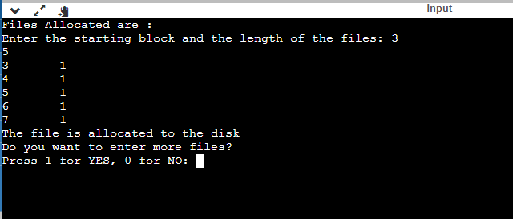

RESULT: Thus the c program to file system where the records of the file are stored one after another both physically and logically. A record of the file can only be accessed by reading all the previous records.Design a program to simulate the file allocation strategy is successfully implemented.