11. **Consider a file system that brings all the file pointers together into an index block. The ith entry in the index block points to the ith block of the file. Design a program to simulate the file allocation strategy.**

#include <stdio.h>

#include <conio.h>

#include <stdlib.h>

int files[50], indexBlock[50], indBlock, n;

void recurse1();

void recurse2();

void recurse1(){

printf("Enter the index block: ");

scanf("%d", &indBlock);

if (files[indBlock] != 1){

printf("Enter the number of blocks and the number of files needed for the index %d on the disk: ", indBlock);

scanf("%d", &n);

}

else{

printf("%d is already allocated\n", indBlock);

recurse1();

}

recurse2();

}

void recurse2(){

int ch;

int flag = 0;

for (int i=0; i<n; i++){

scanf("%d", &indexBlock[i]);

if (files[indexBlock[i]] == 0)

flag++;

}

if (flag == n){

for (int j=0; j<n; j++){

files[indexBlock[j]] = 1;

}

printf("Allocated\n");

printf("File Indexed\n");

for (int k=0; k<n; k++)

{

printf("%d ------> %d : %d\n", indBlock, indexBlock[k], files[indexBlock[k]]);

}

}

else{

printf("File in the index is already allocated\n");

printf("Enter another indexed file\n");

recurse2();

}

printf("Do you want to enter more files?\n");

printf("Enter 1 for Yes, Enter 0 for No: ");

scanf("%d", &ch);

if (ch == 1)

recurse1();

else

exit(0);

return;

}

int main()

{

for(int i=0;i<50;i++)

files[i]=0;

recurse1();

return 0;

}

OUTPUT:

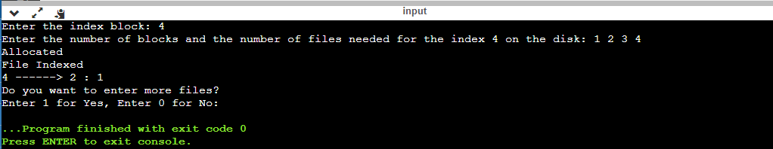

RESULT:

Thus the c program to file system that brings all the file pointers together into an index block. The ith entry in the index block points to the ith block of the file. Design a program to simulate the file allocation strategy is successfully implemented.