12. **With linked allocation, each file is a linked list of disk blocks; the disk blocks may be scattered anywhere on the disk. The directory contains a pointer to the first and last blocks of the file. Each block contains a pointer to the next block. Design a program to simulate the file allocation strategy.**

#include <stdio.h>

#include <conio.h>

#include <stdlib.h>

void recursivePart(int pages[]){

int st, len, k, c, j;

printf("Enter the index of the starting block and its length: ");

scanf("%d%d", &st, &len);

k = len;

if (pages[st] == 0){

for (j = st; j < (st + k); j++){

if (pages[j] == 0){

pages[j] = 1;

printf("%d------>%d\n", j, pages[j]);

}

else {

printf("The block %d is already allocated \n", j);

k++;

}

}

}

else

printf("The block %d is already allocated \n", st);

printf("Do you want to enter more files? \n");

printf("Enter 1 for Yes, Enter 0 for No: ");

scanf("%d", &c);

if (c==1)

recursivePart(pages);

else

exit(0);

return;

}

int main(){

int pages[50], p, a;

for (int i = 0; i < 50; i++)

pages[i] = 0;

printf("Enter the number of blocks already allocated: ");

scanf("%d", &p);

printf("Enter the blocks already allocated: ");

for (int i = 0; i < p; i++){

scanf("%d", &a);

pages[a] = 1;

}

recursivePart(pages);

getch();

return 0;

}

OUTPUT:

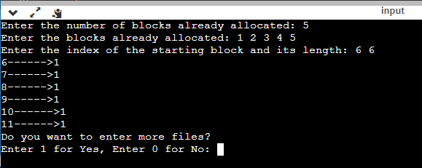

RESULT:

Thus the c program to do With linked allocation, each file is a linked list of disk blocks; the disk blocks may be scattered anywhere on the disk. The directory contains a pointer to the first and last blocks of the file. Each block contains a pointer to the next block. Design a program to simulate the file allocation strategy is successfully implemented.