9. **Construct a program to simulate the optimal paging technique of memory management. The operating system replaces the page that will not be used for the longest period of time in future**

#include<stdio.h>

void main()

{

int no_of_frames, no_of_pages, frames[10], pages[30], temp[10], flag1, flag2, flag3, i, j, k,pos, max, faults = 0;

printf("Enter number of frames: "); scanf("%d", &no_of_frames);

printf("Enter number of pages: "); scanf("%d", &no_of_pages);

printf("Enter page reference string: ");

for(i = 0; i < no_of_pages; ++i)

{

scanf("%d", &pages[i]);

}

for(i = 0; i < no_of_frames; ++i){ frames[i] = -1;

}

for(i = 0; i < no_of_pages; ++i){ flag1 = flag2 = 0; for(j = 0; j < no_of_frames; ++j){ if(frames[j] == pages[i]){ flag1 = flag2 = 1;

break;

}

}

if(flag1 == 0){

for(j = 0; j < no_of_frames; ++j)

{

if(frames[j] == -1){faults++;

frames[j] = pages[i];flag2 = 1;

break;

}

}

}

if(flag2 == 0){ flag3 =0;

for(j = 0; j < no_of_frames; ++j){ temp[j] = -1; for(k = i + 1; k < no_of_pages; ++k){ if(frames[j] == pages[k]){ temp[j] = k; break;

}

}

}

for(j = 0; j < no_of_frames; ++j){ if(temp[j] == -1){ pos = j; flag3 = 1; break;

}

} if(flag3 ==0){ max = temp[0];

pos = 0;

for(j = 1; j < no_of_frames; ++j){ if(temp[j] > max)

{ max = temp[j]; pos = j;

}

}

}

frames[pos] = pages[i];faults++; } printf("\n");

for(j = 0; j < no_of_frames; ++j){

printf("%d\t", frames[j]);

}

}

printf("\n\nTotal Page Faults = %d", faults);

}

OUTPUT:

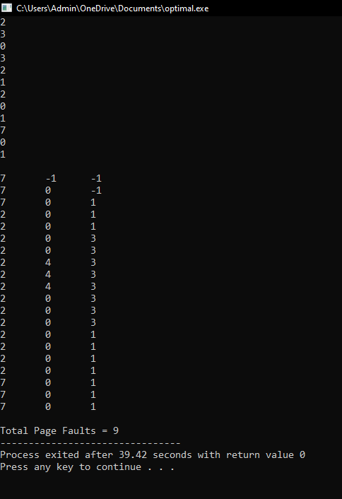

RESULT:  
 Thus the c program to simulate the optimal paging technique of memory management. The operating system replaces the page that will not be used for the longest period of time in future is successfully implemented