NAME :kalyan

REG NO :192110675

COURSE :software engineering

CODE :CSA1001

FACULTY :DR.MARY VALANTINA.G

DATE :26/09/22

**LAB MANUAL 1 TO 4**

**EXPERIMENT:1**

1.Draw a USE-CASE diagram for Online Voting System using CASE tools

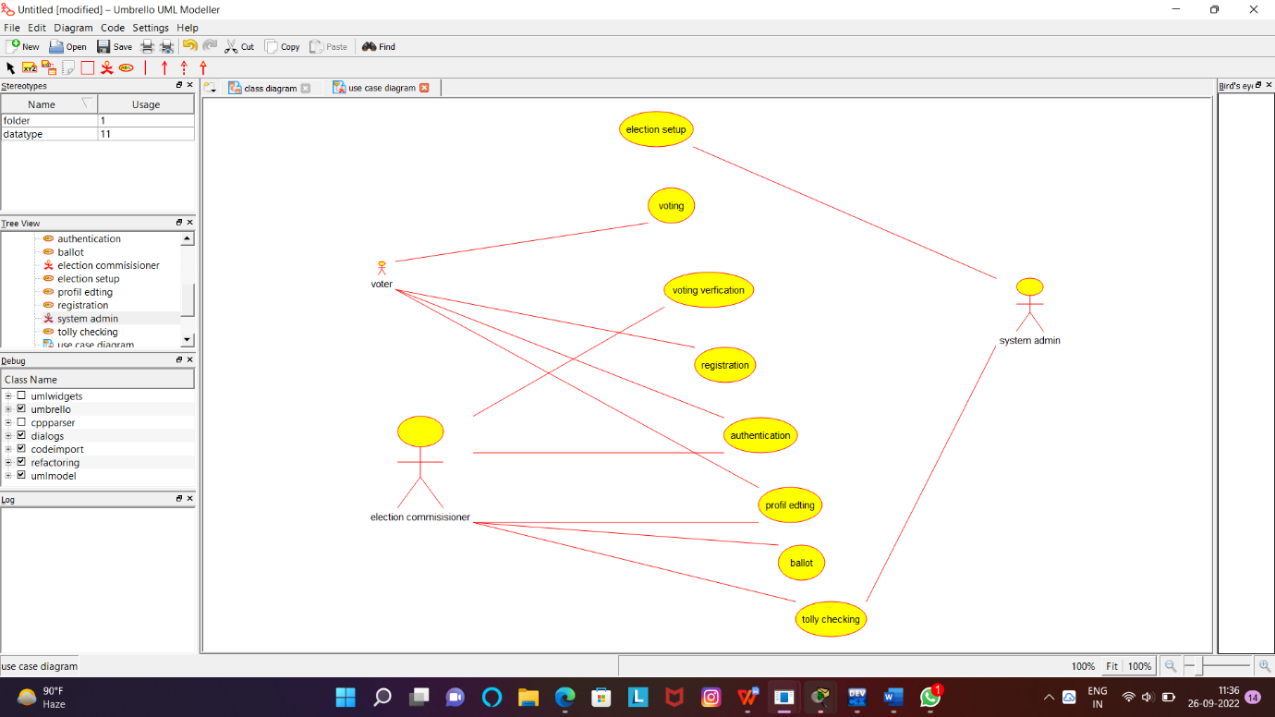

RESULT:Successfully designed online voting system

EXPERIMENT:2

2.Draw a USE-CASE diagram for Library Management System using CASE tools.

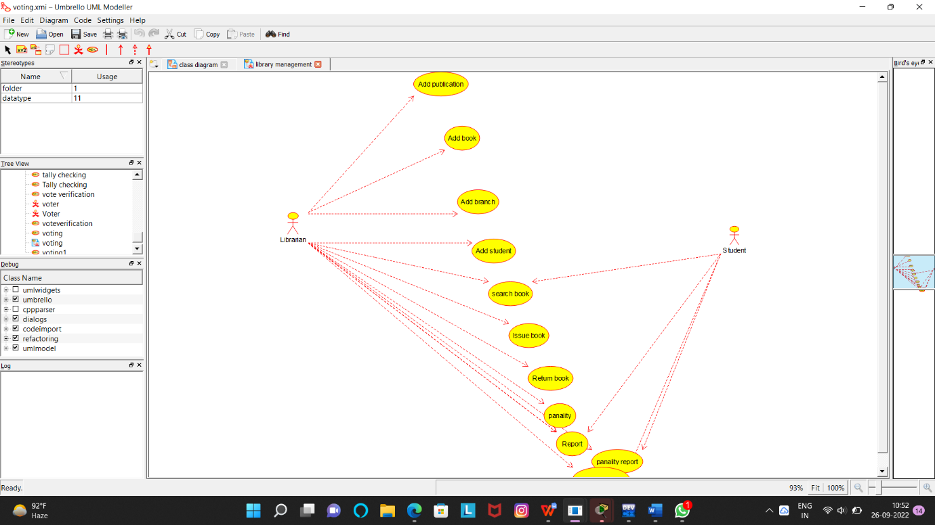

RESULT:Successfully designed library management system

EXPERIMENT:3

3.Draw a USE-CASE diagram for Online Shopping system using CASE tools.

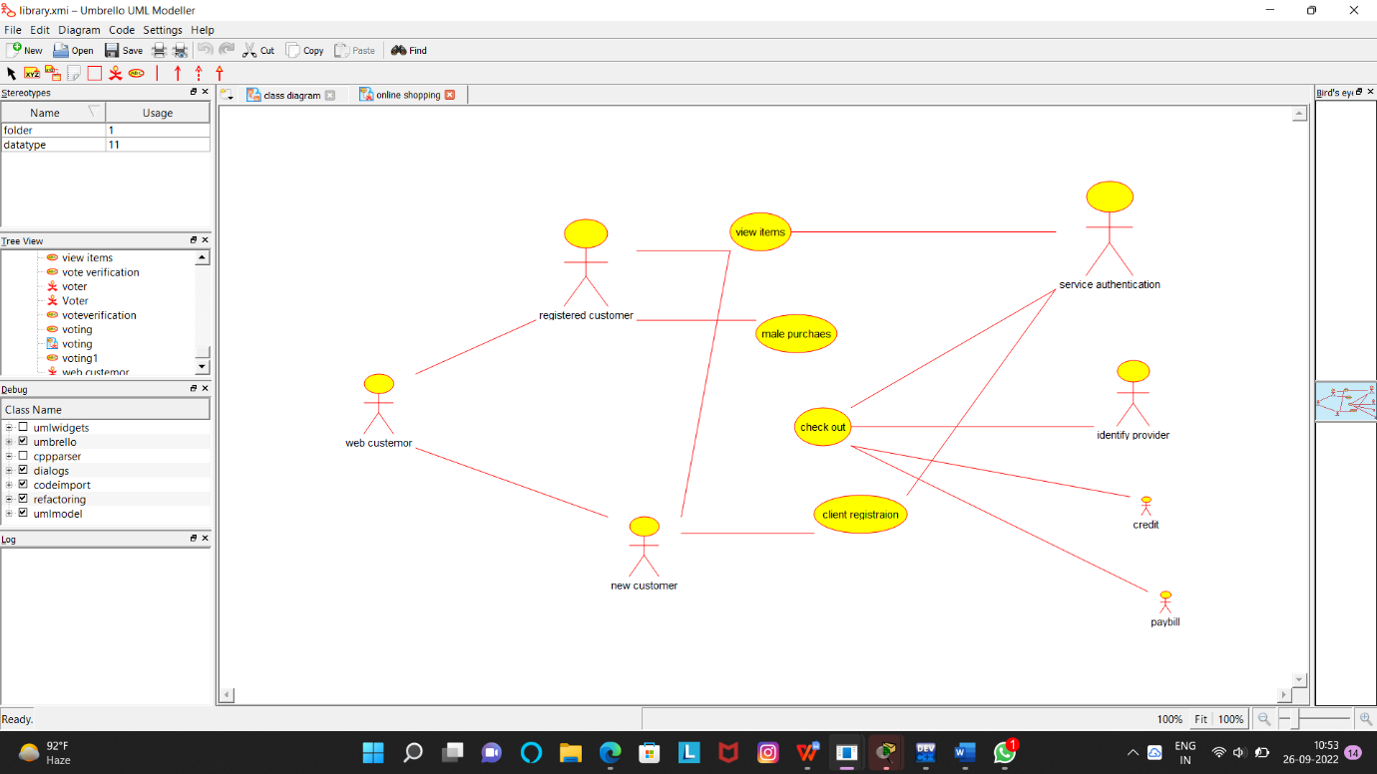

RESULT:Successfully designed online shopping system

EXPRIMENT:4

4.Draw a USE-CASE diagram for Online Railway Reservation System using CASE tools.

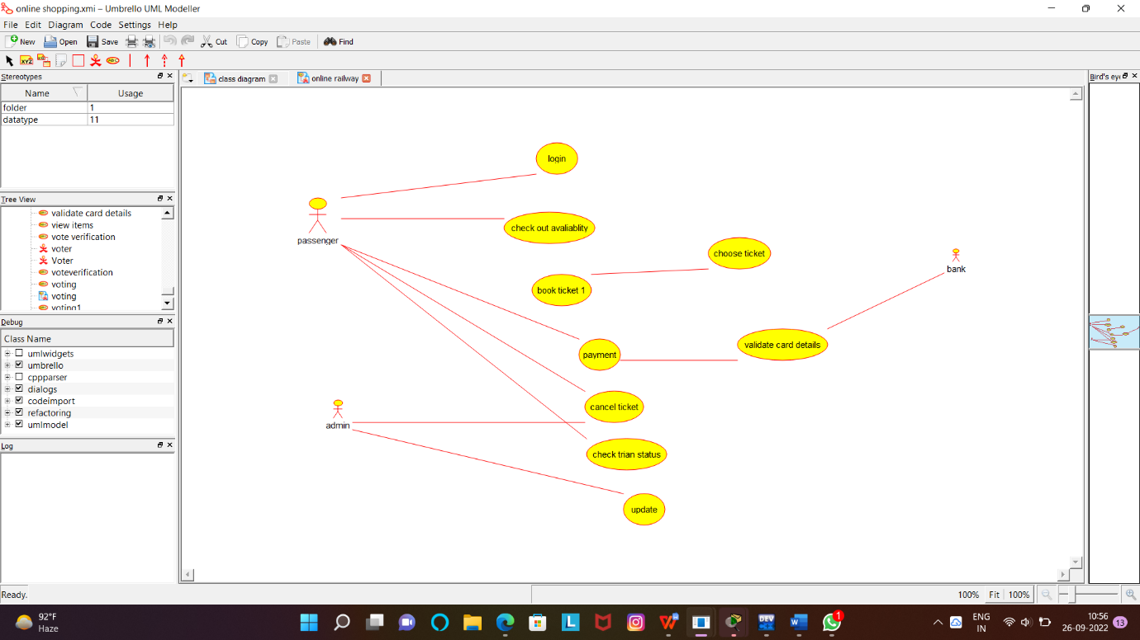

RESULT:Successfully designed online railway reservation