#### 1.Caluculating Average student marks?

#### Program:

import java.util.*;  
class average  
{  
 public static void main(String args[])  
 {  
  
 int a[]=new int[20];  
 double sum=0,avg;  
 int n,i;  
 Scanner s=new Scanner(System.*in*);  
 System.*out*.println("enter the num of elements:");  
 n=s.nextInt();  
 System.*out*.println("enter the "+n+"\telements:");  
 for(i=0;i<n;i++)  
 a[i]=s.nextInt();  
  
 for(i=0;i<n;i++)  
 sum=sum+a[i];  
  
 avg=sum/n;  
 System.*out*.println("average :"+avg);  
  
 }  
}

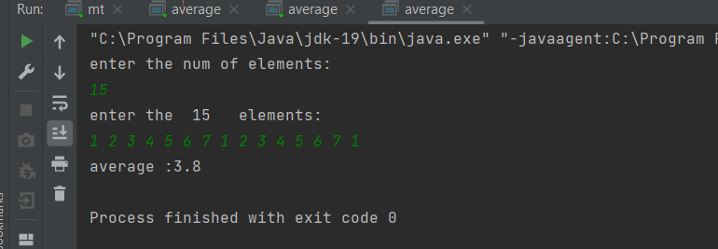

#### 2. Matrix Addition?

#### Program:

class MatrixAddition

{

public static void main(String args[])

{

int a[][]={{1,3,4},{2,4,3},{3,4,5}};

int b[][]={{1,3,4},{2,4,3},{1,2,4}};

int c[][]=new int[3][3];

for(int i=0;i<3;i++){

for(int j=0;j<3;j++){

c[i][j]=a[i][j]+b[i][j];

System.*out*.print(c[i][j]+" ");

}

System.*out*.println();

}

}

}

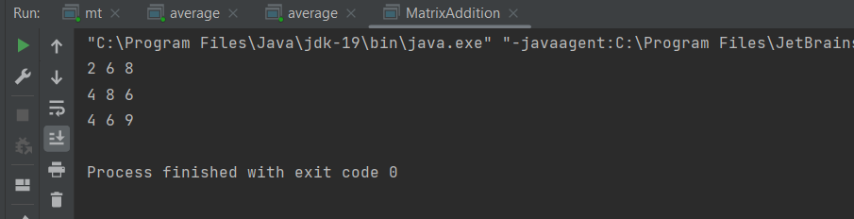

**3. Matrix subtraction**

#### Program:

class matsub  
{  
 public static void main(String args[])  
 {  
 int a[][]={{1,3,4},{2,4,3},{3,4,5}};  
 int b[][]={{1,3,4},{2,4,3},{1,2,4}};  
 int c[][]=new int[3][3];  
 for(int i=0;i<3;i++){  
 for(int j=0;j<3;j++){  
 c[i][j]=a[i][j]-b[i][j];  
 System.*out*.print(c[i][j]+" ");  
 }  
 System.*out*.println();  
 }  
 }  
}

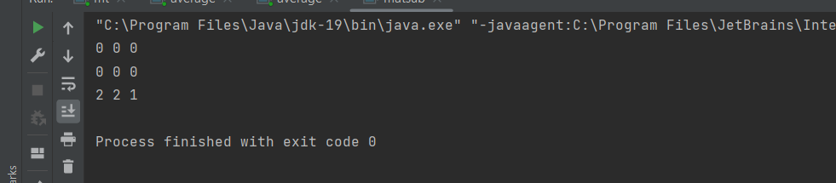

#### 4. Area of Rectangle?

#### Program:

import java.util.Scanner;  
class rect  
{  
 void area(int height, int width)  
 {  
 int res=height*width;  
 System.*out*.println("area of rectangle is :"+res);  
 }  
}  
  
class rectangle  
{  
 public static void main(String[] args)  
 {  
 int h,w;  
 Scanner s=new Scanner(System.*in*);  
 System.*out*.println("enter the height:");  
 h=s.nextInt();  
 System.*out*.println("enter the width:");  
 w=s.nextInt();  
 rect o=new rect();  
 o.area(h,w);  
 }  
}

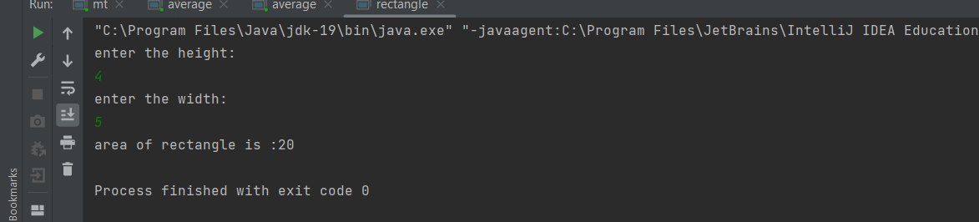

#### 5. Area of circle?

#### Program:

import java.util.*;  
class circle  
{  
 double radius;  
 void area() {  
 Scanner s = new Scanner(System.*in*);  
 System.*out*.println("Enter the radius:");  
 radius = s.nextDouble();  
 }  
 void cal()  
 {  
 double result = 3.14*radius*radius;  
 System.*out*.println("Area of rectangle=" +result);  
 }  
}  
class r  
{  
 public static void main(String []arg)  
 {  
 circle obj=new circle();  
 obj.area();  
 obj.cal();  
 }  
}

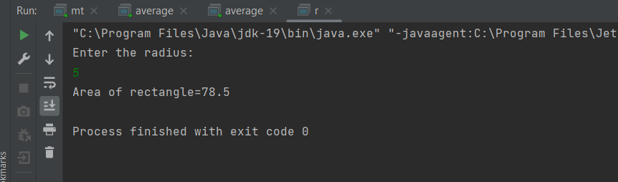

#### 6.simple Interest?

#### Program:

import java.util.*;  
class interest  
{  
 float p,t,r,si;  
 void area() {  
 Scanner s = new Scanner(System.*in*);  
 System.*out*.println("Enter the principel amount:");  
 p= s.nextFloat();  
 System.*out*.println("Enter the time:");  
 t=s.nextFloat();  
 System.*out*.println("Enter the Rate:");  
 r=s.nextFloat();  
 }  
 void cal()  
 {  
 float result=p*t*r/100;  
 System.*out*.println("Simple Interest=" +result);  
 }  
}  
class Inter  
{  
 public static void main(String []arg)  
 {  
 interest obj=new interest();  
 obj.area();  
 obj.cal();  
 }  
}

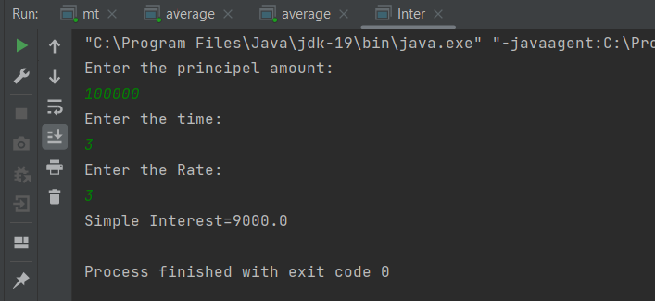

**7.Area of Rectangle**

**Program:**

import java.util.Scanner;  
class rect  
{  
 void area(int height, int width)  
 {  
 int res=height*width;  
 System.*out*.println("area of rectangle is :"+res);  
 }  
}  
  
class rectangle  
{  
 public static void main(String[] args)  
 {  
 int h,w;  
 Scanner s=new Scanner(System.*in*);  
 System.*out*.println("enter the height:");  
 h=s.nextInt();  
 System.*out*.println("enter the width:");  
 w=s.nextInt();  
 rect o=new rect();  
 o.area(h,w);  
 }  
}

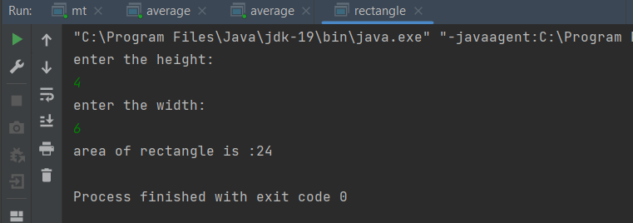

#### 8.Box using oops.

#### Program:

class Box  
{  
 double width,height,depth;  
 Box(double w,double h,double d)  
 {  
 width=w;  
 height=h;  
 depth=d;  
 }  
 double volume()  
 {  
 return width*height*depth;  
 }  
 public static void main(String[] arg)  
 {  
 Box obj=new Box(10.5,20.5,30.4);  
 double res3=obj.volume();  
 System.*out*.println("result3: "+res3);  
 }  
}

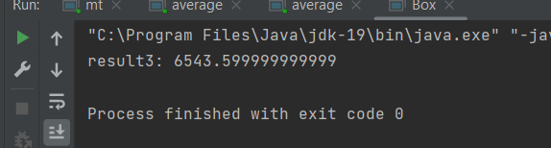

#### 9.Sum of series?

#### Program:

import java.util.*;  
class SumofSeries1  
{  
 int n,sum=0;  
 void sum()  
 {  
 Scanner s=new Scanner(System.*in*);  
 System.*out*.println("Enter a number");  
 n=s.nextInt();  
 }  
 void cal()  
 {  
 for(int i=0;i<=n;i++)  
 {  
 sum=sum+i;  
 }  
 System.*out*.println("Sum = "+sum);  
 }  
 public static void main(String[] arg)  
 {  
 SumofSeries1 obj=new SumofSeries1();  
 obj.sum();  
 obj.cal();  
 }  
}

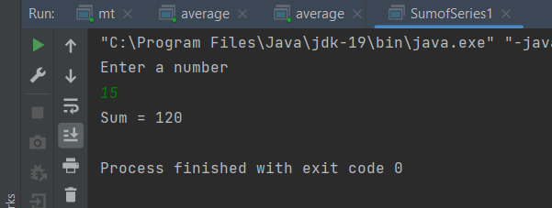

#### 10. Area of triangle?

**Program:**

import java.util.*;  
class triangle1  
{  
 int base,height;  
 void area()  
 {  
 Scanner s=new Scanner(System.*in*);  
 System.*out*.println("Enter the base of triangle: ");  
 base=s.nextInt();  
 System.*out*.println("Enter the height of triangle: ");  
 height=s.nextInt();  
 }  
 void cal()  
 {  
 int result=base*height/2;  
 System.*out*.println("Area of triangle= "+result);  
 }  
 public static void main(String[] arg)  
 {  
 triangle1 obj=new triangle1();  
 obj.area();  
 obj.cal();  
 }  
}

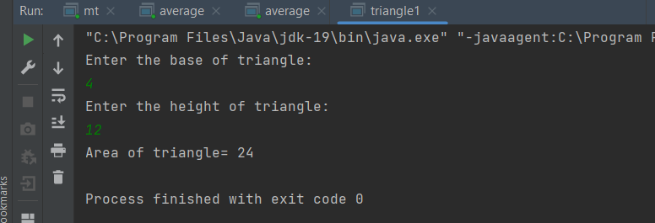

**ASSIGNMENT -2**

1.Implement a class Account. An account has

• a balance

• functions to add

• and withdraw money,

• and a function to inquire about the current balance.

Condition:

1. Pass a value into a constructor to set an initial balance.

2. If no value is passed the initial balance should be set to $0.

3. Charge a $5 penalty if an attempt is made to withdraw more money than is available in the account.

4. Enhance the Account class to compute interest on the current balance.

public class Account {  
 private double balance;  
 private double interestRate;  
 public Account(double initialBalance) {  
 if (initialBalance < 0) {  
 System.*out*.println("Initial balance cannot be negative. Setting balance to $0.");  
 this.balance = 0;  
 } else {  
 this.balance = initialBalance;  
 }  
 this.interestRate = 0.03;  
 }  
 public void deposit(double amount) {  
 if (amount > 0) {  
 balance += amount;  
 System.*out*.println("$" + amount + " deposited successfully.");  
 } else {  
 System.*out*.println("Invalid deposit amount. Please enter a positive amount.");  
 }  
 }  
  
 public void withdraw(double amount) {  
 if (amount > 0) {  
 if (balance >= amount) {  
 balance -= amount;  
 System.*out*.println("$" + amount + " withdrawn successfully.");  
 } else {  
 System.*out*.println("Insufficient funds. A $5 penalty will be charged.");  
 balance -= 5;  
 }  
 } else {  
 System.*out*.println("Invalid withdrawal amount. Please enter a positive amount.");  
 }  
 }  
 public double getBalance() {  
 return balance;  
 }  
  
 public void computeInterest() {  
 double interest = balance * interestRate;  
 balance += interest;  
 System.*out*.println("Interest of $" + interest + " added to the account.");  
 }  
  
 public static void main(String[] args) {  
 Account myAccount = new Account(1000);  
 myAccount.deposit(500);  
 myAccount.withdraw(800);  
 myAccount.withdraw(200);  
 myAccount.computeInterest();  
 double currentBalance = myAccount.getBalance();  
 System.*out*.println("Current balance: $" + currentBalance);  
 }  
}

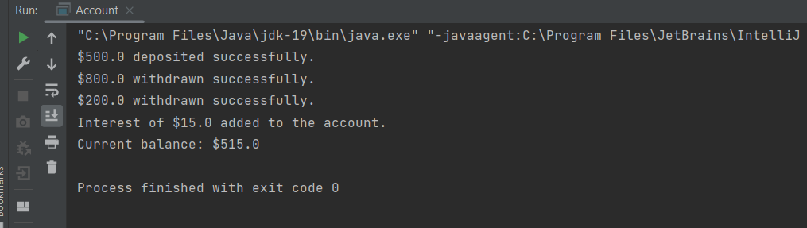

2. Write a class called Triangle that can be used to represent a triangle. It should include the following methods that return Boolean values indicating if the particular property holds:

• isRight (a right triangle)

• isScalene (no two sides are the same length)

• isIsosceles (exactly two sides are the same length)

• isEquilateral (all three sides are the same length)

class Triangle  
{  
 private double a;  
 private double b;  
 private double c;  
 public Triangle(double a, double b, double c)  
 {  
 this.a = a;  
 this.b = b;  
 this.c = c;  
 }  
 public boolean isRight()  
 {  
 double hypotenuse = Math.*max*(a, Math.*max*(b, c));  
 if (hypotenuse == a)  
 {  
 return a * a == b * b + c * c;  
 }  
 else if (hypotenuse == b)  
 {  
 return b * b == a * a + c * c;  
 }  
 else  
 {  
 return c * c == a * a + b * b;  
 }  
 }  
 public boolean isScalene()  
 {  
 return a!=b && a!=c && b!=c;  
 }  
 public boolean isIsosceles()  
 {  
 return a == b || a == c || b == c;  
 }  
 public boolean isEquilateral()  
 {  
 return a == b && a == c;  
 }  
}  
  
class Traingleclass  
{  
 public static void main(String[] args)  
 {  
 Triangle triangle1 = new Triangle(3, 4, 5);  
 System.*out*.println("Is triangle1 a right triangle? " + triangle1.isRight());  
 System.*out*.println("Is triangle1 scalene? " + triangle1.isScalene());  
 System.*out*.println("Is triangle1 isosceles? " + triangle1.isIsosceles());  
 System.*out*.println("Is triangle1 equilateral? " + triangle1.isEquilateral());  
  
 }  
}

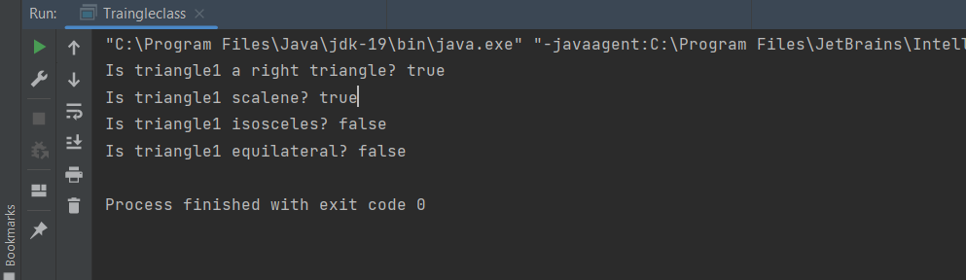

3. Write a program for matrix multiplication.

Sample Input:

Mat1 = 1 2

5 3

Mat2 = 2 3

4 1

Sample Output:

Mat Sum = 10 5

        22    18

import java.util.*;  
class mt {  
 public static void main(String[] args) {  
 int i, j, k,n;  
 int a[][] = new int[4][4];  
 int b[][] = new int[4][4];  
 int c[][] = new int[4][4];  
 Scanner s = new Scanner(System.*in*);  
 System.*out*.println("enter no of rows and column:");  
 n=s.nextInt();  
 System.*out*.println("enter the elements of matrix1:");  
 for(i=0;i<n;i++)  
 {  
 for(j=0;j<n;j++)  
 {  
 a[i][j]=s.nextInt();  
 }  
 }  
 System.*out*.println("enter the elements of matrix2:");  
 for(i=0;i<n;i++)  
 {  
 for(j=0;j<n;j++)  
 {  
 b[i][j]=s.nextInt();  
 }  
 }  
 System.*out*.println("multipled matrix :");  
 for(i=0;i<n;i++)  
 {  
 for(j=0;j<n;j++)  
 {  
 c[i][j] = 0;  
 for(k=0;k<n;k++)  
 {  
 c[i][j]+=a[i][k] * b[k][j];  
 }  
 System.*out*.print(c[i][j] + " ");  
 }  
 System.*out*.println();  
 }  
 }  
}

