**ASSIGNMENT-III**

1. Write a Java program to enter the marks of a student in four subjects. Then calculate the total and aggregate, and display the grade obtained by the student. If the student scores an aggregate greater than 75%, then the grade is Distinction. If the aggregate is 60>= and <75, then the grade is First Division. If the aggregate is 50 >= and <60, then the grade is Second Division. If the aggregate is 40>= and <50, then the grade is Third Division, else the grade is Fail. Using Multilevel inheritance concept.

Sample Input & Output:

Enter the marks in python: 90

Enter the marks in c programming: 91

Enter the marks in Mathematics: 92

Enter the marks in Physics: 93

Total= 366

Aggregate = 91.5

DISTINCTION

Test cases:

a) 18, 76,93,65

b) 73,78,79,75

c) 98,106,120,95

d) 96,73, -85,95

e) 78,59.8,76,79

import java.util.*;  
class S  
{  
 public double total,aggreg,flag=0;  
 public double s1,s2,s3,s4;  
 void getmark()  
 {  
 Scanner s=new Scanner(System.*in*);  
 System.*out*.println("Enter Marks of sub1:");  
 s1=s.nextDouble();  
 System.*out*.println("Enter Marks of sub2:");  
 s2=s.nextDouble();  
 System.*out*.println("Enter Marks of sub3:");  
 s3=s.nextDouble();  
 System.*out*.println("Enter Marks of sub4:");  
 s4=s.nextDouble();  
 }  
}  
class verify extends S  
{  
 void calculat()  
 {  
 if(((s1<0 || s1>100)||(s2<0 || s2>100)||(s3<0 || s3>100)||(s4<0||s4>100)))  
 {  
 System.*out*.println("Enter proper marks piz");  
 }  
 else  
 {  
 total=s1+s2+s3+s4;  
 System.*out*.println("total marks:"+total);  
 aggreg=total/4;  
 System.*out*.println("Avarage:"+aggreg);  
 flag=1;  
 }  
 }  
}  
class grades extends verify  
{  
 void g()  
 {  
 if(flag==1)  
 {  
 if(aggreg>75)  
 {  
 System.*out*.println("Distinction");  
 }  
 else if(aggreg>=60 && aggreg<75)  
 {  
 System.*out*.println("First Divison");  
 }  
 else if(aggreg>=50 && aggreg<60)  
 {  
 System.*out*.println("Second Divison");  
 }  
 else if(aggreg>=40 && aggreg<50)  
 {  
 System.*out*.println("Third Divison");  
 }  
 else  
 {  
 System.*out*.println("Fail");  
 }  
 }  
 else  
 {  
 System.*out*.println("The Marks Range is 0-100");  
 }  
 }  
}  
  
class out  
{  
 public static void main(String args[])  
 {  
 grades o=new grades();  
 o.getmark();  
 o.calculat();  
 o.g();  
 }  
}

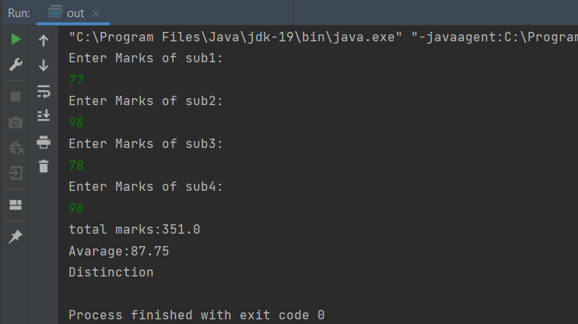

2.Write a Java program for the area of the circle, the volume of the cylinder, and the volume of the cone. Using Multilevel inheritance concept.

Area of Circle: pi × radius2

Volume of cylinder: pi × radius2 × height

Volume of cone: (1/3) × pi × radius2 × height

import java.util.*;  
class c  
{  
 protected float r,h;  
 public double carea;  
 void getr()  
 {  
 Scanner s=new Scanner(System.*in*);  
 System.*out*.println("eneter the radius:");  
 r=s.nextFloat();  
 System.*out*.println("eneter the height:");  
 h=s.nextFloat();  
 }  
  
 void ccal()  
 {  
 carea=3.14*r*r;  
 }  
}  
  
class cylinder extends c  
{  
 protected double cyvol;  
 void cycal()  
 {  
 cyvol=carea*h;  
 }  
}  
  
class cone extends cylinder  
{  
 public double convol;  
 void conecal()  
 {  
 convol= cyvol/3;  
 }  
  
 void display()  
 {  
 System.*out*.println("The area of circle:"+ carea);  
 System.*out*.println("The Volume of cylinder:"+ cyvol);  
 System.*out*.println("The volume of cone:"+ convol);  
 }  
}  
  
class inher  
{  
 public static void main (String[] args)  
 {  
 cone obj=new cone();  
 obj.getr();  
 obj.ccal();  
 obj.cycal();  
 obj.conecal();  
 obj.display();  
  
 }  
}

