DATE:12/09/22

COURSE NAME:DATA WAREHOUSING AND DATA MINING FOR MEDICAL APPICATIONS

COURSE CODE: CSA1654

NAME OF THE STUDENT: M.OOHA

REG NO:192111142

BRANCH:CSE

# EXPERIMENT :5

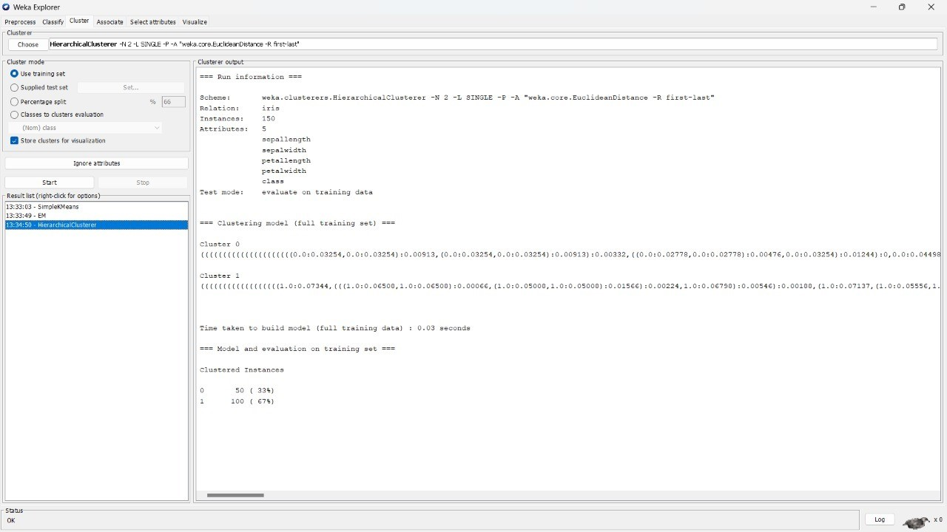

## EXPERIMENT :-6

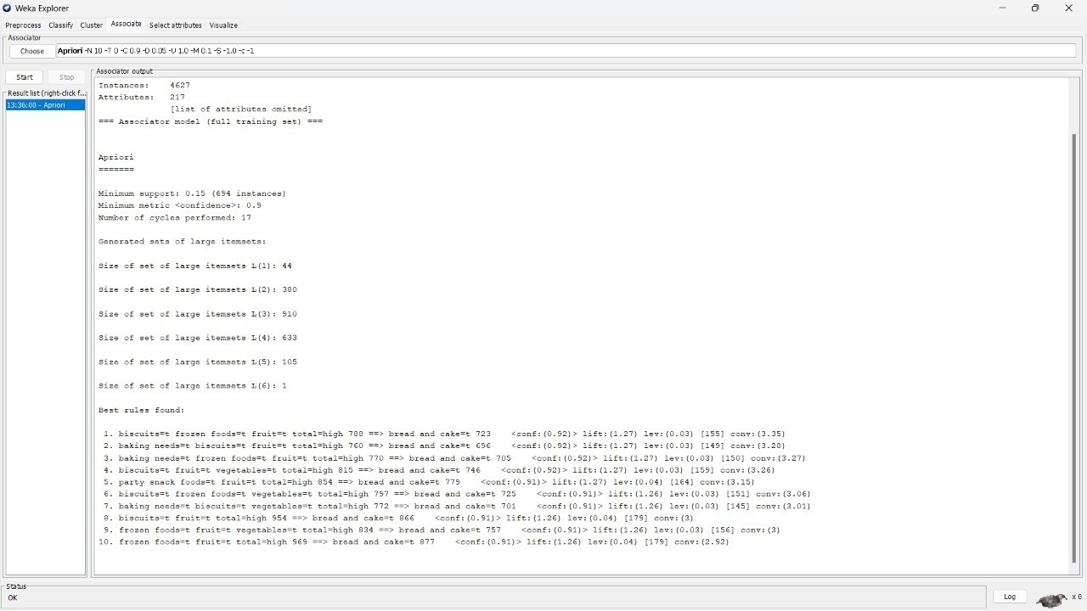

### EXPRIMENT:-7

