Date:10/09/22

Course name:-Data warehousing and Data mining for medical applications

Course code:-CSA1654

Name of the student:-Ch.Indhu Priya

REG NO:-192111191

EXPERIMENT:1

@relation playing

@attribute condition {sunny,cloudy,raining}

@attribute temperature numeric

@attribute class{yes,no}

@data

sunny 85 yes

sunny 76 yes

cloudy 95 no

raining 87 yes

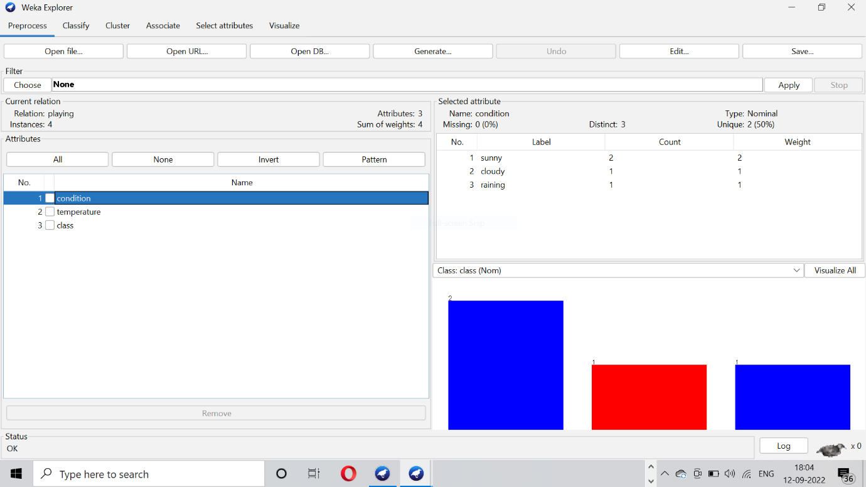

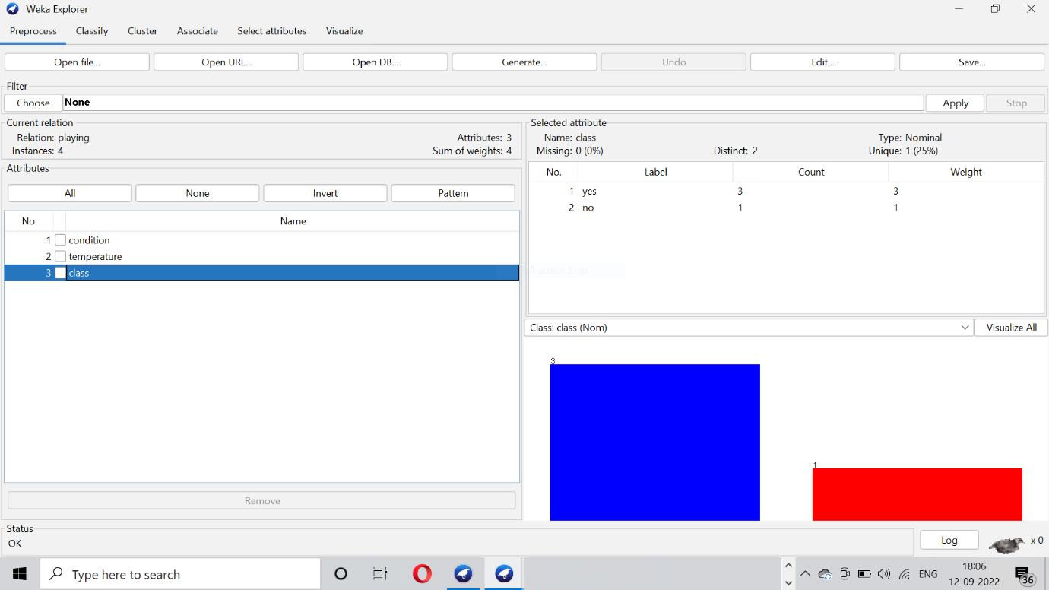

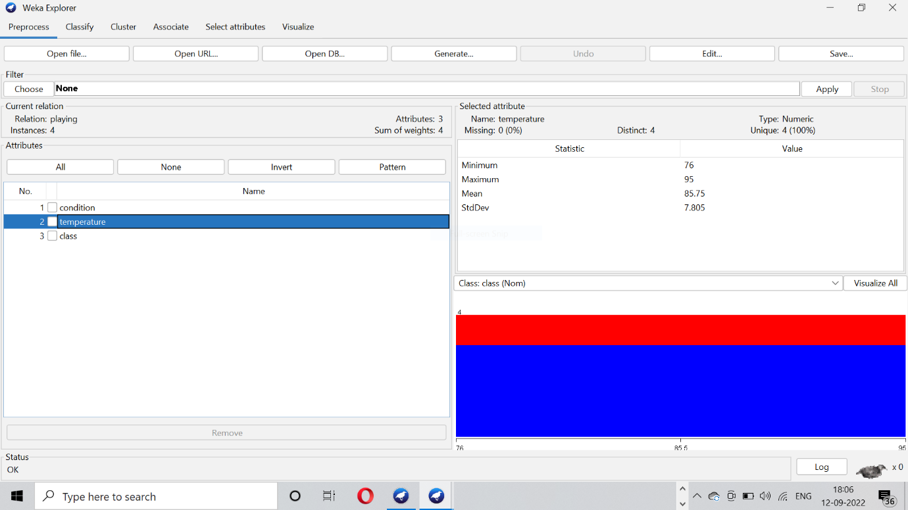

EXPERIMENT 2:-

