**TEACEROUTE, PING, IFCONFIG, IPCONFIG, NETSAT**

**Exp no:-3**

**Aim:**

Using TraceRoute, ping, ifconfig(LINUX), ipconfig(WINDOWS), and netstat Command.

**Procedure:**

Step 1: open windows command prompt and Type tracert command and type tracert [www.saveetha.com -](http://www.saveetha.com/)> “Enter”

Step 2: Type ping command and type IP Address press “Enter”

Step 3: Type ifconfig command

Step 4: Type netstat command

**Output:**

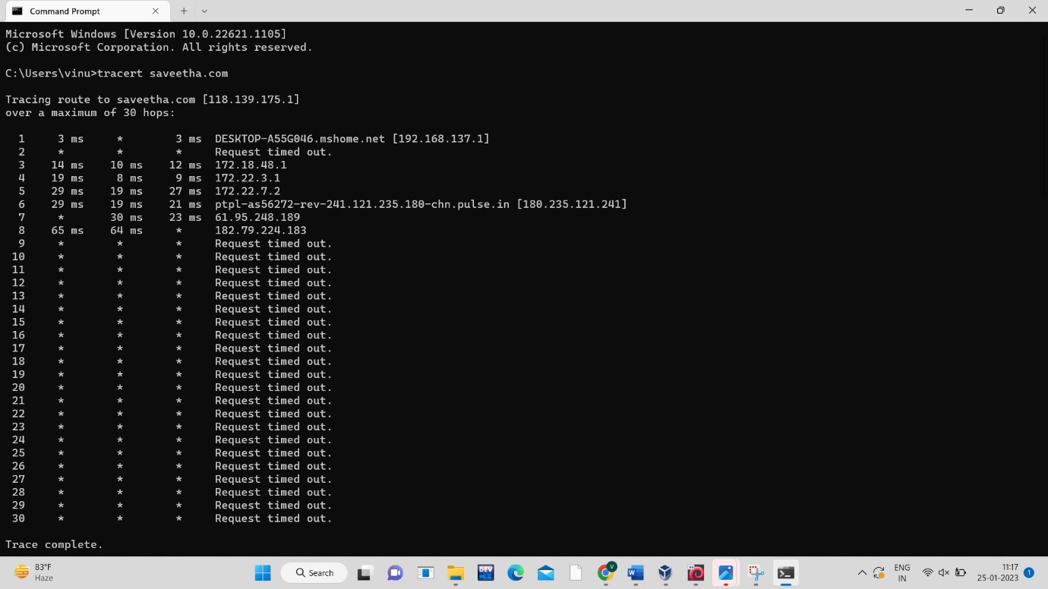

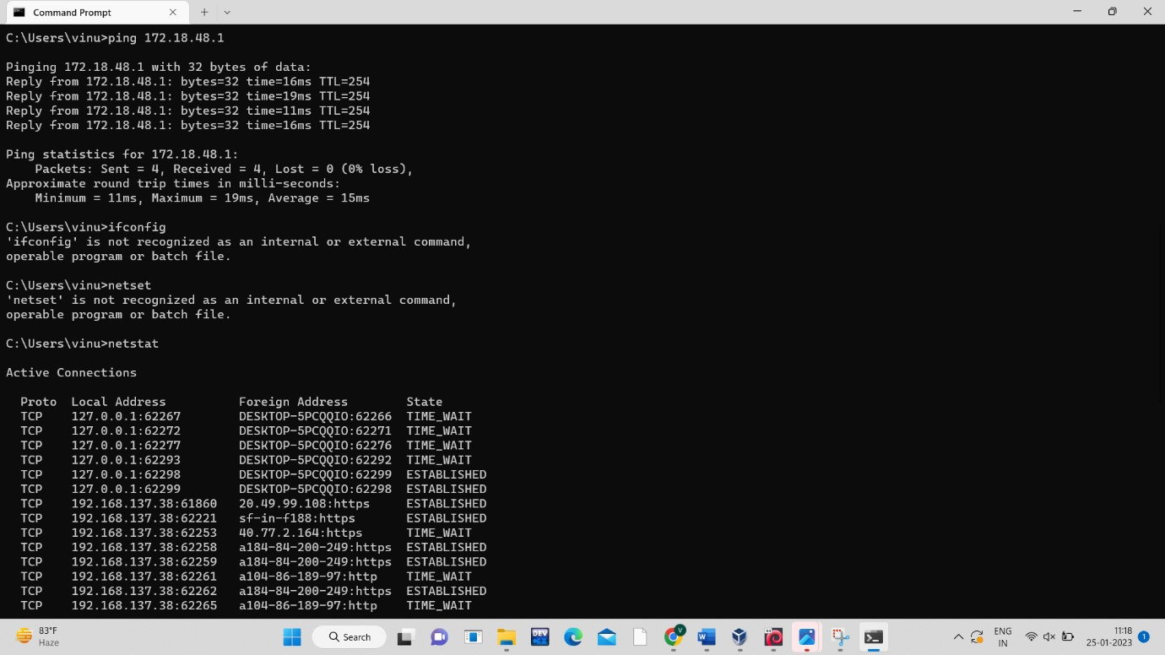

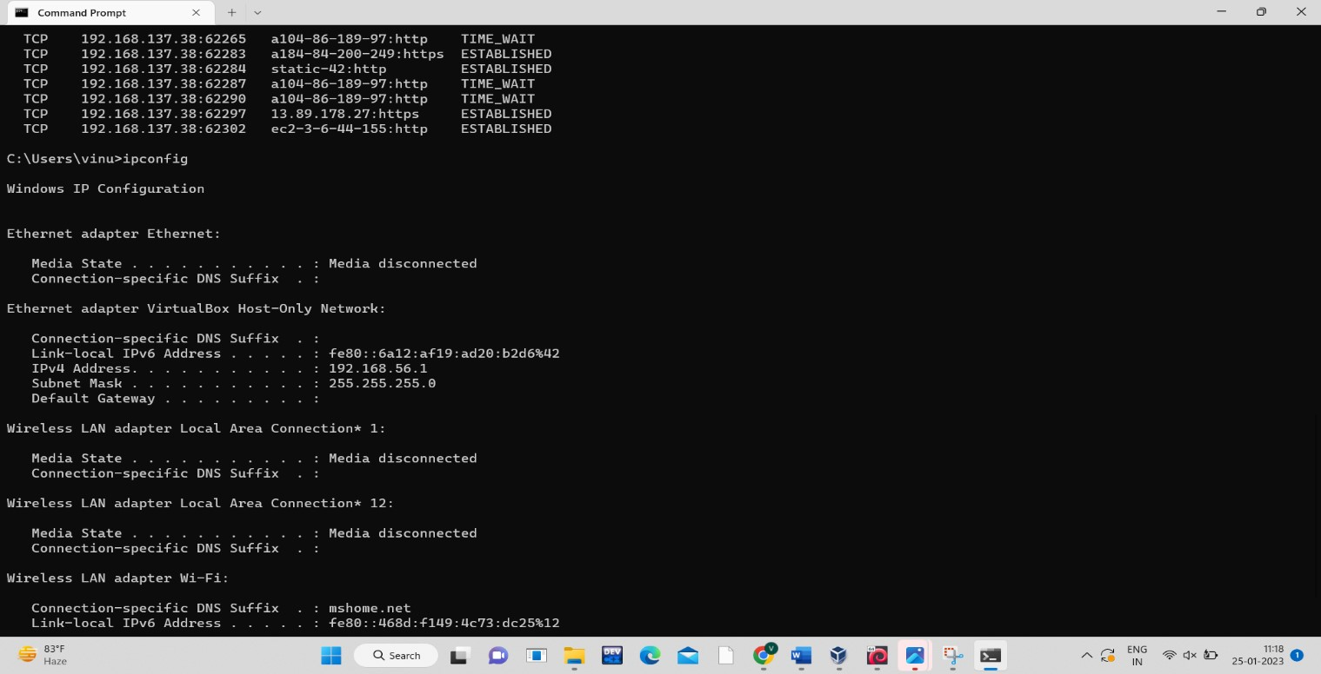

**Result:**

Hence the above commands are executed successfully.