**WHOIS**

Exp No:-1

Aim:

To find out the Whois, DNS Records and Diagonstics for particular website by using Whois search.

Procedure:

Step1: Open the WHO.is website

Step 2: Enter the website name in search bar and hit the “enter button”

Step 3: Show you information about [www.saveetha.com](http://www.saveetha.com/)

**Output:**

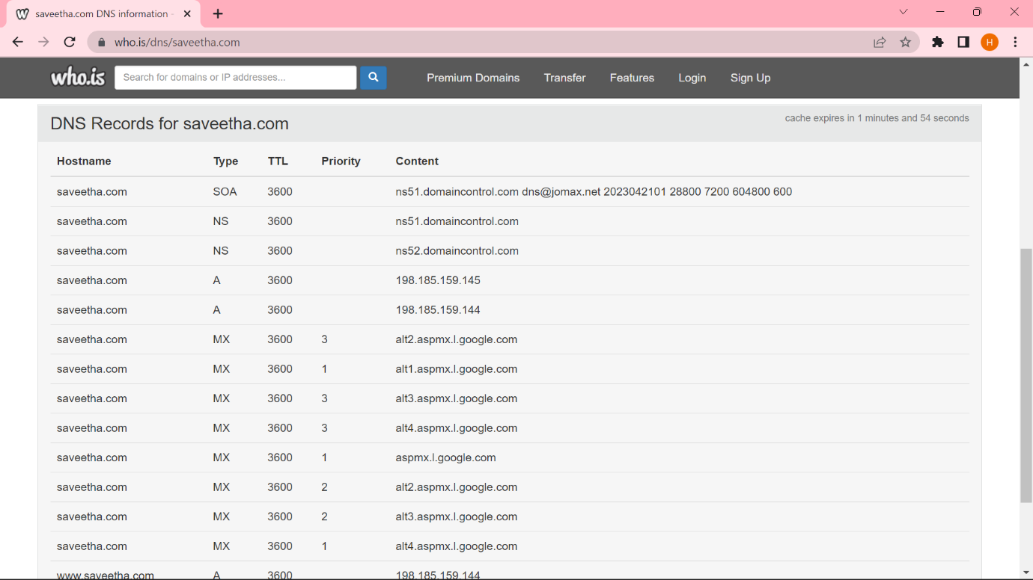

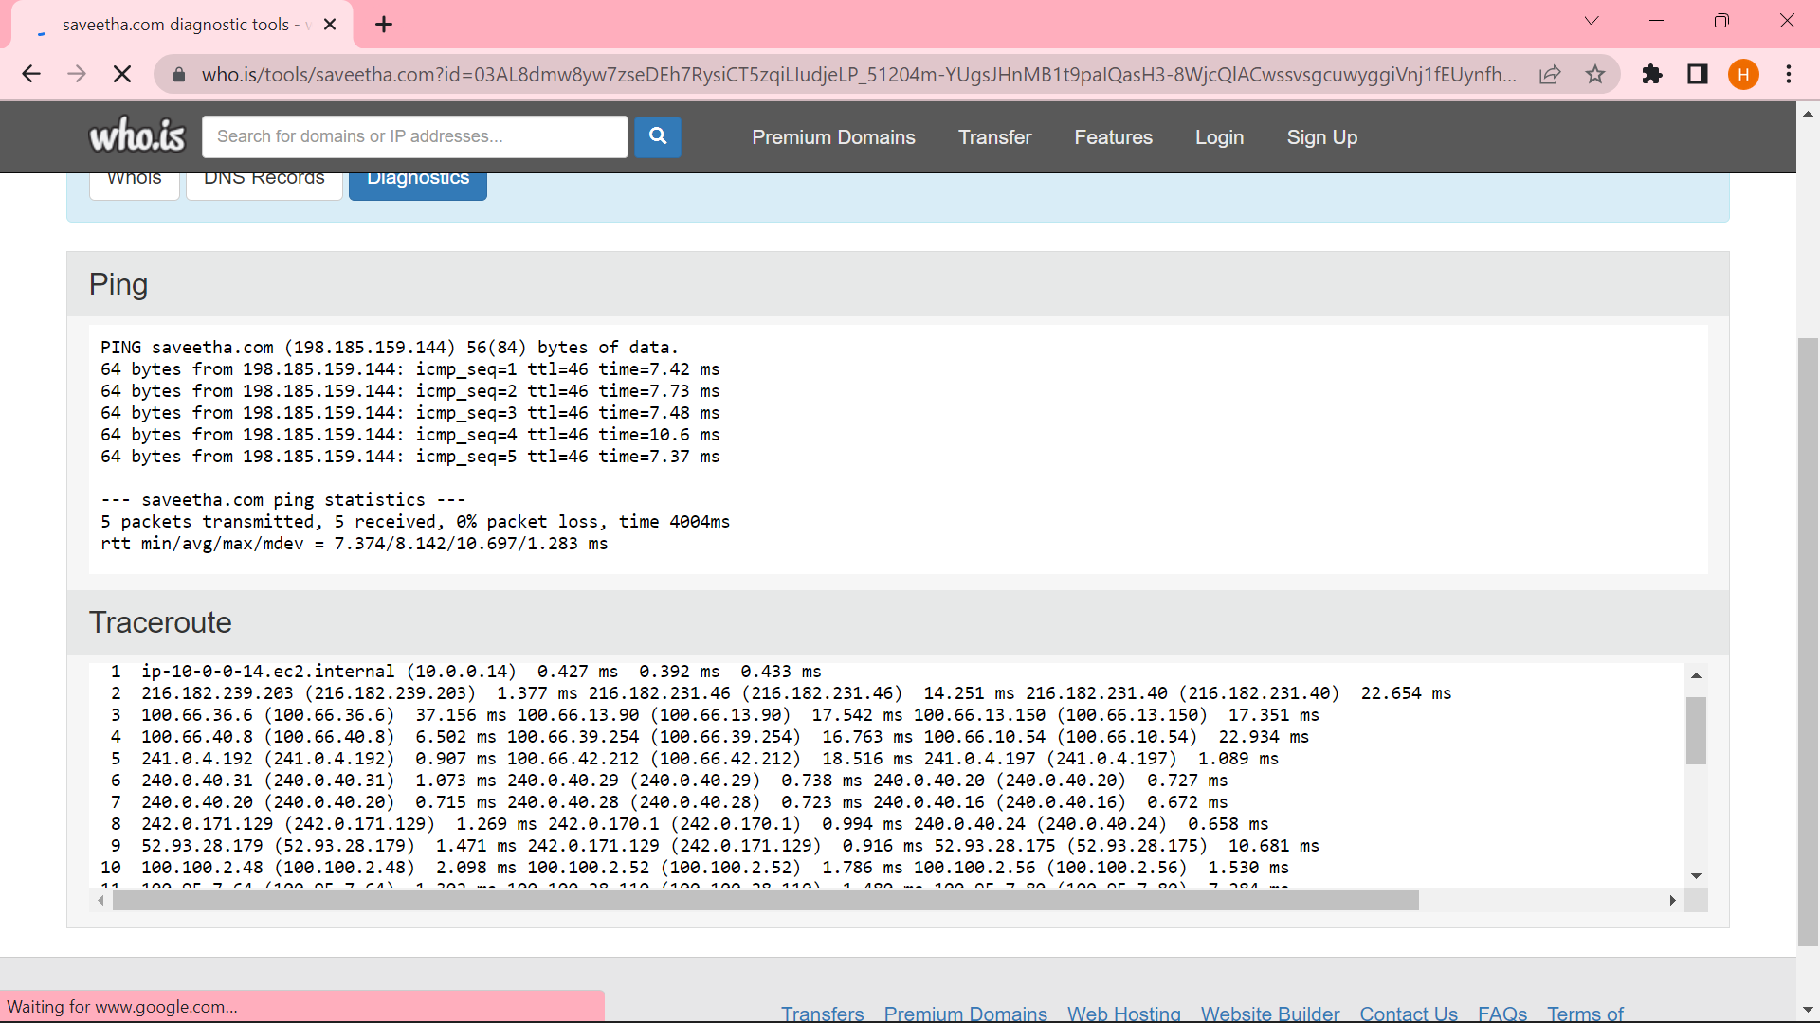

**Result:**

Hence we have successfully find out the Whois, DNS Records and Diagonstics for saveetha website by using Whois search.