LAB EXERCISE

G.Chinna

192111581

1.Write a R program to take input from the user (name and age) and display the values. Also print the version of R installation

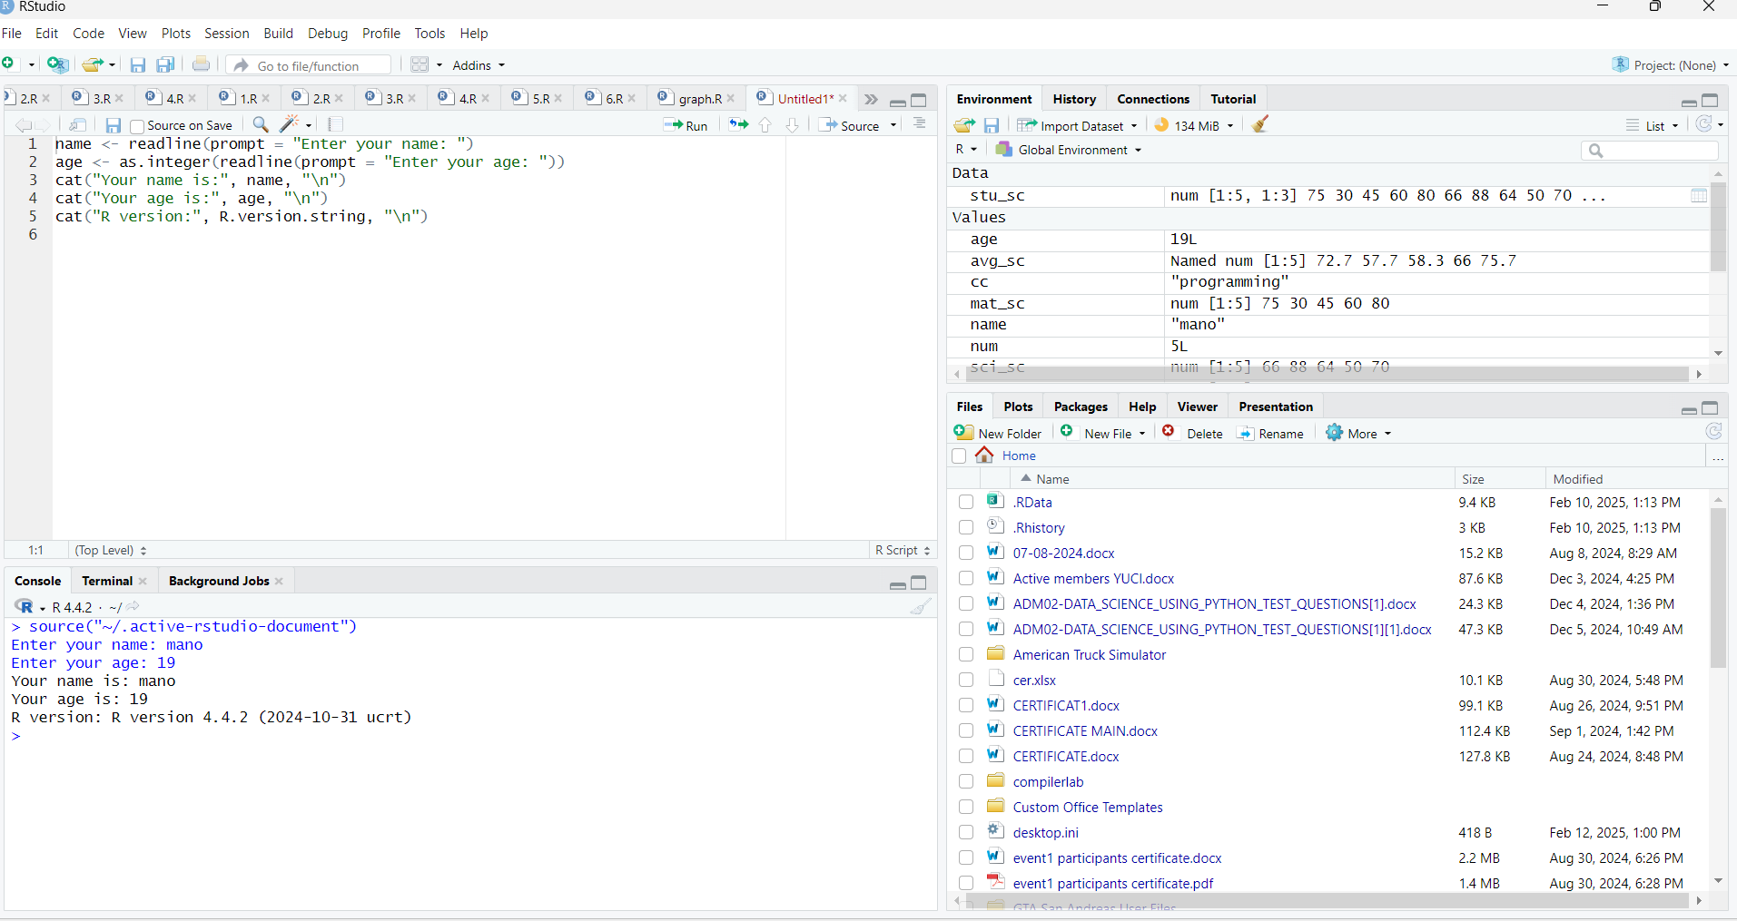

2. Write a R program to get the details of the objects in memory

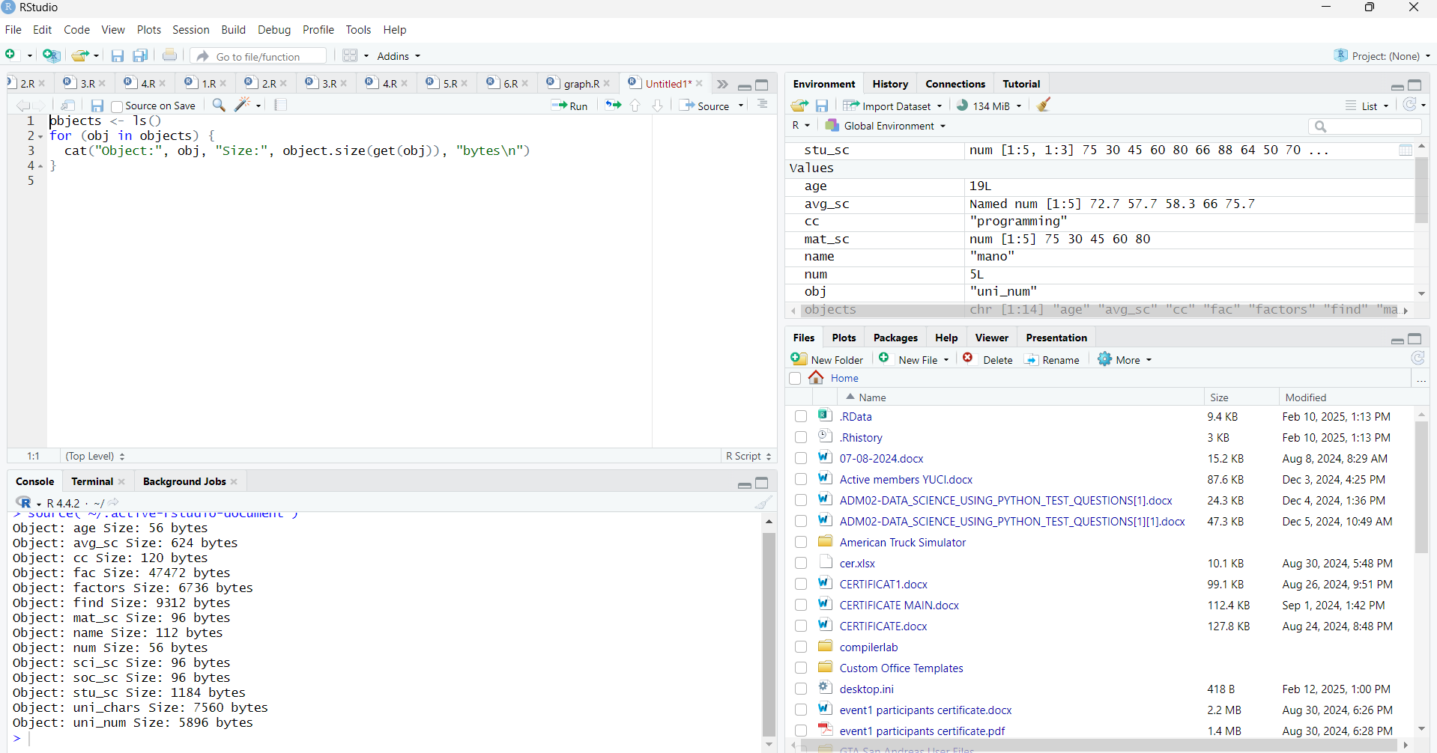

3. Write a R program to create a sequence of numbers from 20 to 50 and find the mean of numbers from 20 to 60 and sum of numbers from 51 to 91

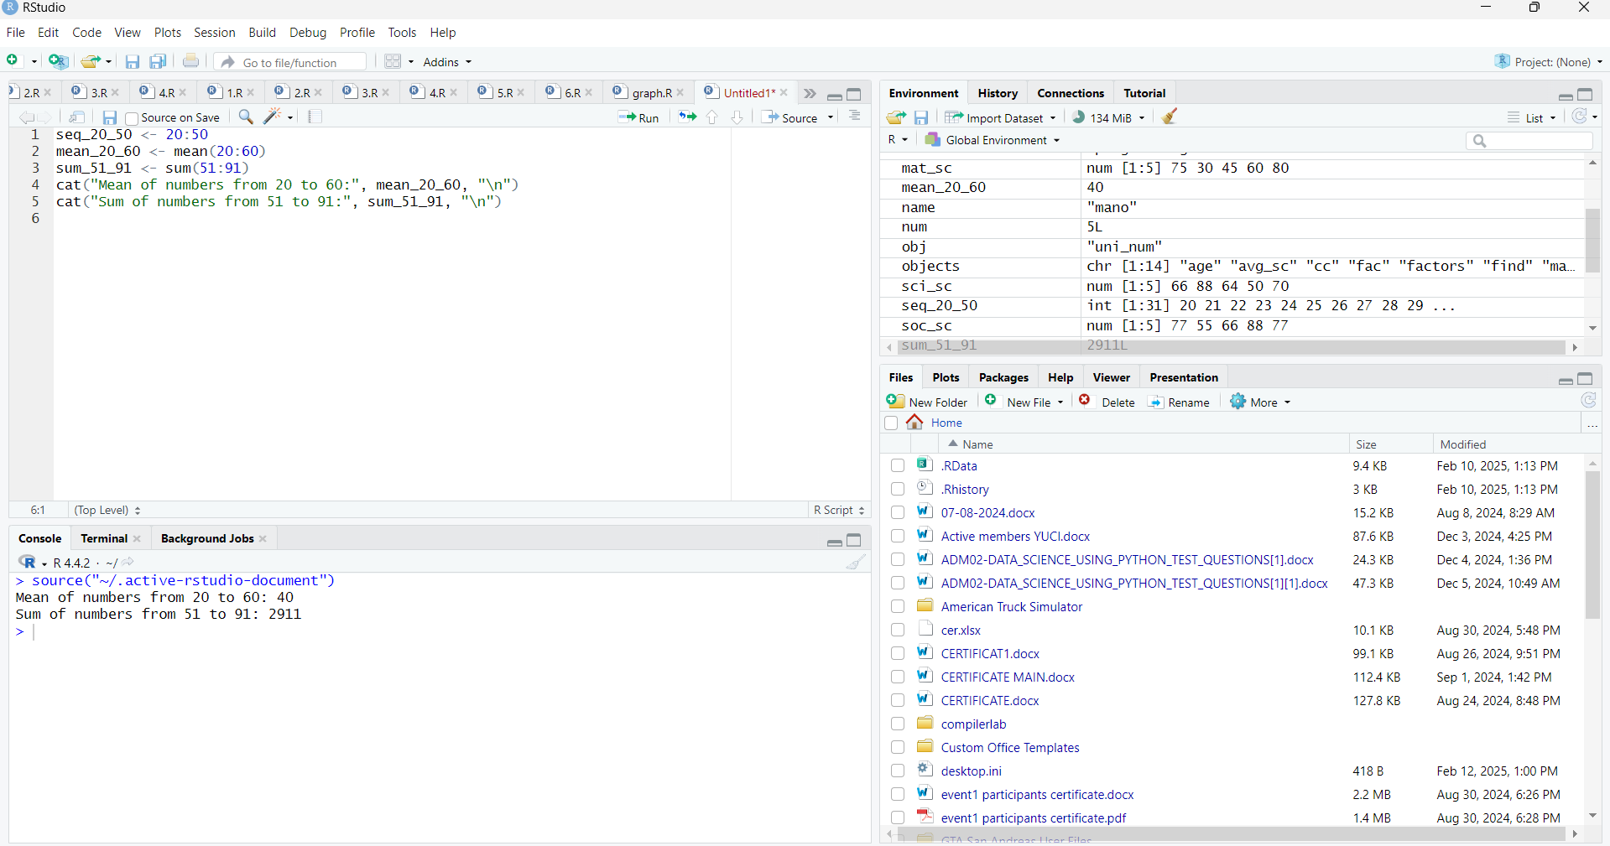

4. Write a R program to create a vector which contains 10 random integer values between -50 and +50.

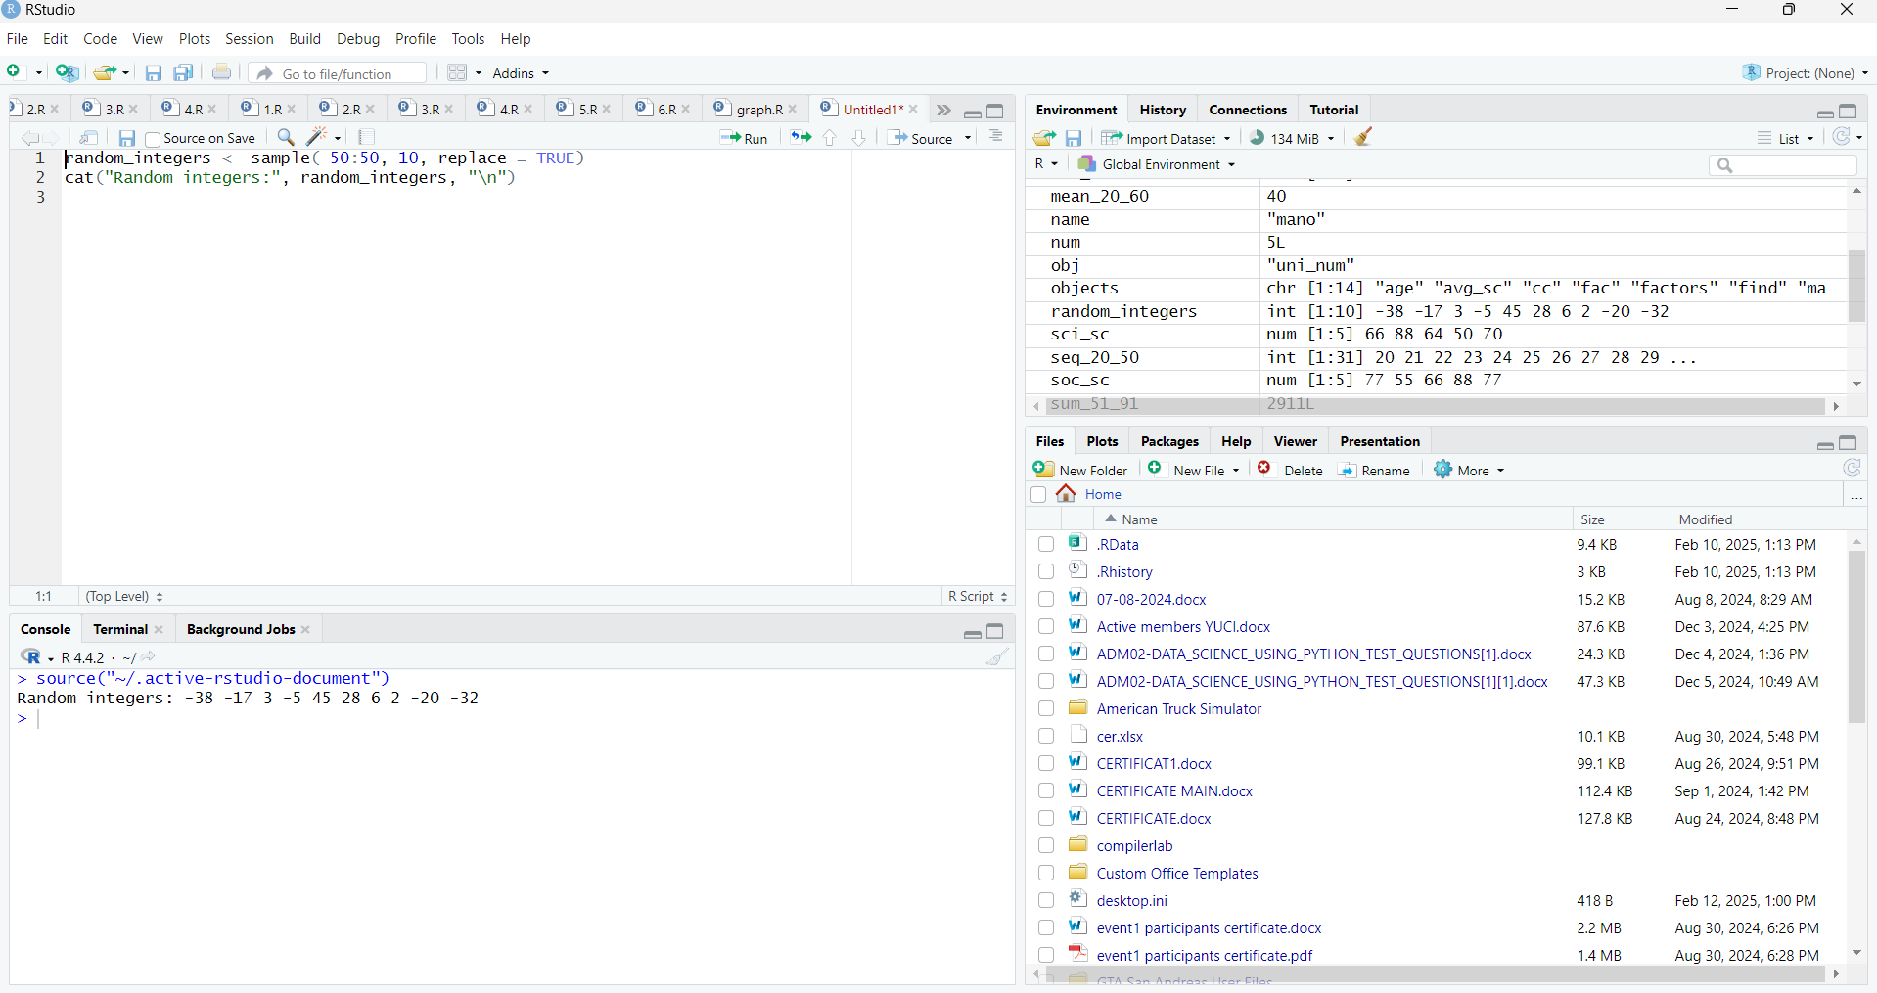

5. Write a R program to get the first 10 Fibonacci numbers.

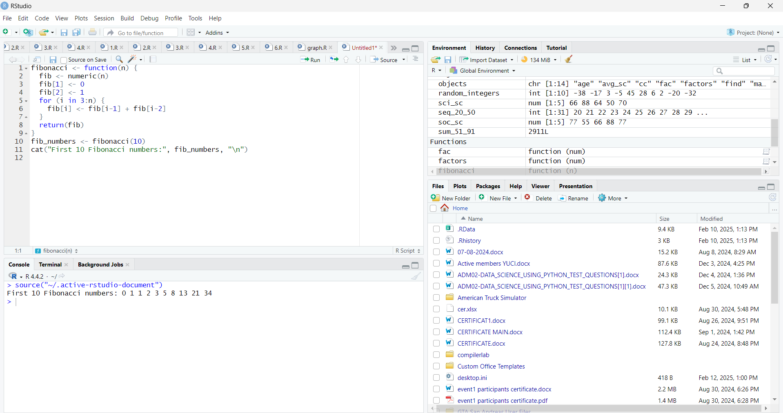

6. Write a R program to get all prime numbers up to a given number (based on the sieve of Eratosthenes)

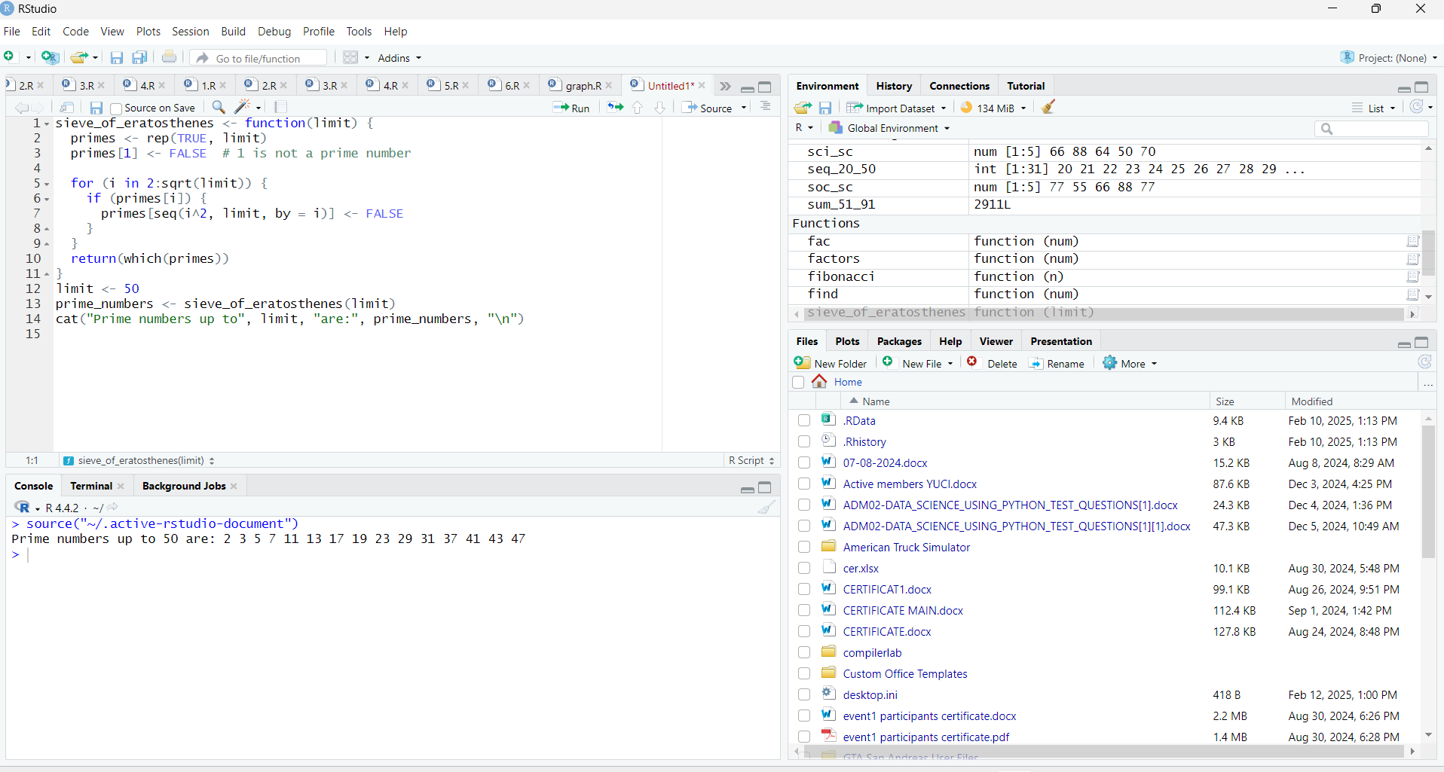

7. Write a R program to print the numbers from 1 to 100 and print "Fizz" for multiples of 3, print "Buzz" for multiples of 5, and print "FizzBuzz" for multiples of both.

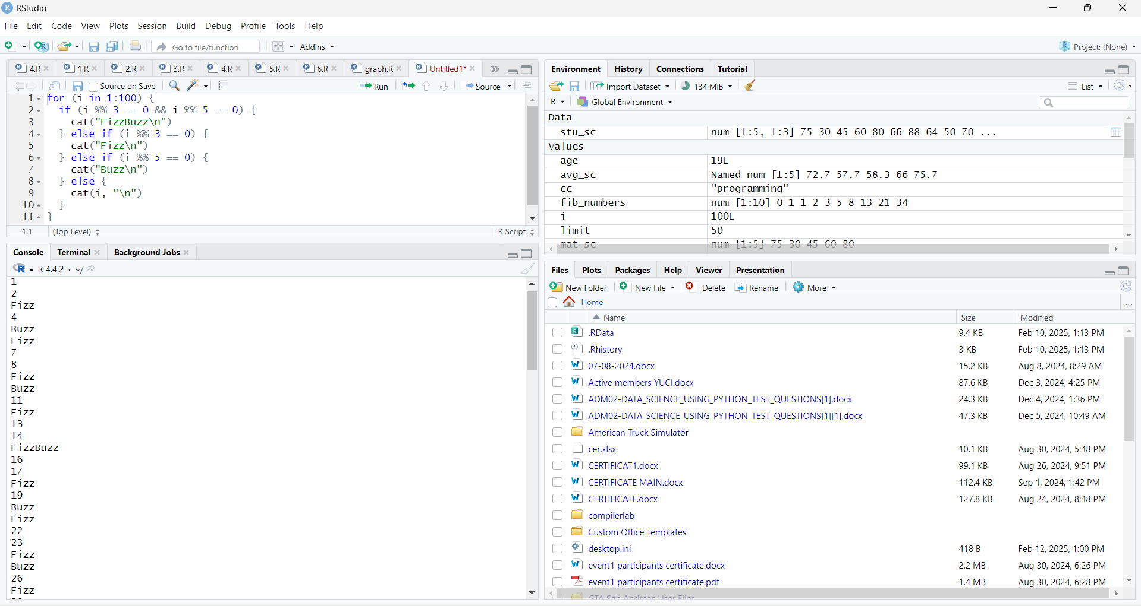

8. Write a R program to extract first 10 English letters in lower case and last 10 letters in upper case and extract letters between 22nd to 24th letters in upper case.

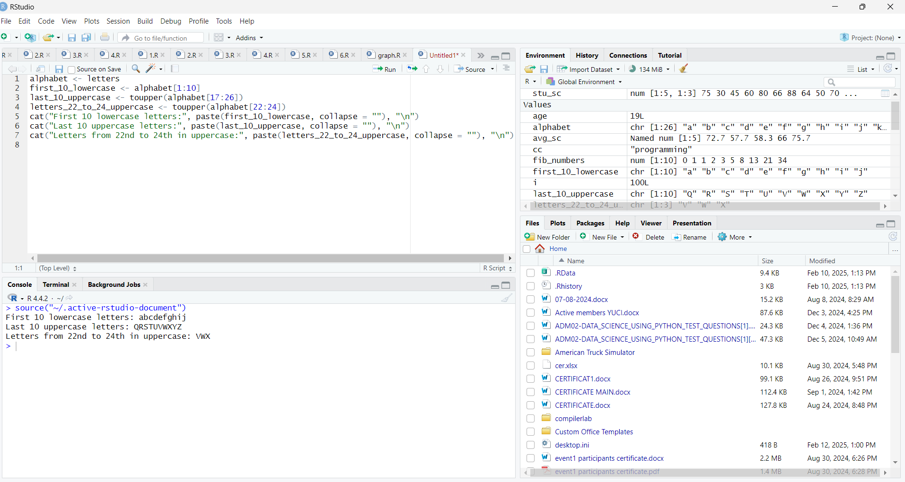

9. Write a R program to find the factors of a given number

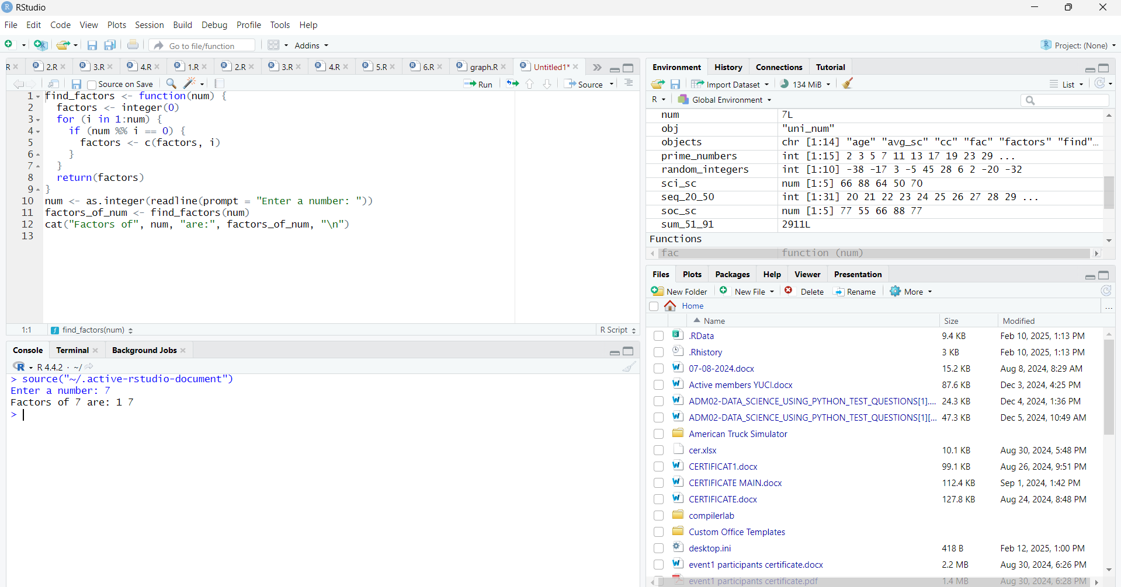

10. Write a R program to find the maximum and the minimum value of a given vector

