11.Develop a system using UML for Conference Management System. It should manage the details of the process that will be taking place at the conference. It should work along with the organizer, who arranges the program and central management system, which consists of all the details of the member and the role he/she, who is going to participate in the presentation.

Class diagram:

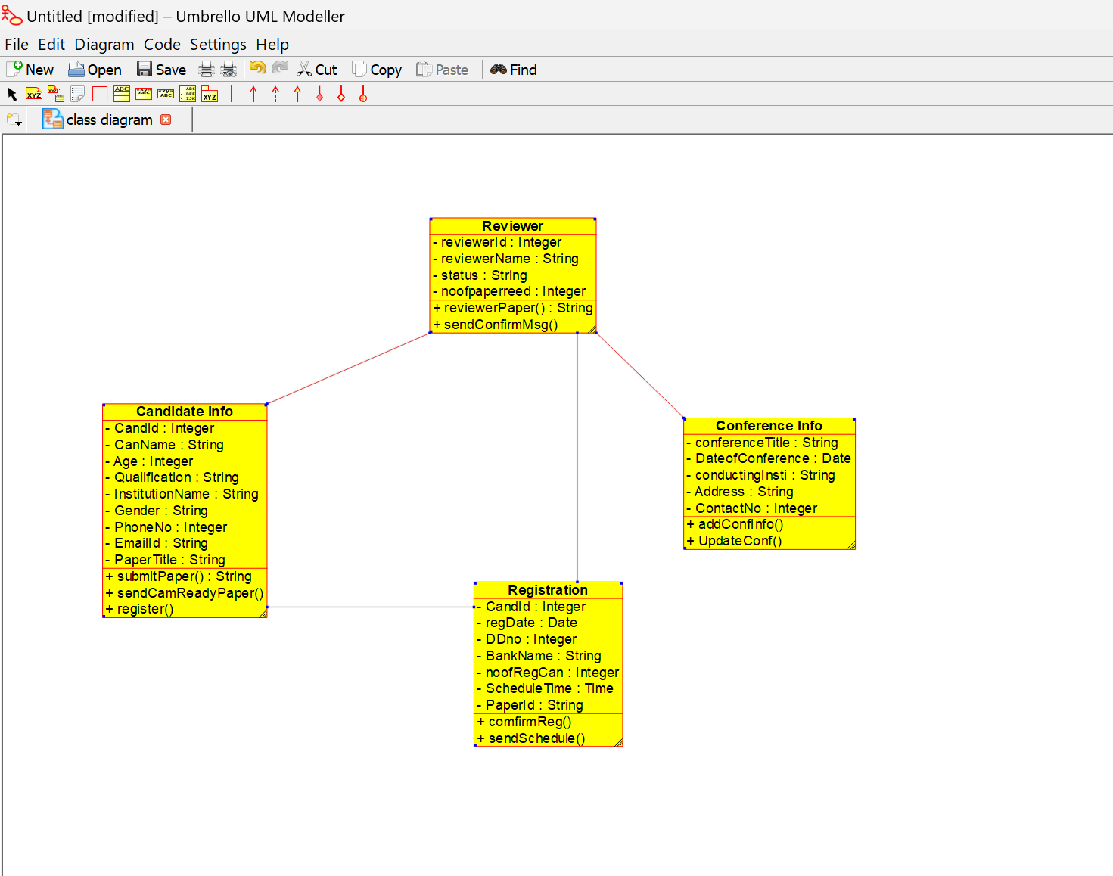

Sequence diagram:

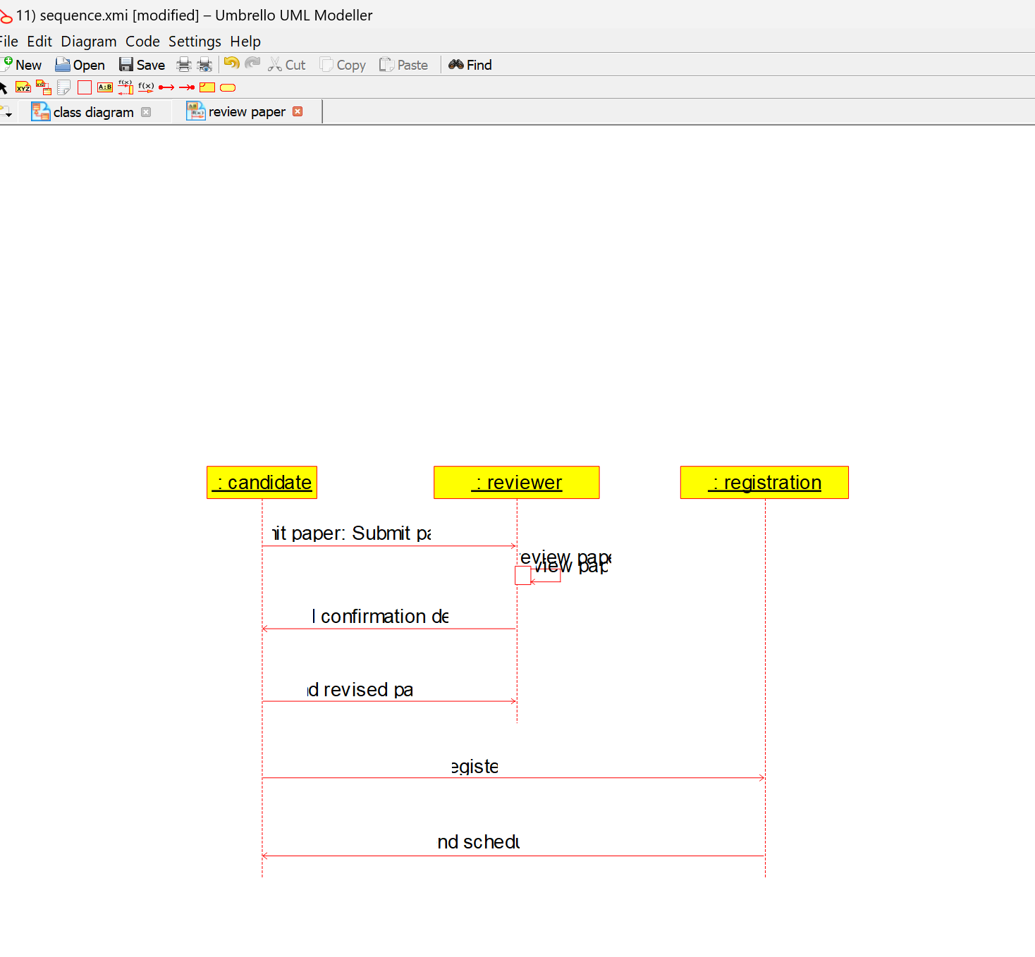

Collaboration diagram:

