15. Develop a system using UML for Blood Bank Registration System. The system should have the list of donors and the hospitals can check for the donor's availability and get their appointment. The donor and the hospital can interact with the central system.

Class diagram:

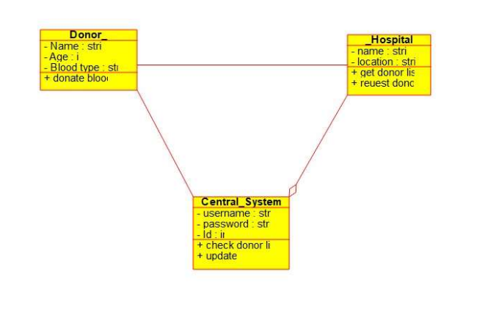

Component diagram:

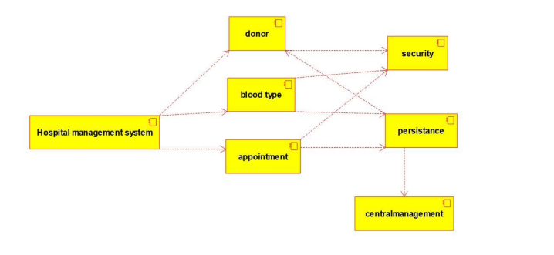

Deployment diagram:

