Artificial Intelligence-MLA0101

6. 8 queens problem in Python

Code:

print ("Enter the number of queens")

N = int(input())

board = [[0]*N for _ in range(N)]

def attack(i, j):

for k in range(0,N):

if board[i][k]==1 or board[k][j]==1:

return True

for k in range(0,N):

for l in range(0,N):

if (k+l==i+j) or (k-l==i-j):

if board[k][l]==1:

return True

return False

def N_queens(n):

if n==0:

return True

for i in range(0,N):

for j in range(0,N):

if (not(attack(i,j))) and (board[i][j]!=1):

board[i][j] = 1

if N_queens(n-1)==True:

return True

board[i][j] = 0

return False

N_queens

for i in board:

print (i)

Screenshort:

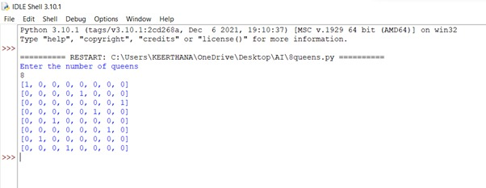

7. Tic-Tac-Toe Game in Python

Code:

import random

class TicTacToe:

def __init__(self):

self.board = []

def create_board(self):

for i in range(3):

row = []

for j in range(3):

row.append('-')

self.board.append(row)

def get_random_first_player(self):

return random.randint(0, 1)

def fix_spot(self, row, col, player):

self.board[row][col] = player

def is_player_win(self, player):

win = None

n = len(self.board)

for i in range(n):

win = True

for j in range(n):

if self.board[i][j] != player:

win = False

break

if win:

return win

for i in range(n):

win = True

for j in range(n):

if self.board[j][i] != player:

win = False

break

if win:

return win

win = True

for i in range(n):

if self.board[i][i] != player:

win = False

break

if win:

return win

win = True

for i in range(n):

if self.board[i][n - 1 - i] != player:

win = False

break

if win:

return win

return False

for row in self.board:

for item in row:

if item == '-':

return False

return True

def is_board_filled(self):

for row in self.board:

for item in row:

if item == '-':

return False

return True

def swap_player_turn(self, player):

return 'X' if player == 'O' else 'O'

def show_board(self):

for row in self.board:

for item in row:

print(item, end=" ")

print()

def start(self):

self.create_board()

player = 'X' if self.get_random_first_player() == 1 else 'O'

while True:

print(f"Player {player} turn")

self.show_board()

row, col = list(

map(int, input("Enter row and column numbers to fix spot: ").split()))

print()

self.fix_spot(row - 1, col - 1, player)

if self.is_player_win(player):

print(f"Player {player} wins the game!")

break

if self.is_board_filled():

print("Match Draw!")

break

player = self.swap_player_turn(player)

print()

self.show_board()

tic_tac_toe = TicTacToe()

tic_tac_toe.start()

Screenshorts:

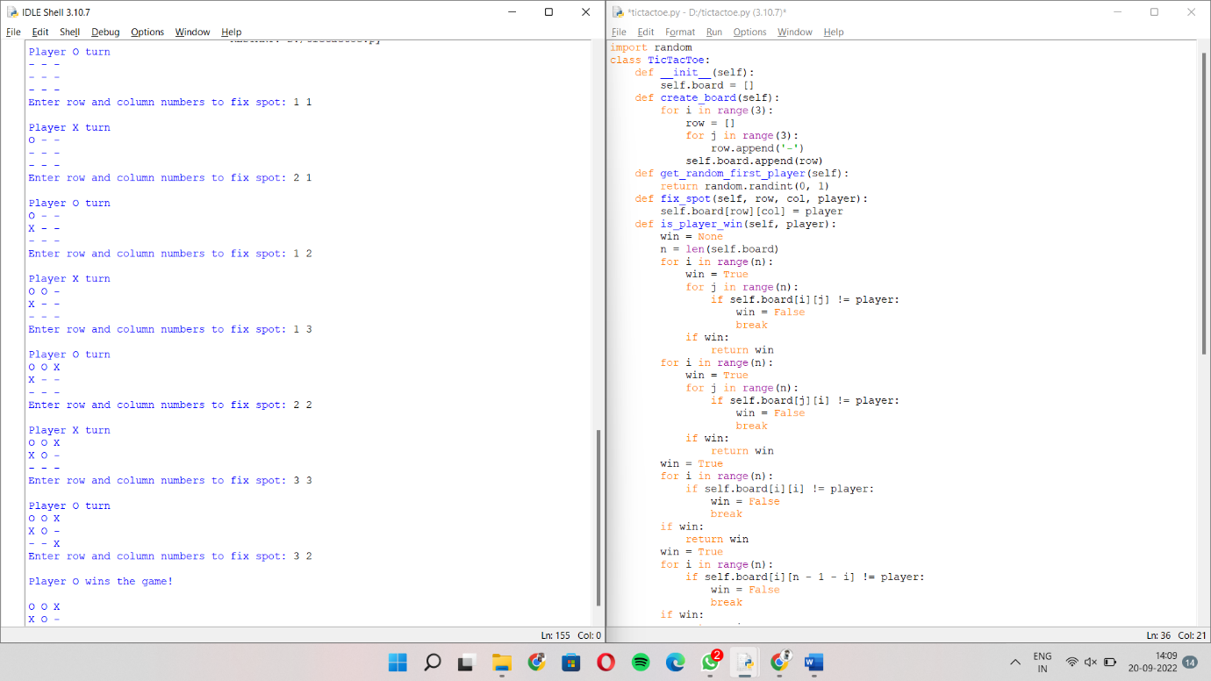

8. To write a python program to implement Travelling Salesman Problem.

Code:

from sys import maxsize

from itertools import permutations

V = 4

def travellingSalesmanProblem(graph, s):

vertex = []

for i in range(V):

if i != s:

vertex.append(i)

min_path = maxsize

next_permutation=permutations(vertex)

for i in next_permutation:

current_pathweight = 0

k = s

for j in i:

current_pathweight += graph[k][j]

k = j

current_pathweight += graph[k][s]

min_path = min(min_path, current_pathweight)

return min_path

if __name__ == "__main__":

graph = [[0, 10, 15, 20], [10, 0, 35, 25],

[15, 35, 0, 30], [20, 25, 30, 0]]

s = 0

print(travellingSalesmanProblem(graph, s))

Screenshorts:

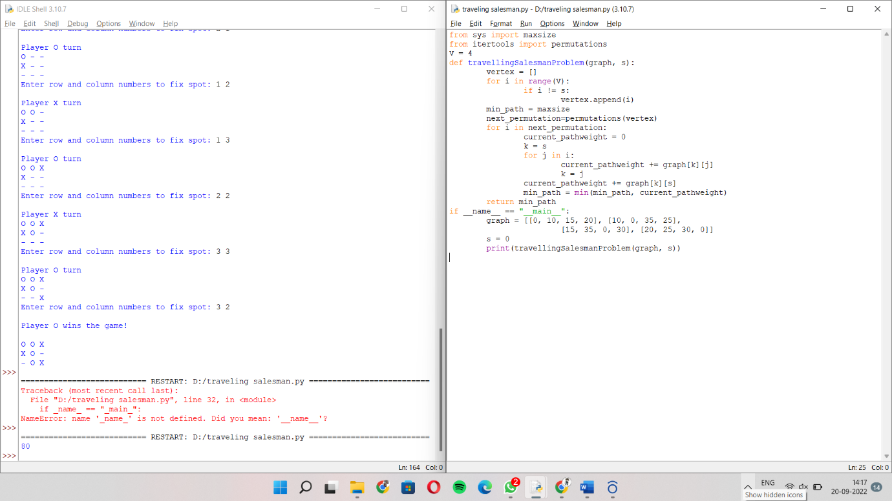

9. write a program to solve tower of hanoi problem in python.

Code:

def TowerOfHanoi(n , source, destination, auxiliary):

if n==1:

print ("Move disk 1 from source",source,"to destination",destination)

return

TowerOfHanoi(n-1, source, auxiliary, destination)

print ("Move disk",n,"from source",source,"to destination",destination)

TowerOfHanoi(n-1, auxiliary, destination, source)

n = 4

TowerOfHanoi(n,'A','B','C')

Screenshorts:

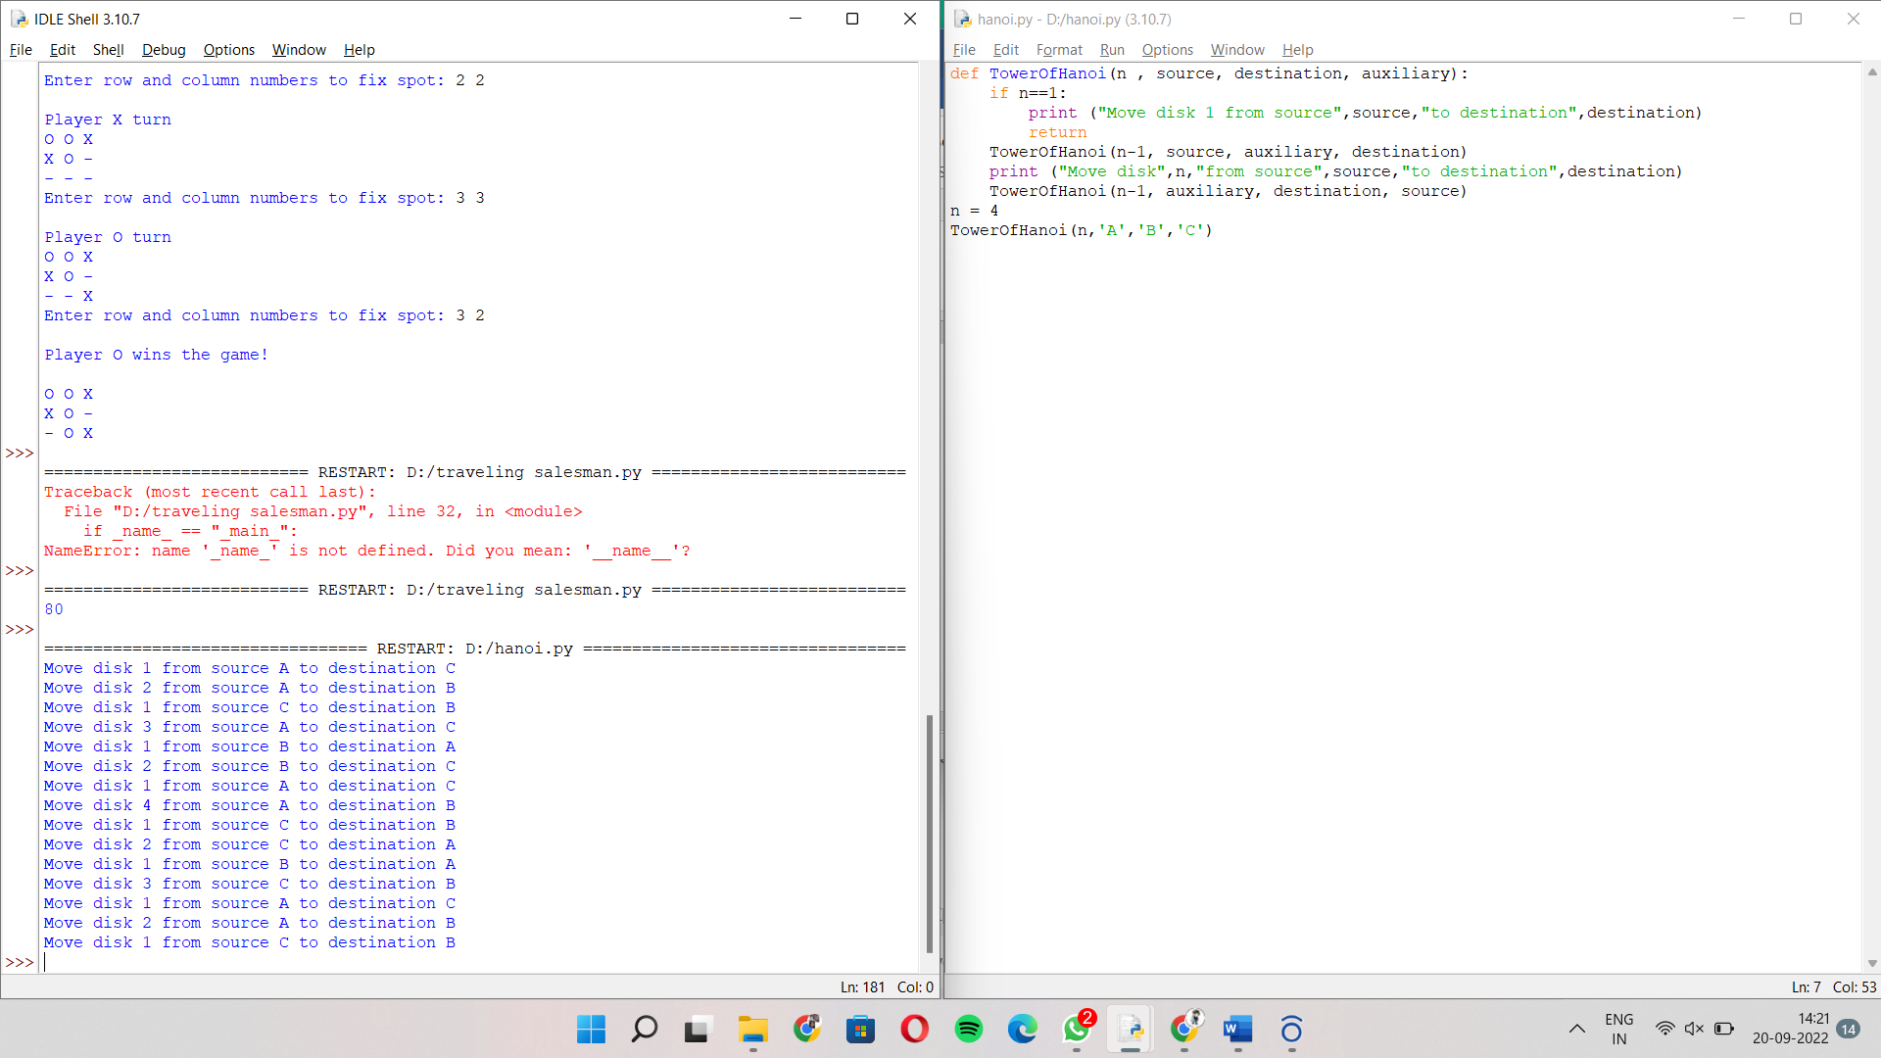

10. Python Program for 0-1 Knapsack Problem

Code:

def knapSack(W, wt, val, n):

K = [[0 for x in range(W + 1)] for x in range(n + 1)]

for i in range(n + 1):

for w in range(W + 1):

if i == 0 or w == 0:

K[i][w] = 0

elif wt[i-1] <= w:

K[i][w] = max(val[i-1] + K[i-1][w-wt[i-1]], K[i-1][w])

else:

K[i][w] = K[i-1][w]

return K[n][W]

val = [50,100,150,200]

wt = [8,16,32,40]

W = 64

n = len(val)

print(knapSack(W, wt, val, n))

Screenshorts:

