THEORY OF COMPUTATION

1 Design DFA to accept bcaaaaaaaaaaaaaa, bc, and c

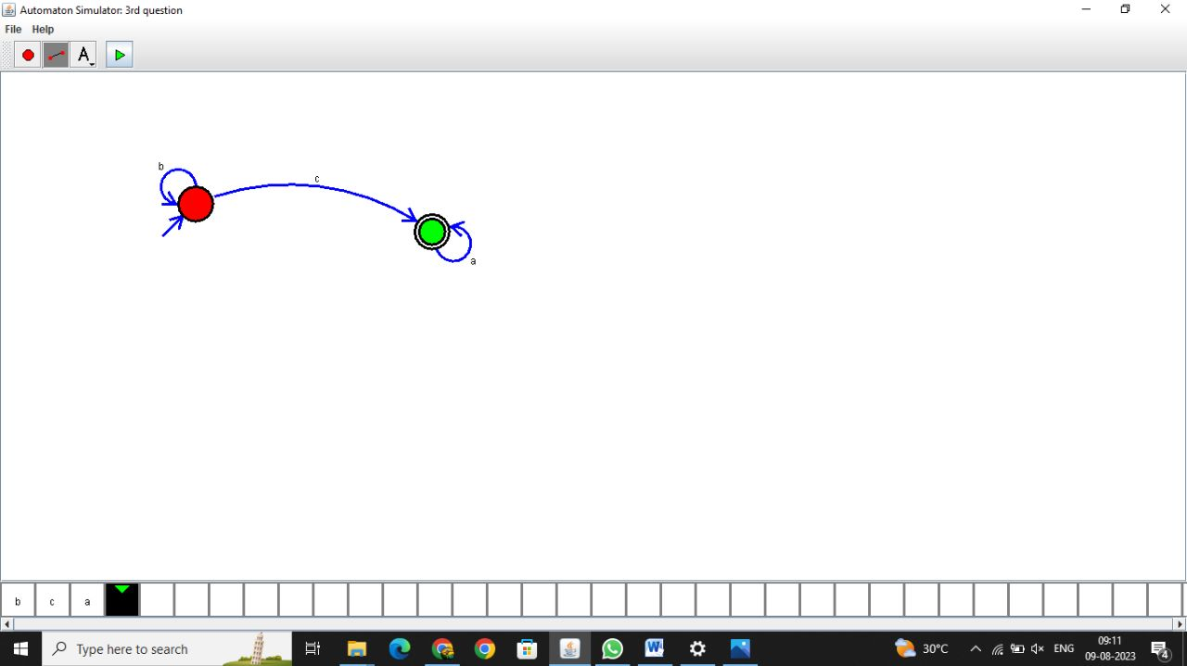

RESULT:

The given string is successfully computed using DFA

2.Design NFA to accept aaaaaa

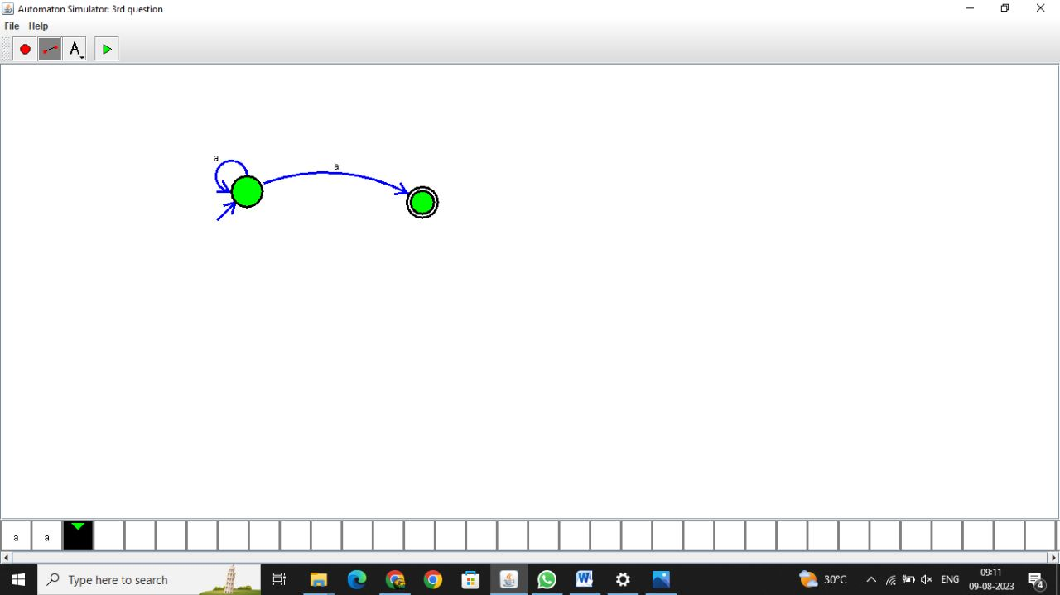

RESULT:

The given string is successfully computed using NFA

3. Design PDA for the input a^nb^n

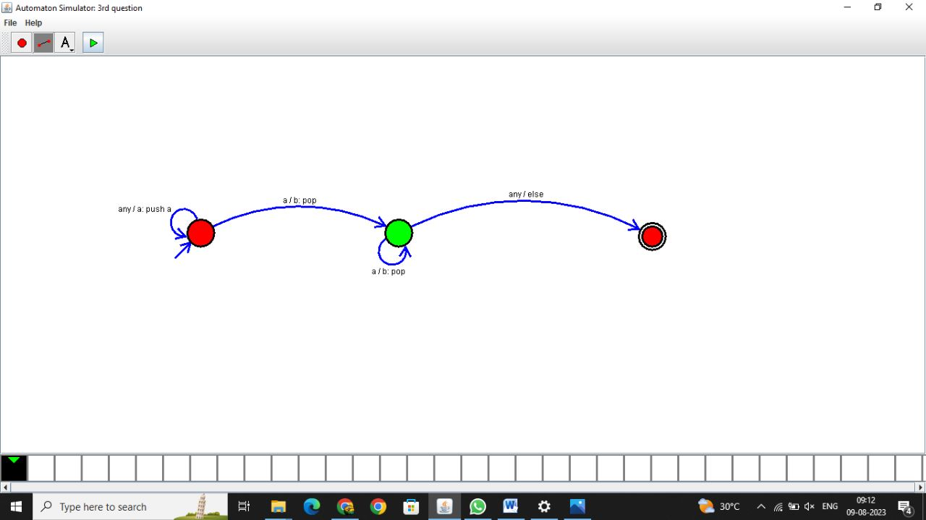

RESULT:

The given string is successfully computed using PDA

4. Design Tm For input a^nb^n

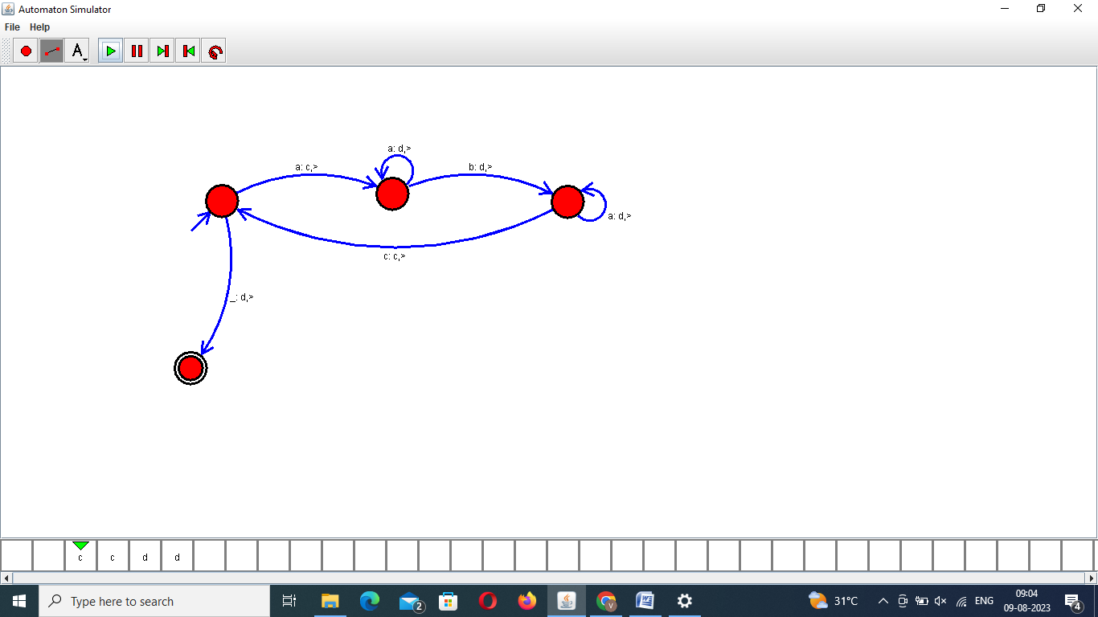

RESULT:

The given string is successfully computed using Touring Machine

5. Design PDA for input aabbbbc ( L=a^nb^2n)

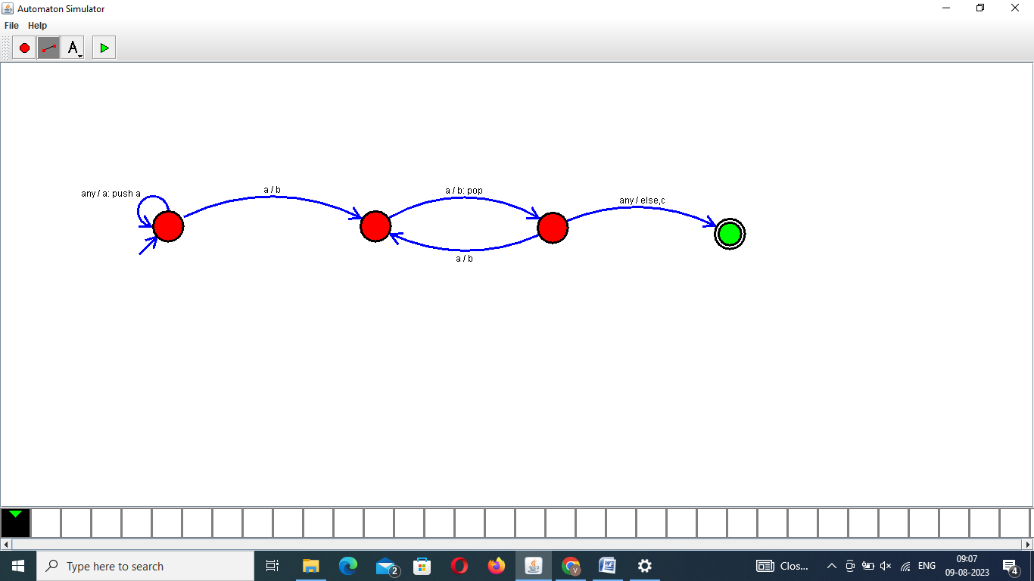

RESULT:

The given string is successfully computed using PDA

6.TM Simulation for Palindrome W= ababa c

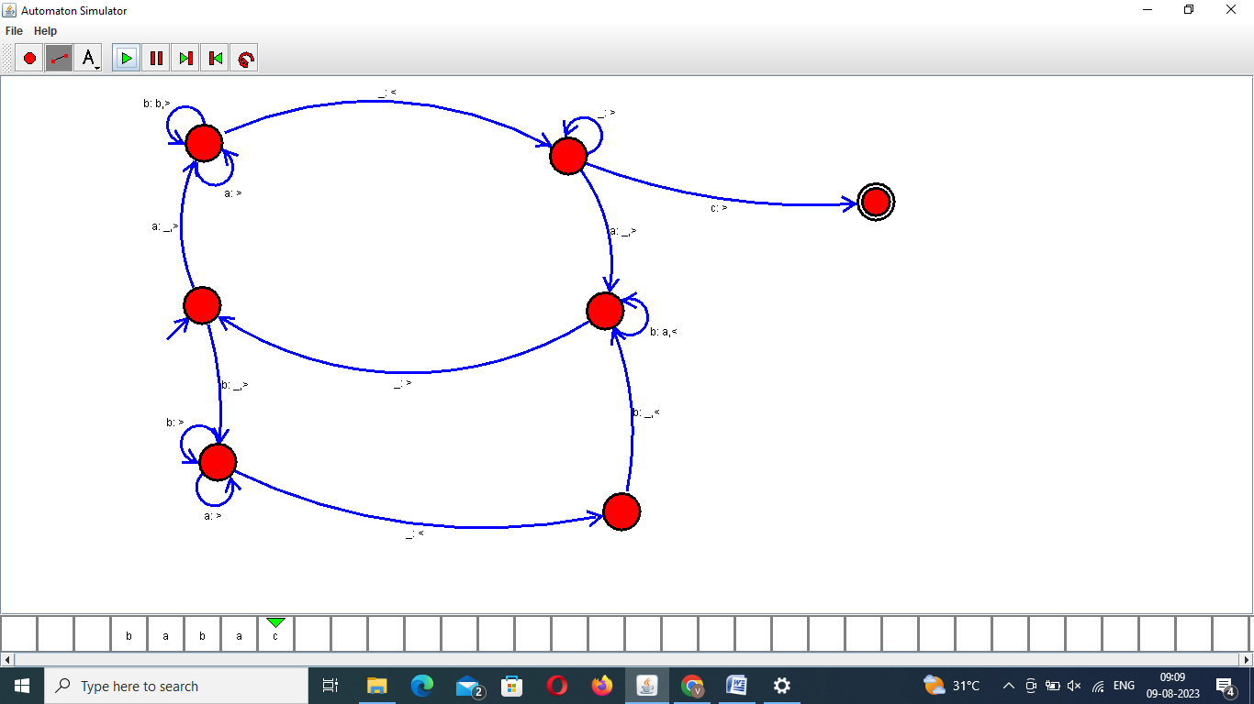

RESULT:

The given string is successfully computed using Touring Machine

7.Design TM to perform addition of following

W= aa + aaaa

After Addition of a’s = aaaaaa

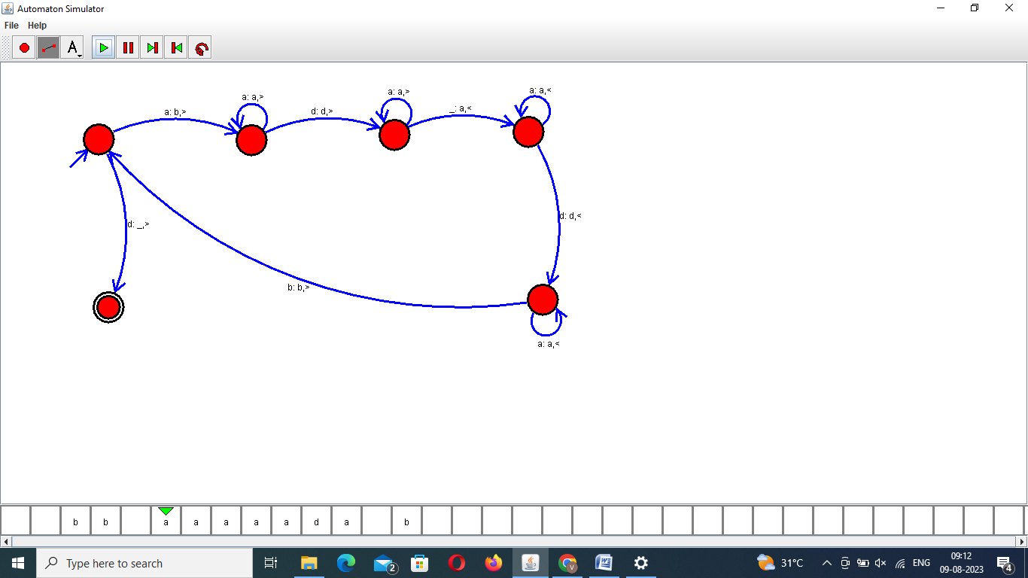

RESULT:

The given string is successfully computed using Touring machine

8.Design TM to perform subtraction W= aaa-aaThe Result of Subtraction is = a

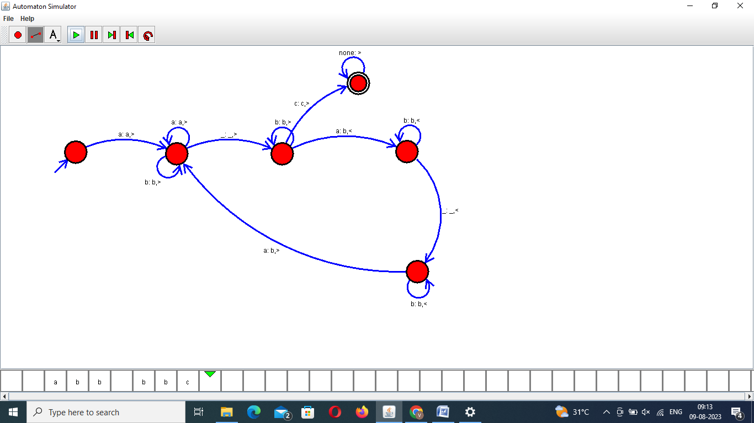

RESULT:

The given string is successfully computed using Touring Machine