13..Demonstrate Infrastructure as a Service (IaaS) by creating a Virtual Machine using a Public Cloud Service Provider (Azure), configure with required memory and CPU.

OPEN AZURE….

CREATE A MICROSOFT AZURE ACCOUNT..

NOW,CREATE A RESOURCE…

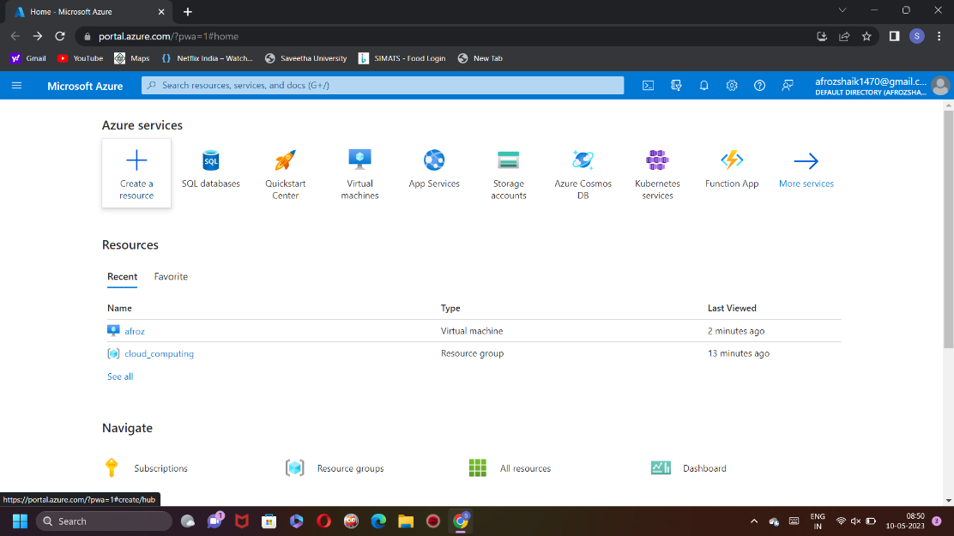

CREATE VIRTUAL MACHINES….

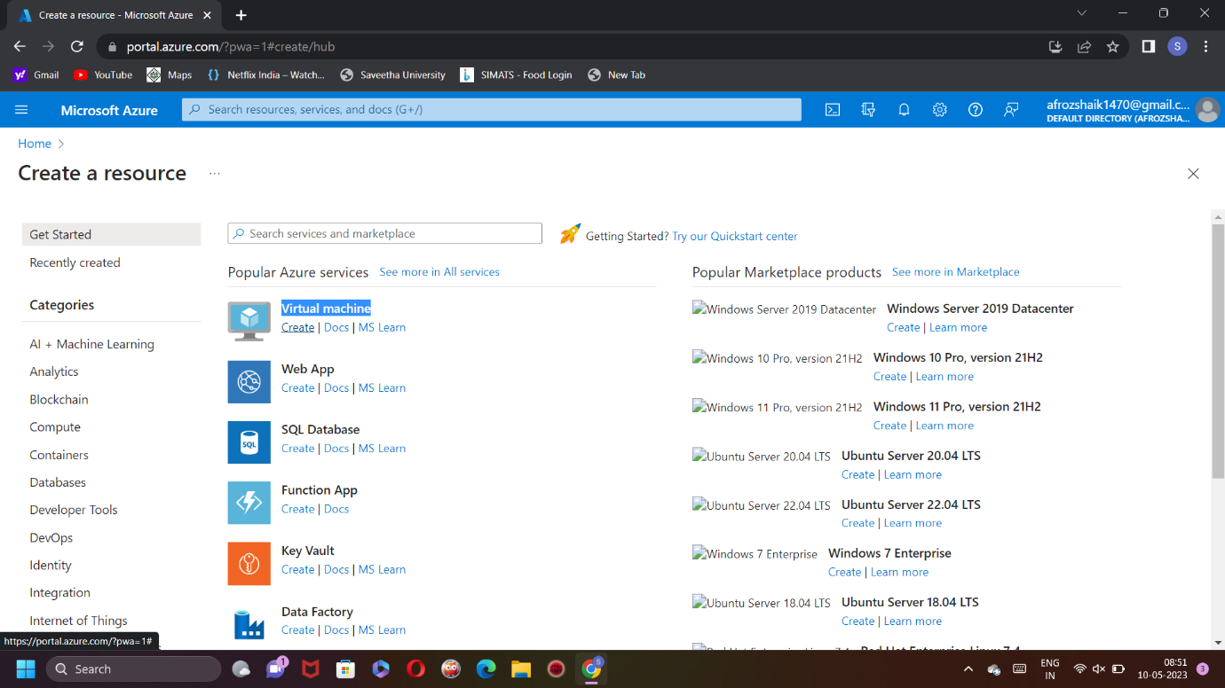

GIVE VM DATA HERE..

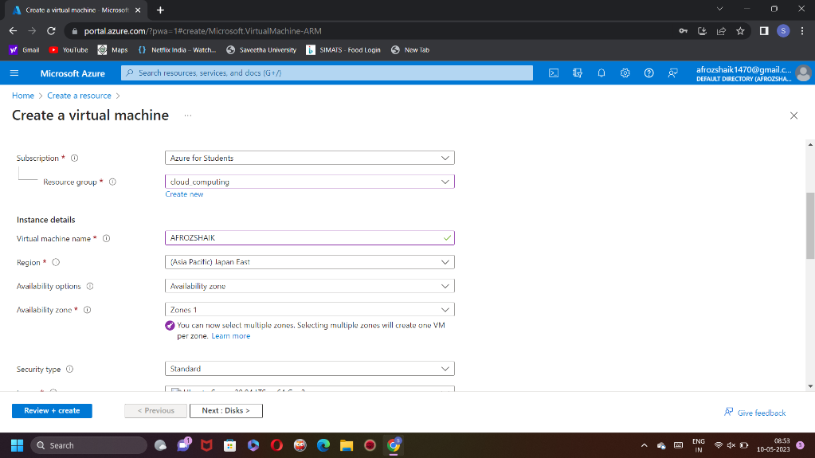

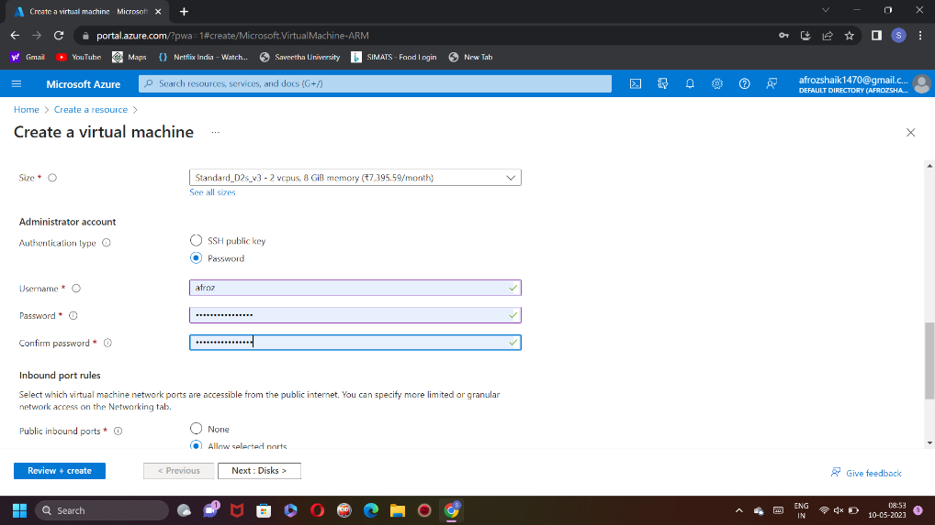

NOW,CLICK ON REVIEW AND CREATE…

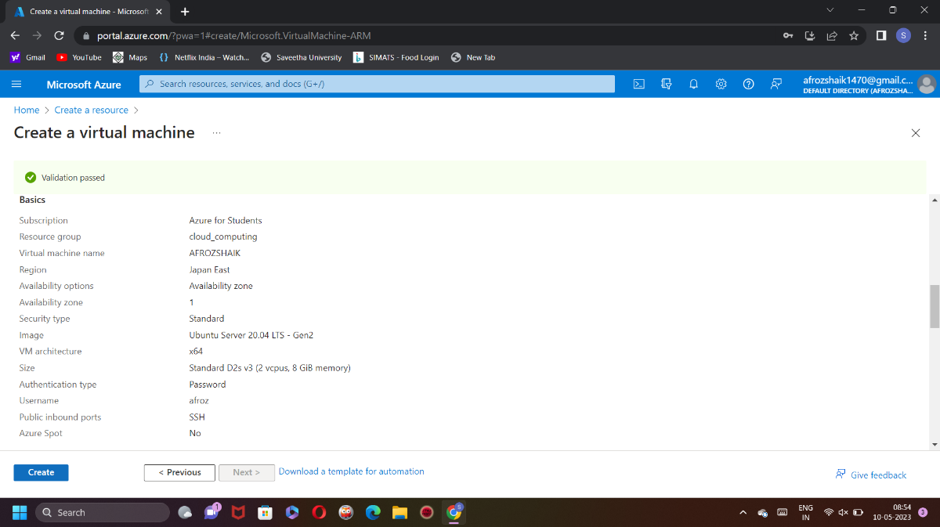

NOW AGAIN CLICK ON CREATE..

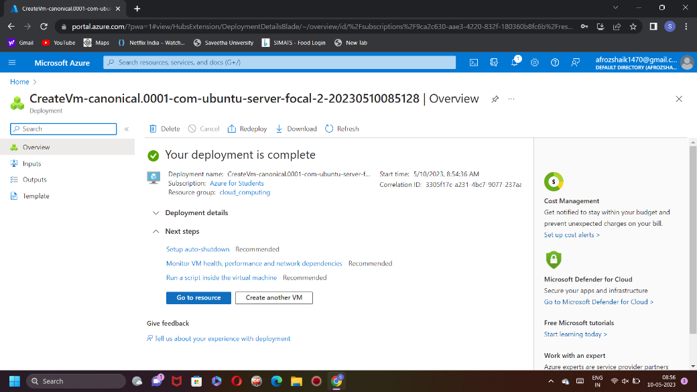

YOUR DEPLOYMENT IS COMPLETE…

AFTER THAT GO TO RESOURCE

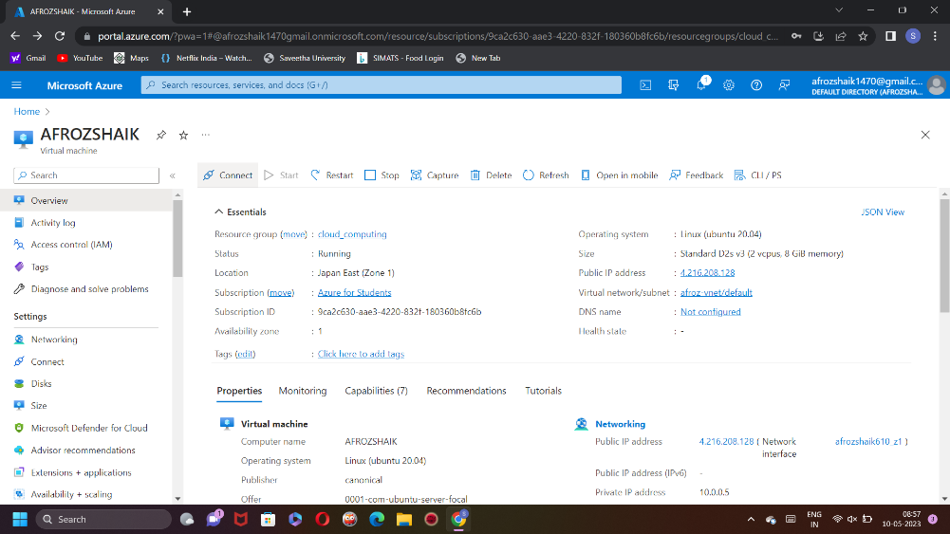

CLICK ON SIZE

CREATE YOUR OWN CPU AND RAM SIZE….

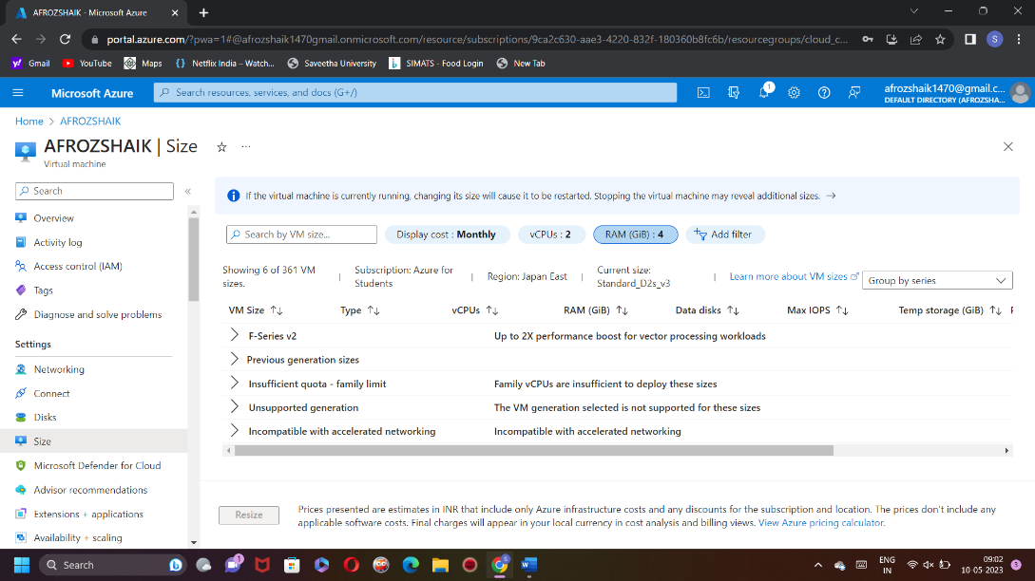

CLICK ON CONNECT

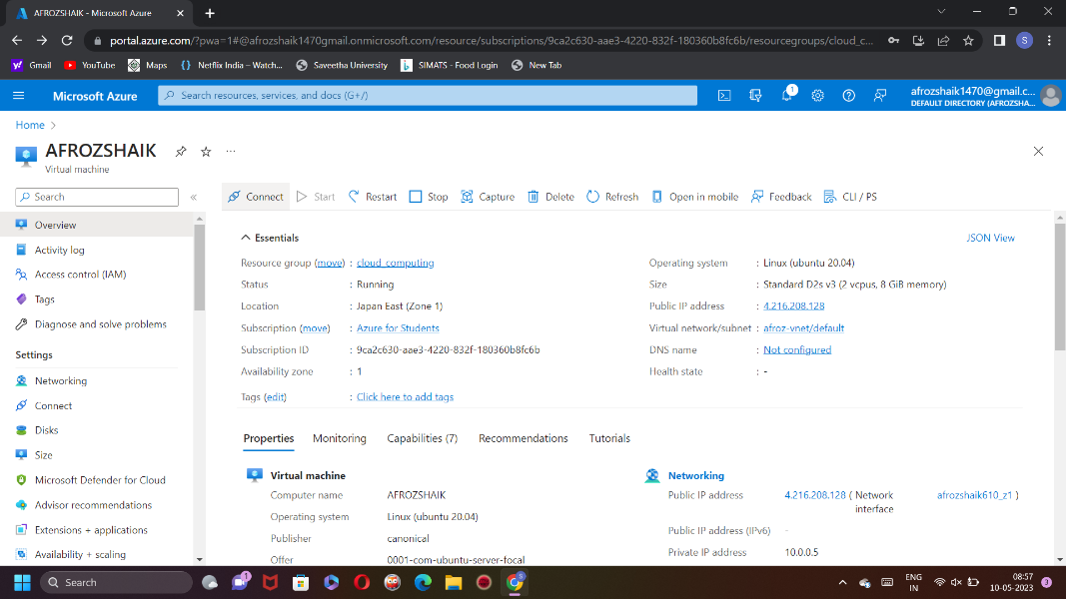

GO TO SSH

UNTIL IT CONNECT…

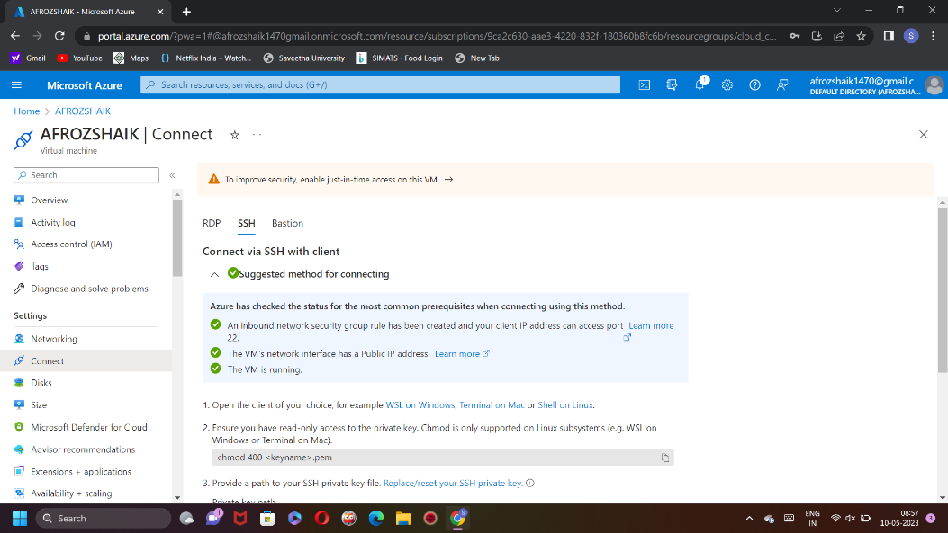

CLICK ON RDP…

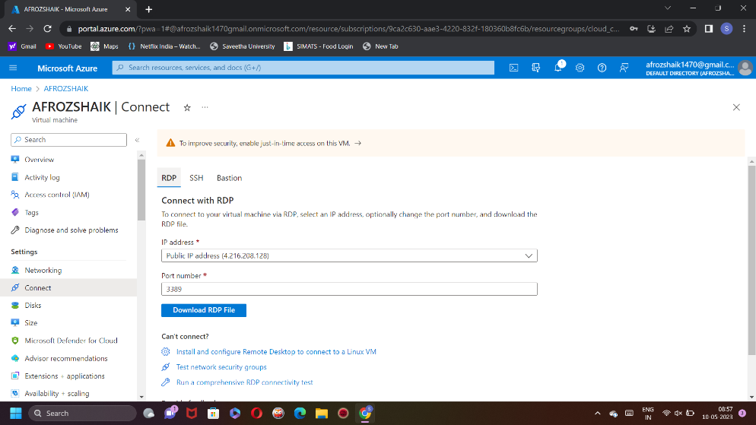

NOW DOWNLOAD THE RDP FILE…

OPEN THE RDP FILE…

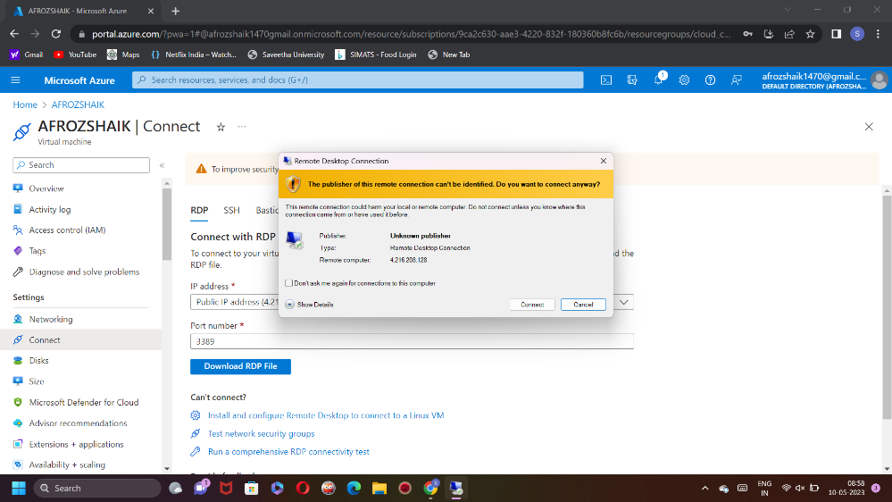

AFTER THAT CONNECT…

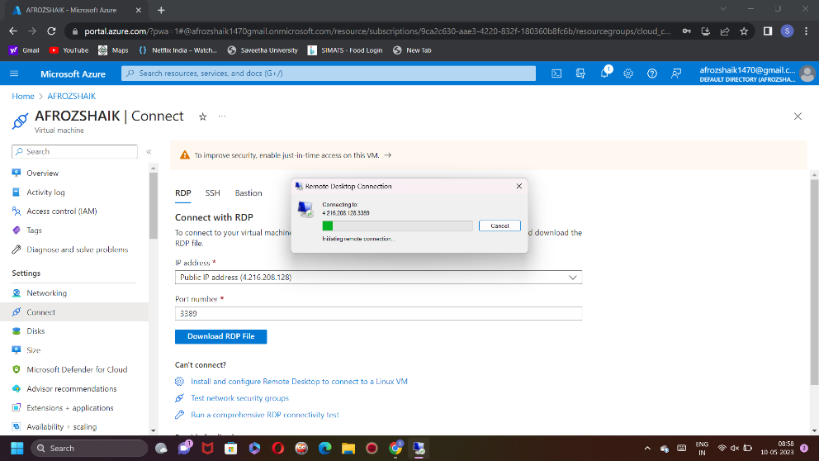

YOU’RE SUCCESSFUL CONNECTED, THEN THE VIRTUAL MACHINE IS READY,

IF NOT,

