EXERCISE-12

Design DFA using simulator to accept the input string “a” ,”ac”,and ”bac”.

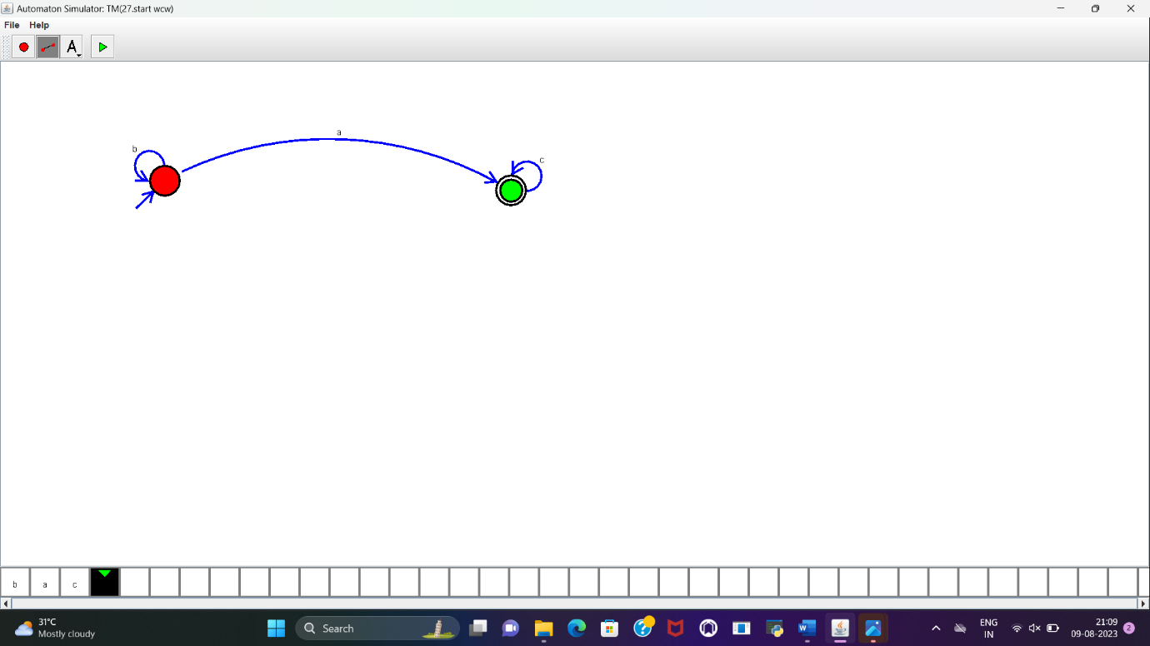

**RESULT:**

DFA to accept the string “a”, “ba”, “bac” is designed and implemented successfully.