EXERCISE-13

Design PDA using simulator to accept the input string aabb

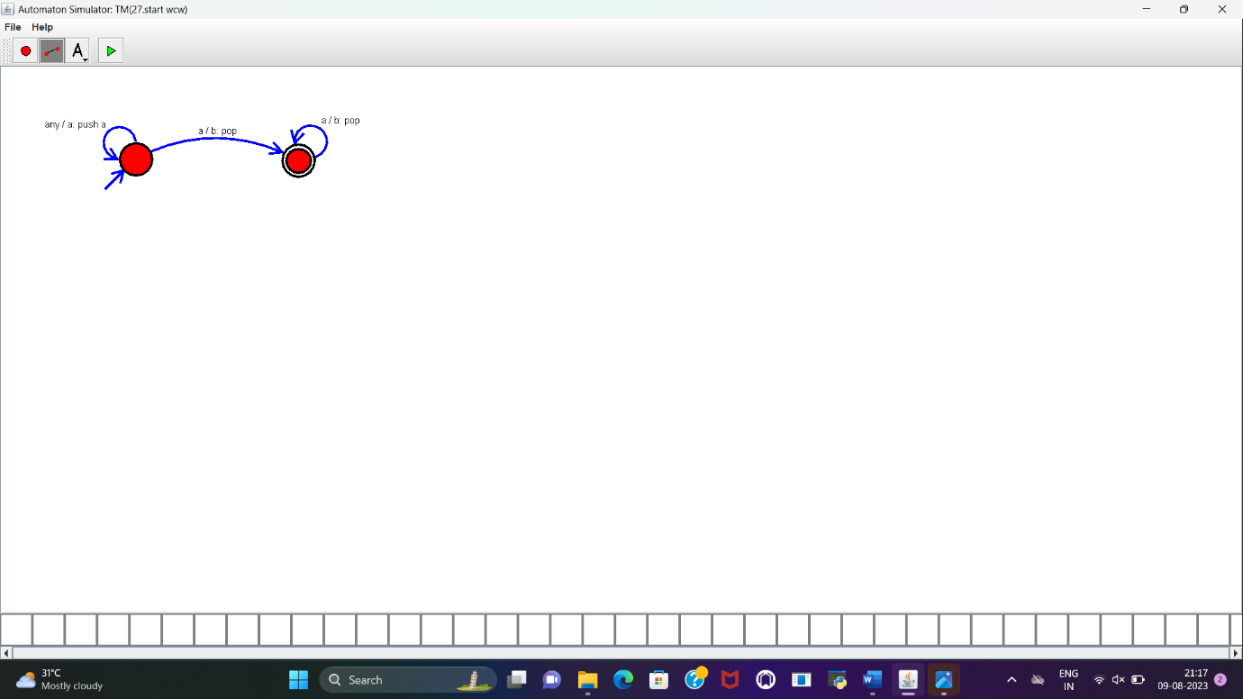

**RESULT:**

PDA is designed to accept the string a^nb^n and implemented successfully.