EXERCISE-14

Design PDA using simulator to accept the input string anb2n

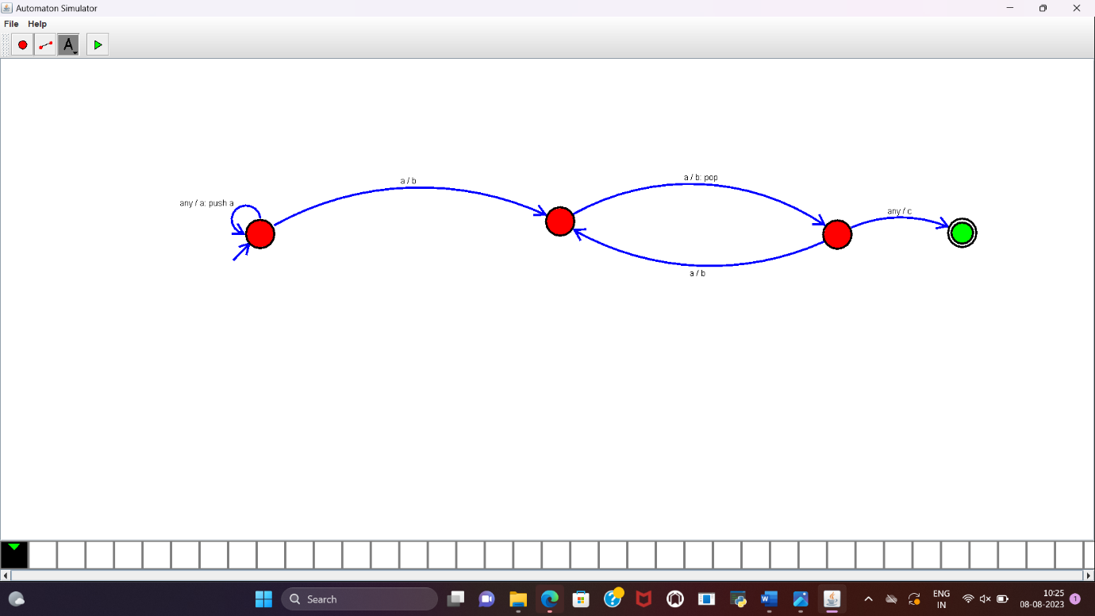

**RESULT** :

PDA to accept the string a^nb^2n is designed and implemented successfully.