EXERCISE-15

Design TM using simulator to accept the input string anbn

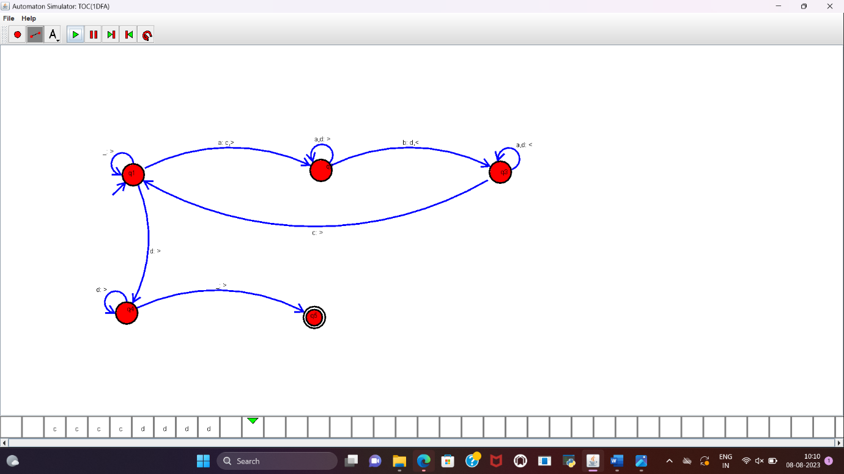

**RESULT :**

TM is designed to accept the string a^nb^n and implemented successfully.