EXERCISE-16

Design TM using simulator to accept the input string anb2n

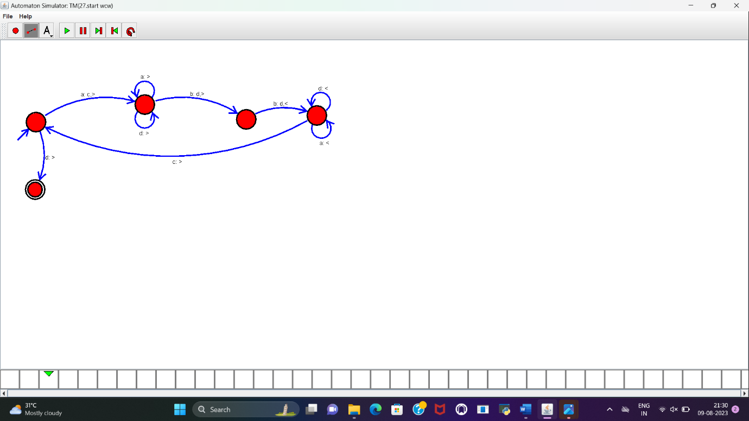

**RESULT :**

TM to accept the string a^nb^2n is designed and implemented successfully.