EXERCISE-17

Design TM using simulator to accept the input string Palindrome ababa

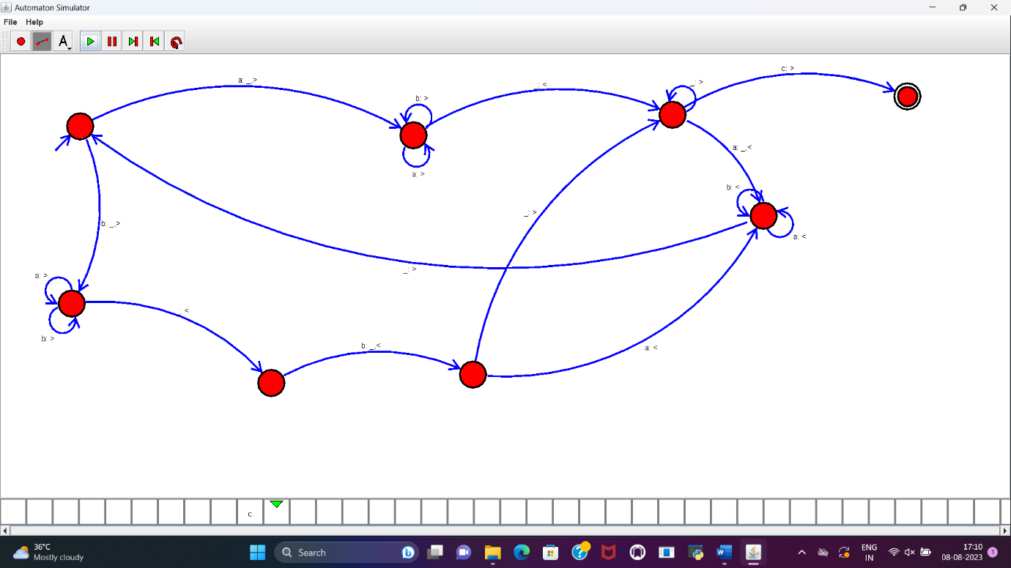

**RESULT :**

TM to accept the string palindrome ababa is designed and implemented successfully.