EXERCISE-18

Design TM using simulator to accept the input string ww

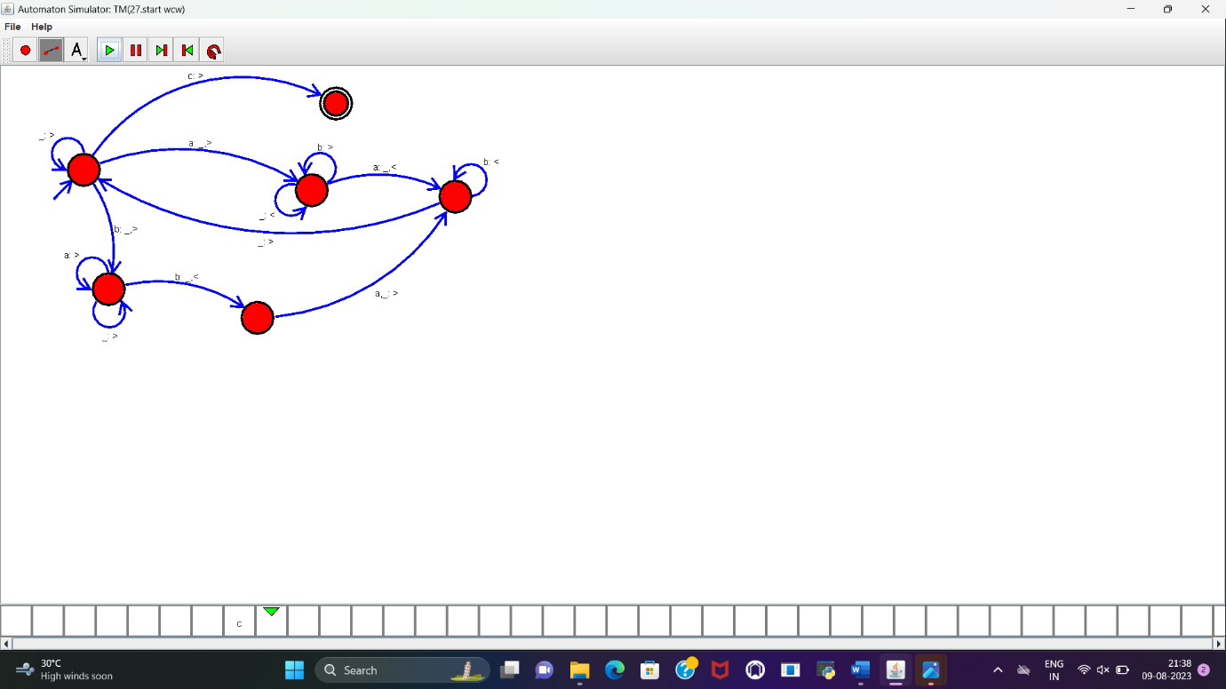

**RESULT :**

TM to accept the input string WW is designed and implemented successfully.