EXERCISE-19

Design TM using simulator to perform addition of ‘aa’ and ‘aaa’

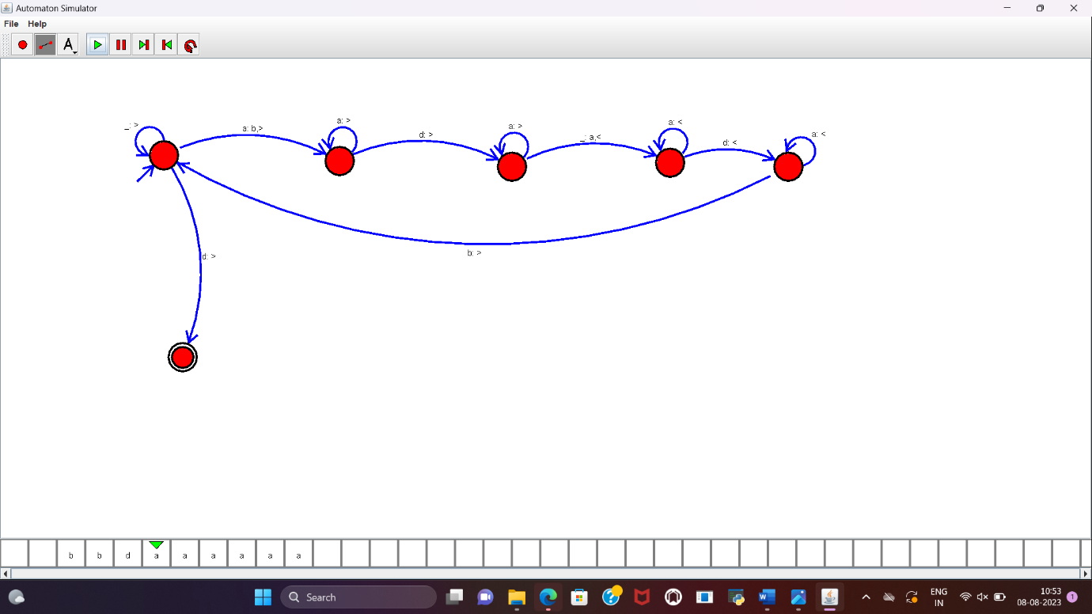

**RESULT :**

TM to perform addition of “aa” and “aaa” is designed and implemented successfully.