EXERCISE-20

Design TM using simulator to perform subtraction of aaa-aa

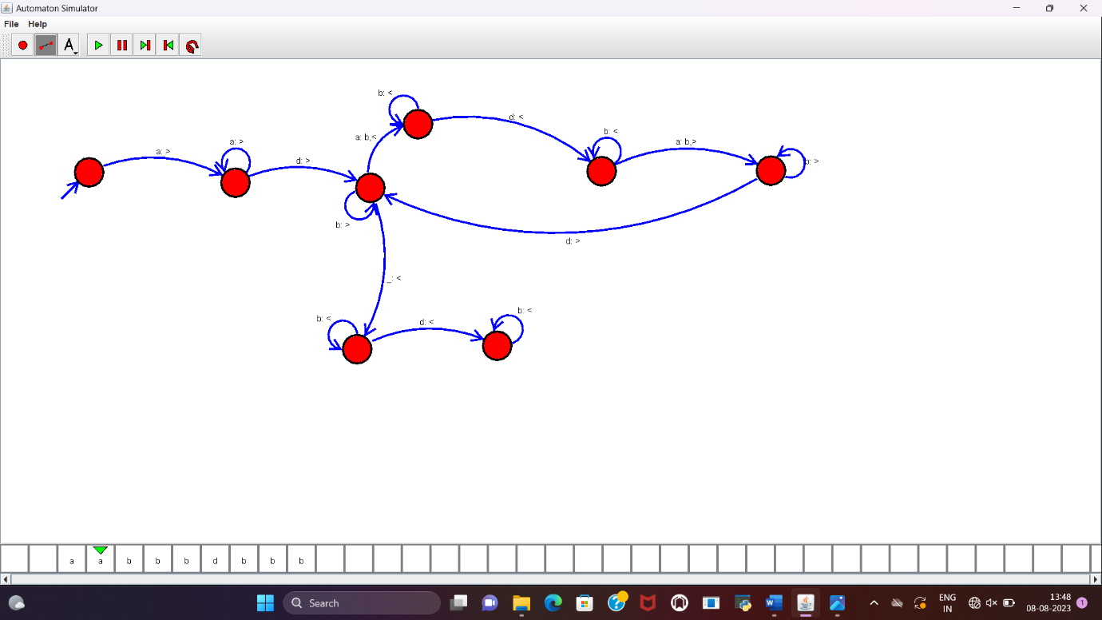

**RESULT :**

TM to perform the subtraction of “aaa”-“aa” is designed and implemented successfully.