EXERCISE-21

Design DFA using simulator to accept even number of a’s.

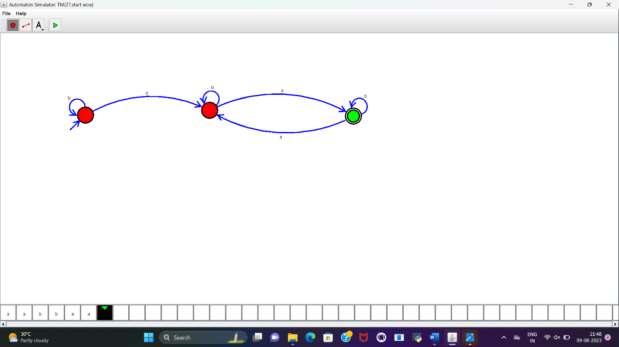

**RESULT :**

DFA to accept the even number of a’s is designed and implemented successfully.