EXERCISE-22

Design DFA using simulator to accept odd number of a’s

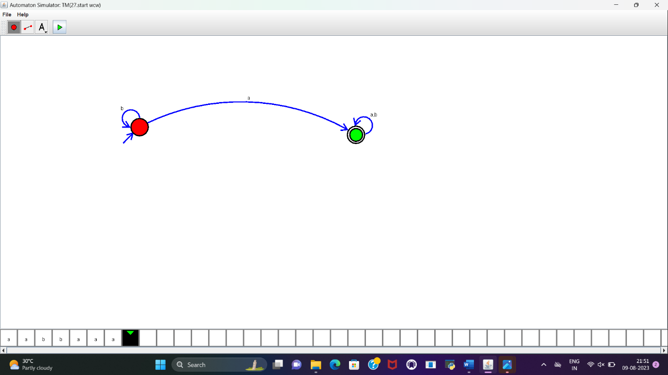

**RESULT :**

DFA to accept odd number of a’s is designed and implemented successfully.