EXERCISE-23

Design DFA using simulator to accept the string the end with ab over set {a,b)

W= aaabab

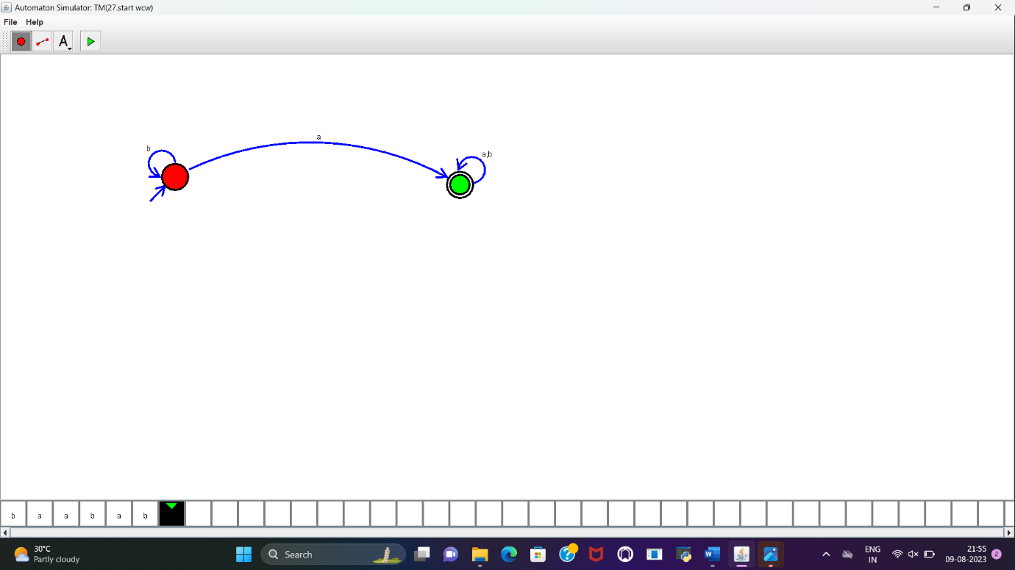

**RESULT :**

DFA to accept the string that end with “ab” over set {a,b} is designed and implemented successfully.