EXERCISE-24

Design DFA using simulator to accept the string having ‘ab’ as substring over the set {a,b}

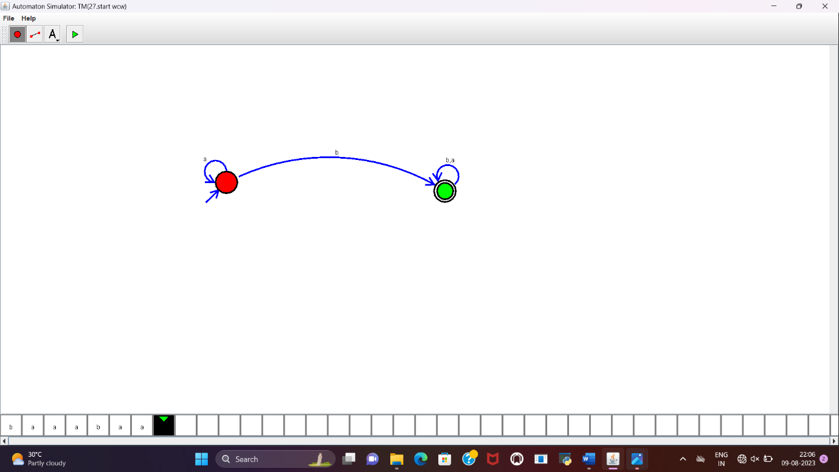

**RESULT:**

DFA to accept the string having “ab” as substring over set {a,b} is designed and implemented successfully.