EXERCISE-25

Design DFA using simulator to accept the string start with a or b over the set {a,b}

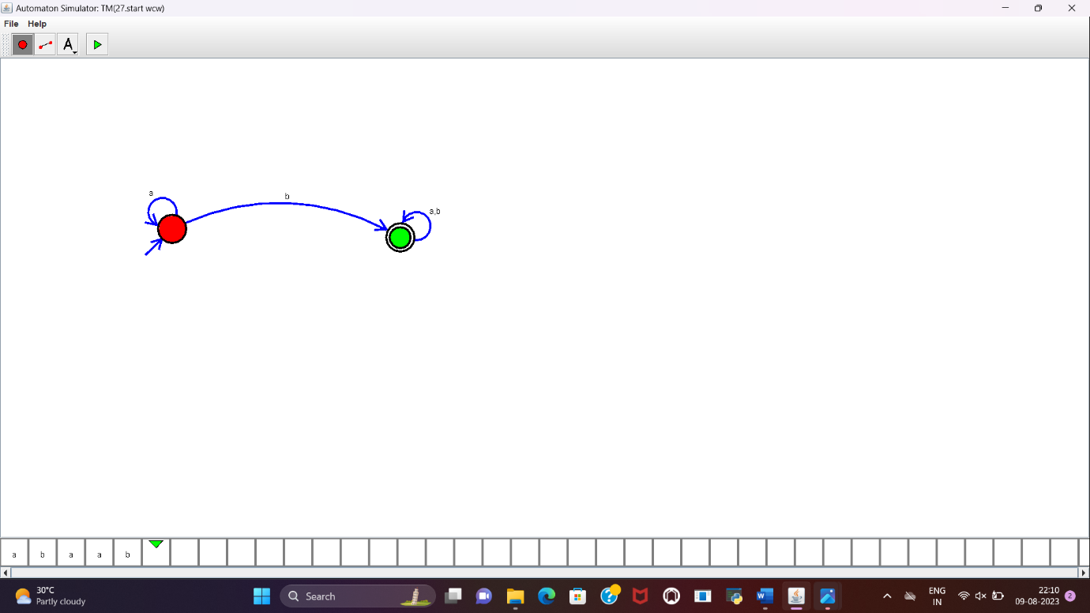

**RESULT:**

DFA to accept the string that start with a or b over set {a,b} is designed and implemented successfully.