EXERCISE-26

Design TM using simulator to accept the input string Palindrome bbabb

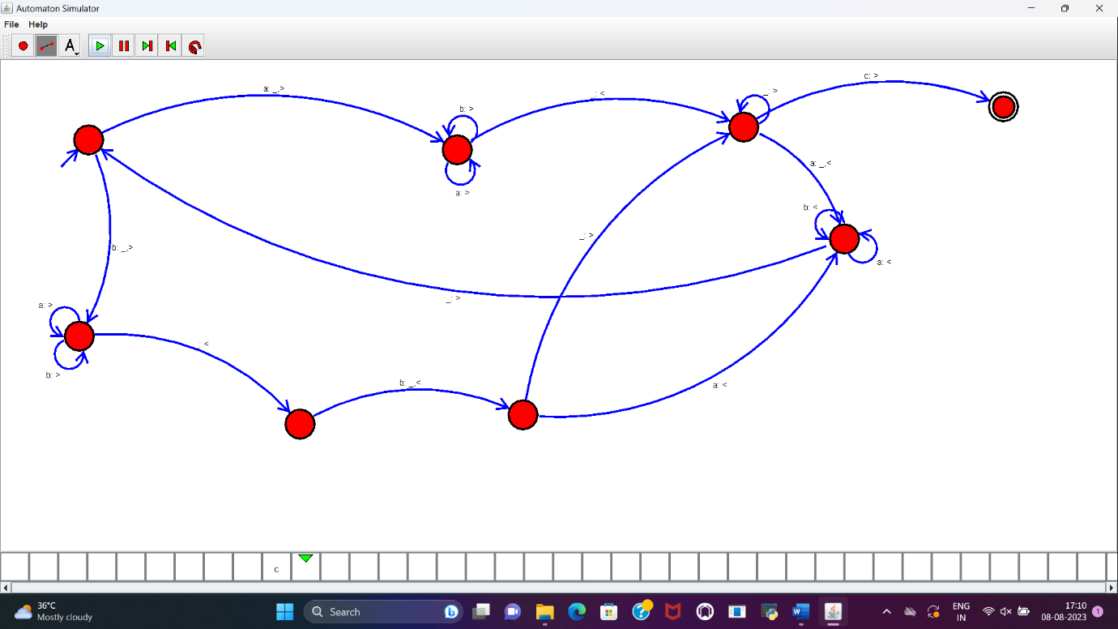

**RESULT :**

TM to accept the input string palindrome bbabb is designed and implemented successfully.