EXERCISE-27

Design TM using simulator to accept the input string wcw

W=ab

WCW=abcab d

d is output reference variable

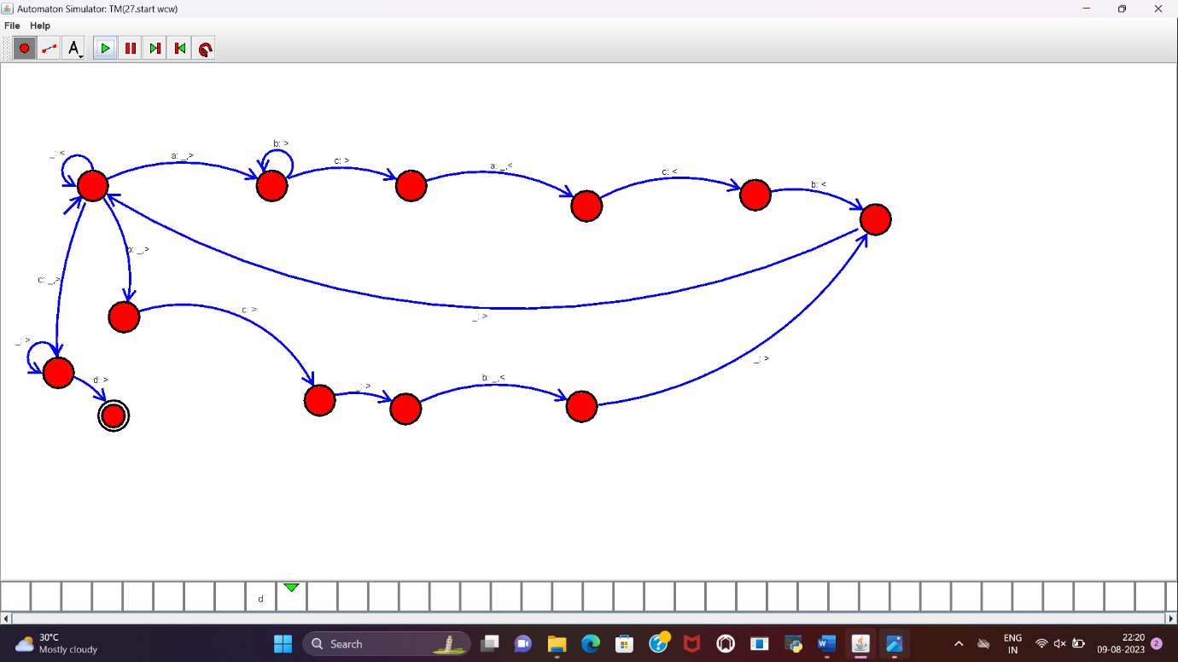

**RESULT:**

TM to accept the string WCW is designed and implemented successfully.