EXERCISE-29

Design DFA using simulator to accept the input string “bc” ,”c”,and ”bcaaa”.

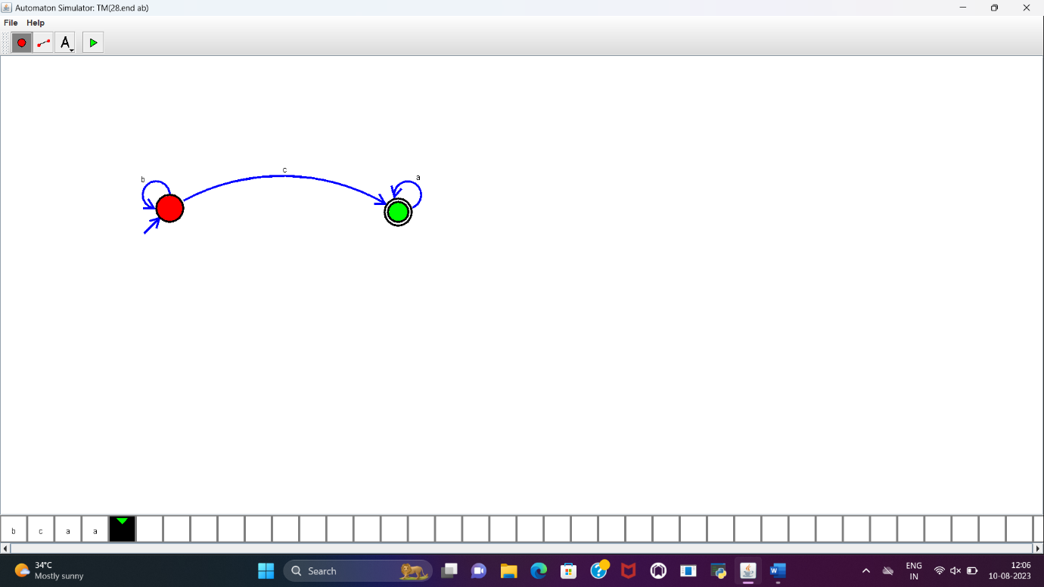

**RESULT:**

DFA to accept the input string “bc”,”c”,”bca” is designed and implemented successfully.