EXERCISE-30

Design NFA to accept any number of a’s where input={a,b}.

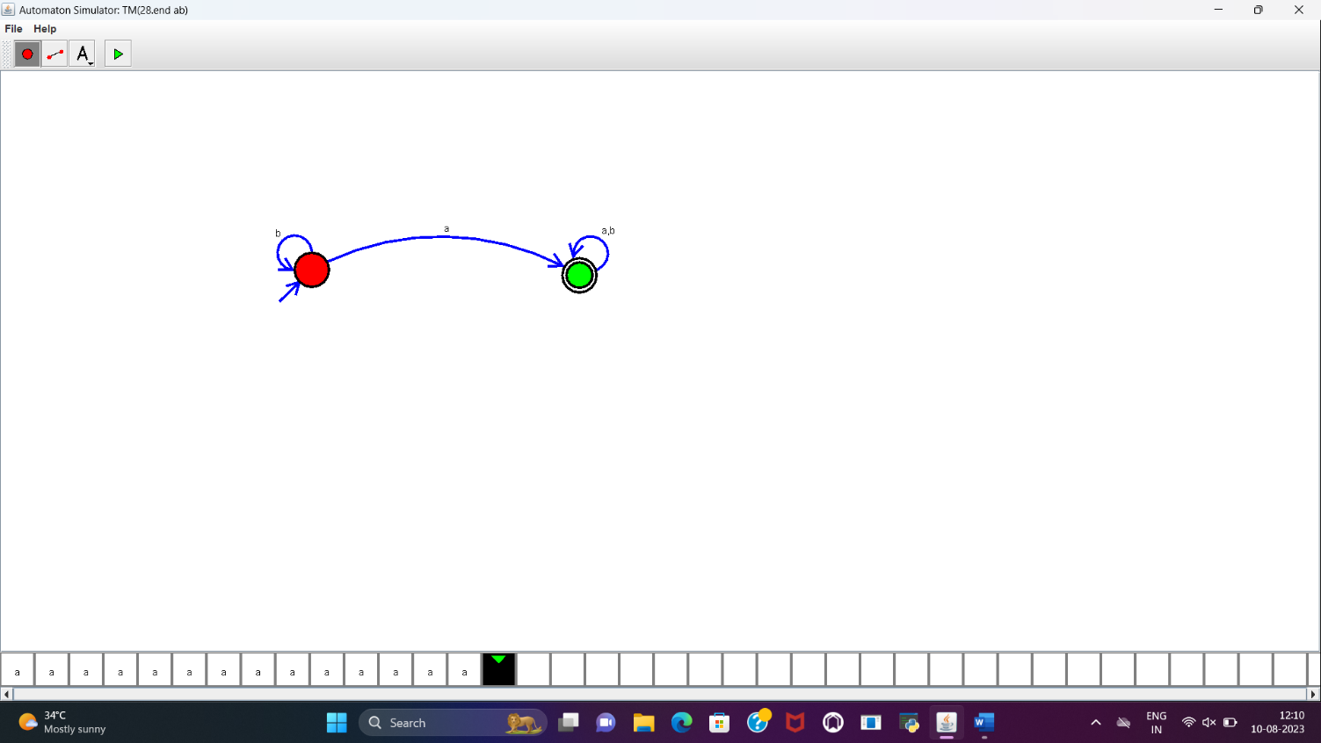

**RESULT:**

NFA to accept any number of a’s is designed and implemented successfully using simulator.