EXERCISE-31

Design PDA using simulator to accept the input string anbn

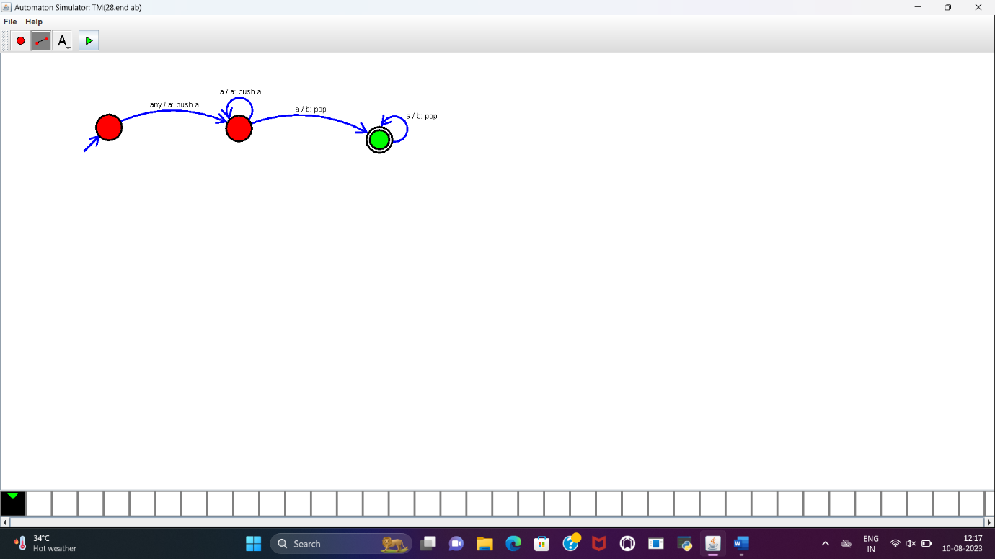

**RESULT:**

PDA to accept the input string a^nb^n is designed and implemented successfully using simulator.