EXERCISE-33

Design DFA using simulator to accept the string having ‘abc’ as substring over the set {a,b,c}

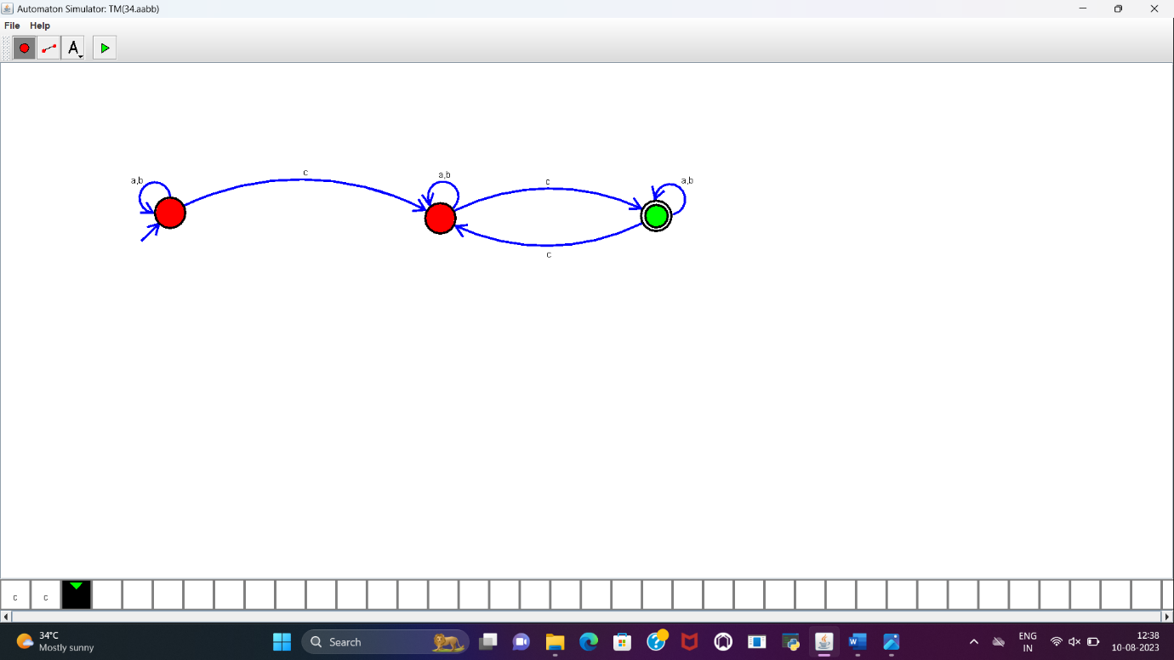

**RESULT:**

DFA to accept even number of c’s over the set of {a,b,c} is designed and implemented successfully using simulator.