EXERCISE-33

Design DFA using simulator to accept even number of c’s over the set {a,b,c}

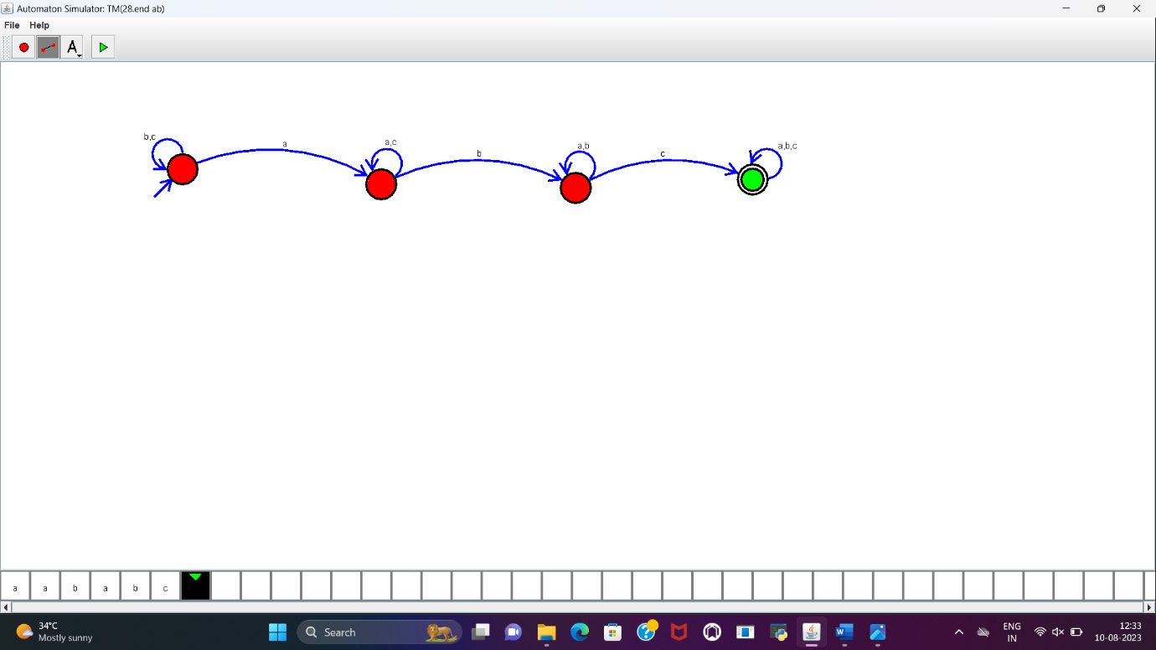

**RESULT:**

DFA to accept the string having “abc” as substring is designed and implemented successfully.