EXERCISE-35

Design DFA using simulator to accept strings in which a’s always appear tripled over input {a,b}

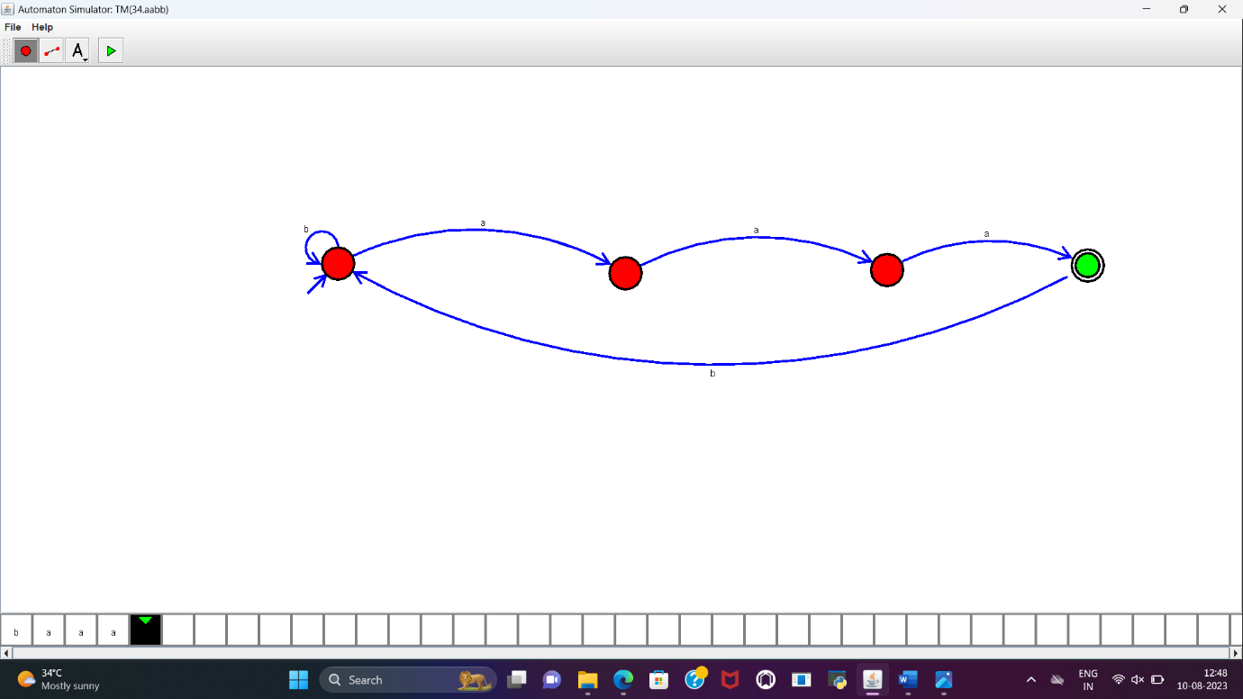

**RESULT:**

DFA to accept the string in which a is always tripled over input{a,b} is designed and implemented successfully using simulator.