EXERCISE-37

Design NFA using simulator to accept the string that start and end with different symbols over the input {a,b}.

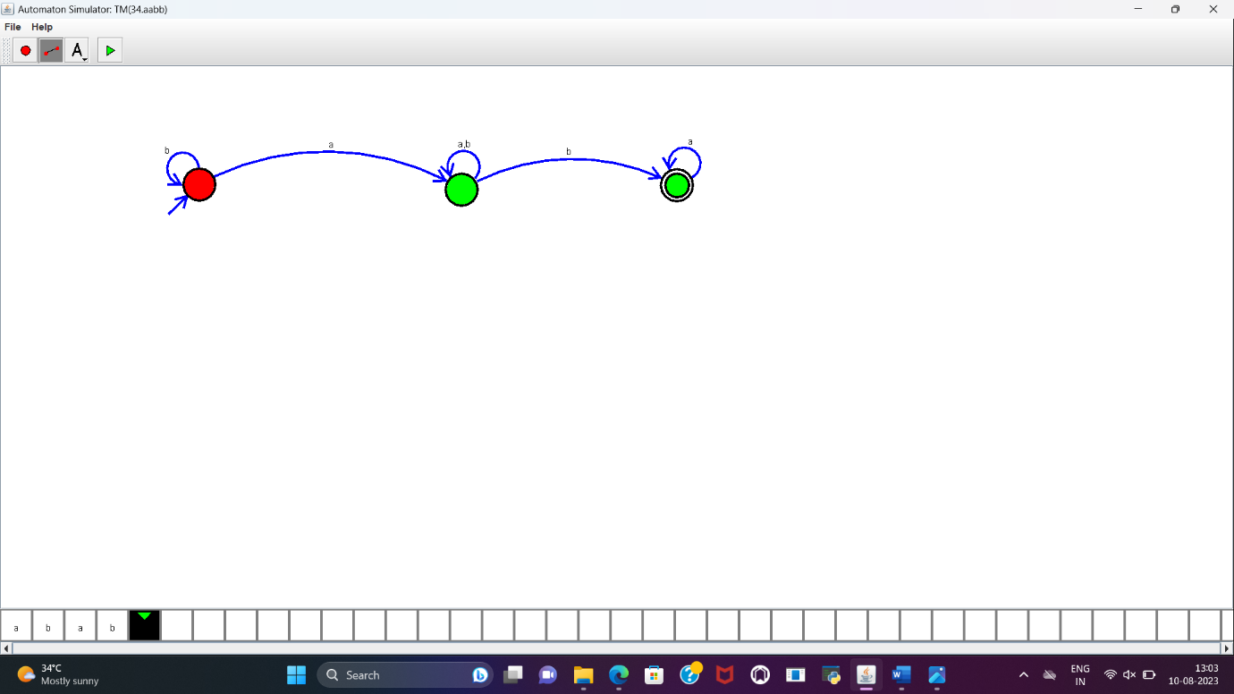

**RESULT:**

NFA to accept the string that start and end with different symbols over input{a,b} is designed and implemented successfully