EXERCISE-38

Design NFA using simulator to accept the input string “bbc” ,”c”,and

”bcaaa”.

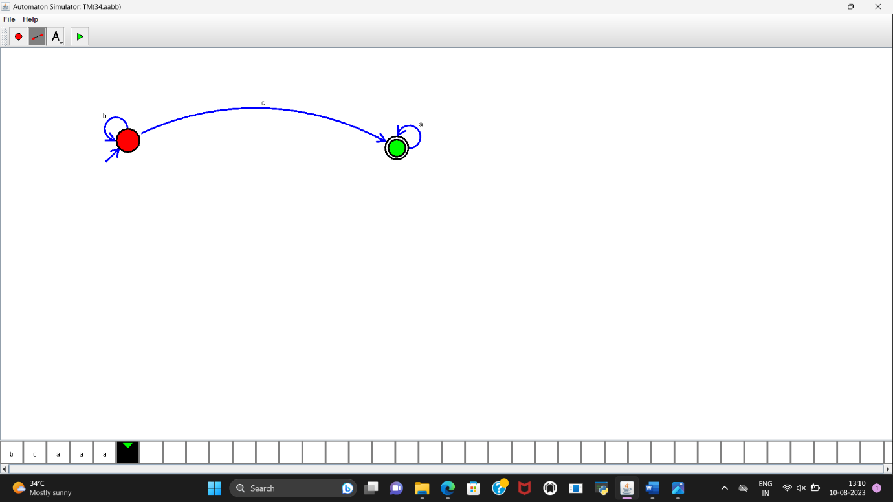

RESULT:

NFA to accept the input string “bbc”,”c”,”bcaaa” is designed and implemented successfully