EXERCISE-39

Design DFA using simulator to accept the string the end with abc over set {a,b,c)

W= abbaababc

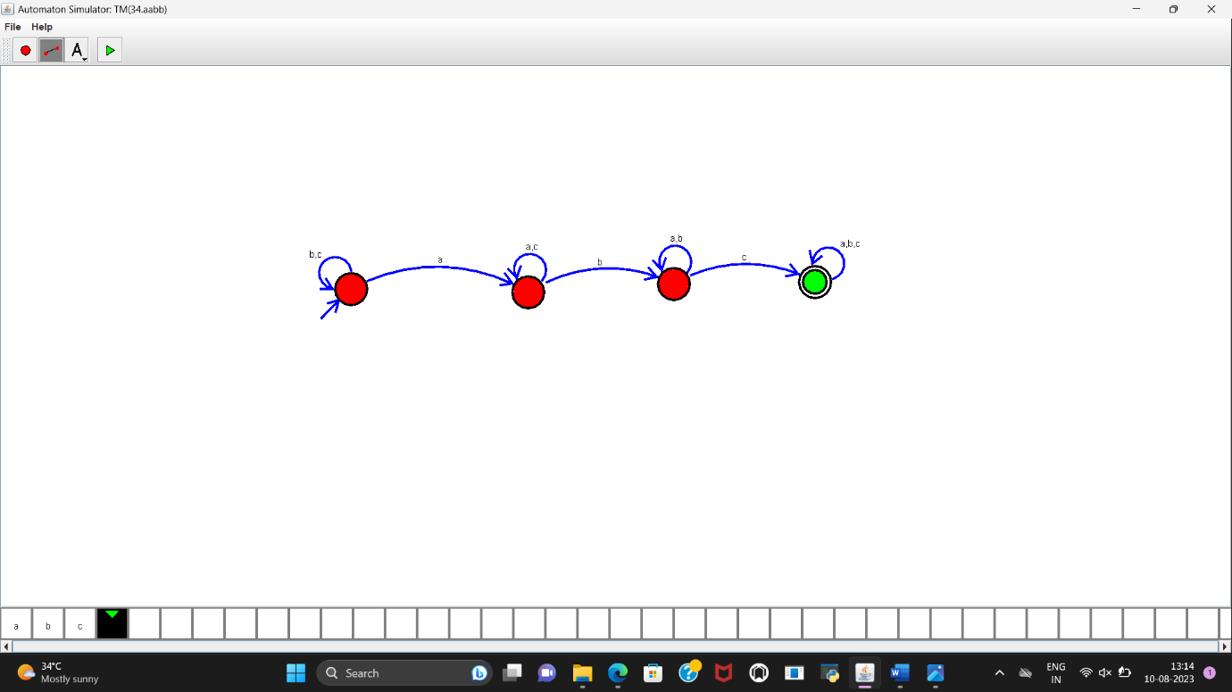

**RESULT:**

DFA to accept the string that end with abc over set{a,b,c} is designed and implemented successfully.