EXERCISE-40

Design NFA to accept any number of b’s where input={a,b}.

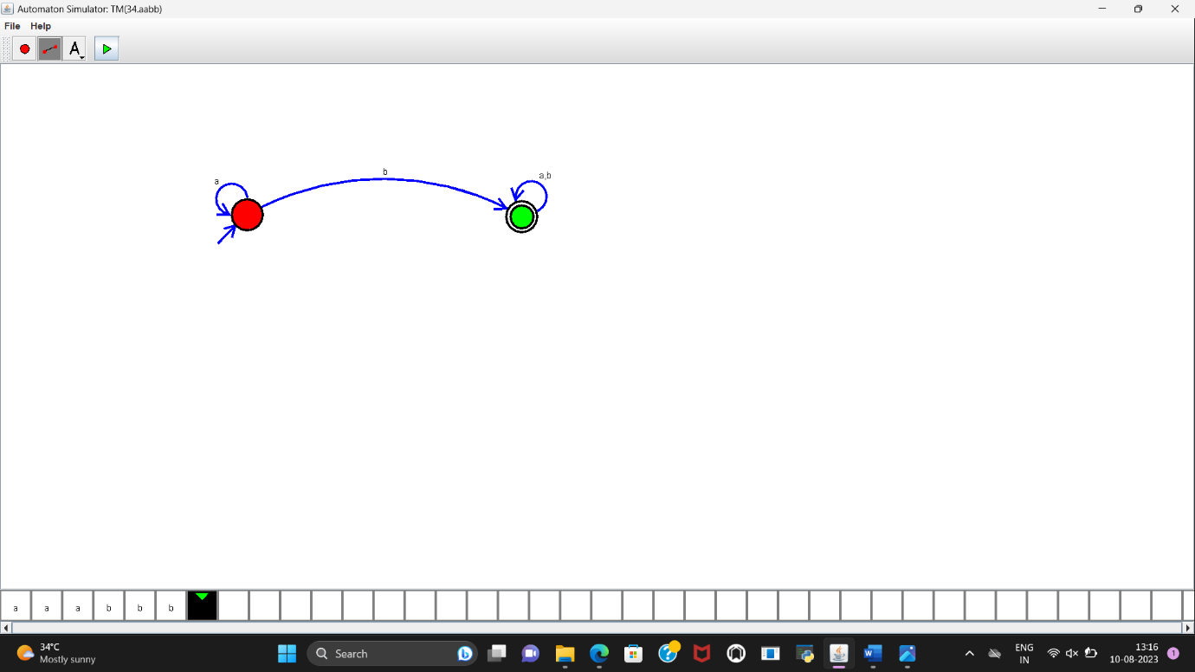

**RESULT:**

NFA to accept any number of b’s where input={a,b} is designed and implemented successfully.