EXERCISE-5

SIMULATING PUSHDOWN AUTOMATA(PDA)

AIM : To write a C program to simulate a PDA for the language L={ 0n 1n | n>=1 } in which equal number of 0’s are followed by equal number of 1’s

ALGORITHM :

1. Get the input string from the user.

2. Define a stack and push the symbol ‘Z’ onto the stack. The symbol ‘Z’ acts as the bottom marker of the stack.

3. Find the length of the string.

4. Read the input string character by character.

5. Read the current input symbol do steps 6 and 7. If the end of the input is reached, go to step 8

6. If the input symbol is 0, push it onto the stack. Print the content of the stack and the remaining input and go to step 5

7. If the input symbol is 1, check whether there is a 0 at the top of the stack. If so, pop it from the stack. Print the content of the stack and the remaining input and go to step 5. If not, print “String not accepted” and quit the program

8. If the stack is empty having only the bottom marker, print “String Accepted”. Otherwise print “String not accepted”

PROGRAM:

#include<stdio.h>

#include<string.h>

char stack[20];

int top;

void push()

{

top=top+1;

stack[top]='0';

stack[top+1]='\0';

}

int pop()

{

if(top<1)

return(0);

else

{

stack[top]='\0';

top=top-1;

return(1);

}

}

void main()

{

int m,i,j,k,l,a,len;

char input[20],rem_input[20];

printf("Simulation of Pushdown Automata for 0n1n\n");

printf("Enter a string : ");

scanf("%s",input);

l=strlen(input);

j=0;stack[0]='Z';top=0;

printf("Stack\tInput\n");

printf("%s\t%s\n",stack,input);

while(1)

{

len=strlen(input);

while(len>0)

{

if(input[0]=='0')

{

push();

m=0;

for(k=1;k<len;k++)

{

rem_input[m]=input[k];

m=m+1;

}

rem_input[m]='\0';

strcpy(input,rem_input);

printf("%s\t%s\n",stack,input);

}

if(input[0]=='1')

{

a=pop();

if(a==0)

{

printf("String not accepted");

goto b;

}

else

{

m=0;

for(k=1;k<len;k++)

{

rem_input[m]=input[k];

m=m+1;

}

rem_input[m]='\0';

strcpy(input,rem_input);

printf("%s\t%s\n",stack,input);

}

}

break;

}

j=j+1;

if(j==(l))

{

break;

}

}

if(top>=1)

{

printf("String not accepted");

}

else

{

printf("String accepted");

}

b:

printf(".............");

}

Output:

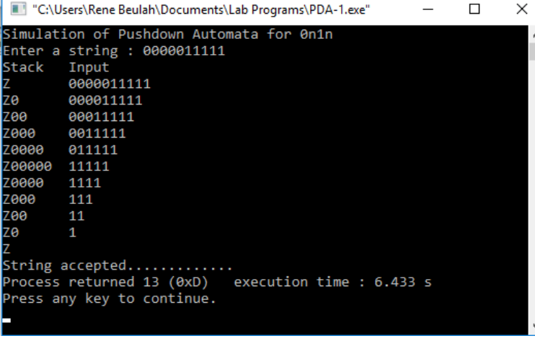

RESULT:

C program to simulate a PDA for the language L={ 0n 1n | n>=1 } in which equal number of 0’s are followed by equal number of 1’s is written and executed and got output successfully.