EXERCISE-32

32.Design TM using simulator to perform string comparison where w={aba aba}

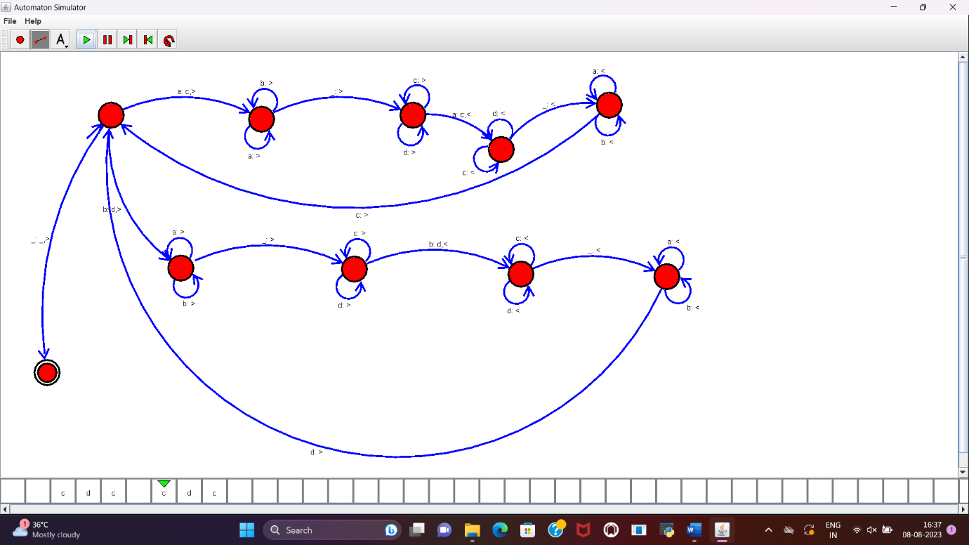

RESULT:

TM to perform string comparision is designed and implemented successfully using simulator.